Energy Efficiency & Weatherization of Affordable Housing
State and Local Fiscal Recovery Funds
2022-2023 Work Plan Pilot
Alachua County, Florida
2022-2023 Work Plan: Energy Efficiency Pilot

TABLE OF CONTENTS
TABLE OF CONTENTS 1
GENERAL OVERVIEW 2
Executive Summary 2
Uses of Funds 2
Promoting equitable outcomes 6
Goals 6
For Pilot Program 6
For Pilot & Full Program 6
Awareness 6
New Energy Efficiency Standards 6
Community Weatherization Coalition (CWC) 7
Access and Distribution 7
Step 1: Residents of Qualified Census Tracts 7
Step 2: Residents of Underserved Communities 7
Step 3: Other Qualified Residents 8
Pilot Outcomes 8
Goals and Targets 8
Efforts to Date to Support Economic and Racial Equity 8
Constraints and Challenges 9
Project Demographic Distribution 9
Community Engagement 12
Labor Practices 12
Use of Evidence 12
Program Expenses 13
Performance Report 13
PROJECT INVENTORY 14
REFERENCES 15
APPENDIX 1: Qualification Criteria for Alachua County Census Tracts 17
APPENDIX 2: Pilot Project Budget 20
APPENDIX 3: Rebuilding Together Northern Central Florida Procurement 21

GENERAL OVERVIEW

Executive Summary
In response to the COVID-19 Pandemic, the Federal government has provided the Alachua County Board of County Commissioners (ACBoCC) funding through the American Rescue Plan (ARPA) State and Local Fiscal Recovery Funds. Many disenfranchised and marginalized communities were disproportionately impacted in their ability to find and maintain affordable housing due to job loss and other income insecurities caused by COVID-19. This project brings affordable housing relief to communities with limited financial resources by addressing the high costs of utilities on renters through energy efficiency improvements and weatherization.
$3 million in ARPA funding is budgeted for this program. From these funds, up to $15,000 per unit is available for eligible rental property owners within the unincorporated areas of Alachua County and smaller municipalities. This grant focuses on electricity efficiency and not natural gas. Alachua County is partnering with Rebuilding Together North Central Florida and the Community Weatherization Coalition to identify applicants, vet contractors, and complete individual projects. The full agreement between Alachua County and Rebuilding Together North Central Florida can be found in the associated Professional Services Agreement.
This work plan covers the pilot project, which is scheduled for seven (7) months, the first six (6) of these months being used to conduct the pilot testing and the final month to analyze the data collected during the pilot project and update the work plan as appropriate. The program will continue to run according to the pilot project work plan until ACBoCC approval of the full work plan. The current timeline of the pilot runs from January 16, 2023 until August 18, 2023. The full work plan is scheduled, pending ACBoCC approval, from August 19, 2023 to December 31, 2026.

Uses of Funds
The ACBoCC will allocate $3 million over four (4) years for weatherization improvements for qualifying households, designed to combat energy insecurity in the county. The Energy Efficiency & Weatherization of Affordable Housing program will run from December 2022 through December 2026 and is targeted to communities that have experienced COVID-based inequities per Treasury guidance under Negative Economic Impacts (EC 2), found in §35.6 Part (b)(3)(ii)(A)(1) of the Final Rule: “Assistance for food; emergency housing needs; burials, home repairs, or weatherization; internet access or digital literacy; cash assistance; and assistance accessing public benefits…” [emphasis ours].
Communities in Alachua County have experienced ongoing struggles around affordable housing and coping with increasingly high summer temperatures due to climate change, a burden that falls inequitably on those with limited financial resources. These problems are exacerbated by ever-increasing rent and utility rates, which are leading to greater energy insecurity in the county, defined as households unable to meet their energy needs. Having access to consistent, affordable housing and basic necessities like electricity and water are critical factors in maintaining health and well-being, as well as preventing disease spread.
Utility rates are set to increase in the coming years. Gainesville Regional Utility (GRU) raised rates in October 2022, increasing electrical costs by 3% and water by 5%, and the utility will continue to increase its rates by 3% and 5% respectively each year from 2023-2027. Due to rising natural gas costs, Clay Electric raised its prices five (5) times in less than a year, and announced another increase in August 2022 which will cost the average user an additional five (5) dollars per billing cycle. Citing these same rising fuel costs, Duke Energy projects its average customers will see a 13% cost increase in 2023. Rising energy prices are poised to drop more Alachua County residents into energy insecurity.
The U.S. Energy Information Administration estimates that homes in the southern US on average spend 4,000kw more than other regions in the country (Figure 1), with air conditioning serving as the single largest electrical consumption end use in residential homes (Figure 2).
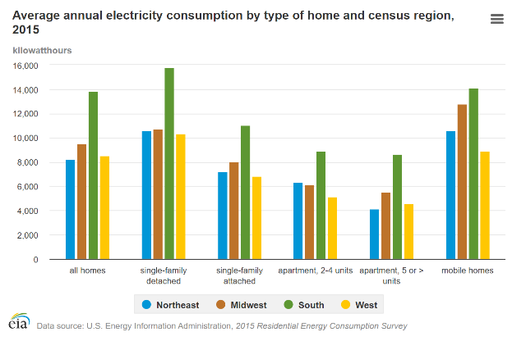
Figure 1: Average annual energy consumption by type of home and census region, 2015. Available at https://www.eia.gov/energyexplained/use-of-energy/electricity-use-in-homes.php. (Last visited October 10, 2022)
Florida residential retail sales of electricity are also slowly increasing in the years since COVID, with July 2022’s consumption peaking higher than any of the six (6) years prior to it (Figure 3). Single-family, duplex, and quadplex units are the only permissible housing types for program participation.
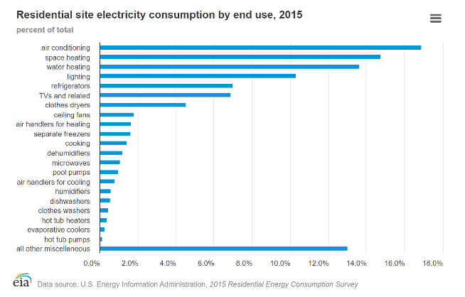
Figure 2: Residential site electricity consumption by end use, 2015 Residential Energy Consumption Survey. (U.S. Energy Information Administration 2019)
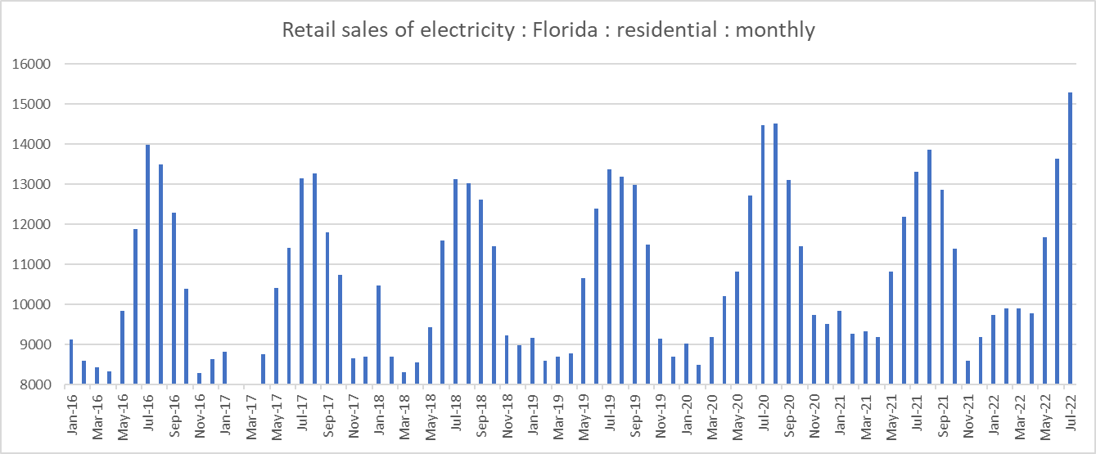
Figure 3: Retail sales of electricity in millions of kilowatthours, Florida monthly residential sales, January 2016 - July 2022, generated in EIA Beta, October 10, 2022. (U.S. Energy Information Administration, n.d.)
Florida electricity consumption (Figure 3) shows a strong trend towards higher electricity use in the summer months, indicating that air conditioning and other weather-focused electrical use is the primary factor driving higher consumption levels. Alachua County’s Energy Efficiency ARPA funding is designed to help reduce the utility burden on Alachua County rental units by addressing some of the largest factors in utility bills, including weatherization upgrades such as new, energy efficient windows, duct insulation, attic insulation, and upgrading to energy efficient air conditioning systems.
Alachua County’s Energy Efficiency & Weatherization of Affordable Housing Program is designed to address a gap in the county’s affordable housing programming by 1.) addressing high utility rates for residents of the county, and 2.) by focusing on rental housing, which traditionally serves as homes for lower income residents, and who have little or no ability or incentive to make energy efficiency improvements to their homes due to lease restrictions.
In 2020, an estimated 23% of renter households in the unincorporated areas of Alachua County were severely cost burdened by their rental payments (defined as their rental payment making up more than 50% of their monthly household income), compared to only 7% of owner-occupied households. An additional 21% of renter households are cost burdened, and have rental payments that make up between 30.1% and 50% of their monthly income, compared to only 11% of owner-occupied homes. In addition to their monthly rent payments, it is common in Alachua County for landlords to require tenants to pay for the cost of their utilities while they occupy the unit, adding an additional housing burden to already stretched budgets, particularly in the summer months.
Because they do not pay utilities, landlords have little incentive to upgrade their rental housing for energy efficiency, and most tenants do not or cannot invest in major upgrades for a home that they do not own. This project attempts to fill this gap, by providing landlords the funding to upgrade their units in a way that reduces the energy burden on renters while protecting the affordability of the unit.
In order to ensure upgraded housing remains affordable, participating landlords will be required to commit to not increasing their rental rates beyond inflation (as calculated by the Consumer Price Index) for a length of time determined by the amount of award they accept, according to the following guidelines:
Award Amount | Term of Affordability Commitment
Up to $5000 | 3 years
$5001 to $10,000 | 5 years
$10,001 to $15,000 | 7 years

Promoting equitable outcomes
ACBoCC will promote outcomes with equity in mind in how we measure our performance and
target assistance through community partnerships over the next four (4) years.

Goals

For Pilot Program
- Test program work plan and subrecipient agreement to determine if alterations or amendments are needed for the smooth functioning of the full program
- Collect data to determine whether program is sufficiently reaching Alachua County residents with an equity lens, and to allow adjustments to outreach plans as needed

For Pilot & Full Program
- Reduce energy insecurity in Alachua County, particularly for the most vulnerable residents. Residents served by the energy efficiency program will be from marginalized communities hardest hit by COVID-19. These residents include low-income, elderly, youth, and housing-insecure populations, and will reflect a broad racial and ethnic demographic
- Promote affordable housing by addressing the largest household expense after rent payments
- Build climate resiliency and energy independence in traditionally underserved areas by reducing the burden on energy infrastructure

Awareness
We will be raising awareness for this program in two (2) ways, 1.) as part of a larger rollout of new energy efficiency standards in the county code, and 2.) using community engagement techniques already being employed by the CWC to spread awareness of weatherization options.

New Energy Efficiency Standards
In addition to the program described in this work plan, the county is independently rolling out new energy efficiency standards for rental units in the unincorporated areas of the county. A benefit of this dual roll-out is the ability to work directly with landlords to help them meet the new energy efficiency standards. As part of the dual roll-out, the County will be promoting the program through the following measures:
- An announcement at Board of Commissioner meetings when appropriate. These meetings are open to the public, including virtually, allowing participants at all ability levels to participate. These meetings are also filmed and recorded with captioning for the hearing impaired.
- A webpage with the program information and application documents. This page will be part of the dual roll-out, so that landlords and renters seeking to understand the new guidelines can easily find information on how to access funding to help bring their units up to code.
- Work with code enforcement to provide informational material on the program directly to landlords whose units do not pass the initial energy efficiency inspection

Community Weatherization Coalition (CWC)
Through our sub-grantee partnership with the Community Weatherization Coalition (CWC) and Rebuilding Together North Central Florida, we will take the following steps to ensure that information regarding the program is freely available to the public.
- Attend community meetings in qualifying neighborhoods to introduce the program and help with applications as needed
- Spread the word via community groups in Alachua County, including, but not limited to, those engaged in climate action and affordable housing
- Promote the program on all partner’s respective social media and/or website(s)
- Reach out to targeted neighborhood contacts, such as the SWAG resource manager, to help disseminate information on the program
- Clipboard/canvass targeted neighborhoods
These steps are described in additional detail in the next section on Community Engagement activities.

Access and Distribution
We are working diligently to minimize the administrative burden on program participants, contractors, and our sub-grantee to engage with the program, in order to improve overall program accessibility. We have developed a three-step process for determining if participants qualify to participate, with the aim of reducing the administrative barriers to participation, as discussed in more detail in the “Project Demographic Distribution” section below. Notice of screening requirements outlining the program’s goals of reaching residents and communities with limited financial resources will be included in all outreach for the program.
Alachua County has chosen to work with an existing, non-profit community partner that has already done extensive work reaching out to marginalized communities with a weatherization focus. This ARPA program will greatly benefit from the relationships and connections this partner has already built in order to ensure that information about and access to the program reaches Alachua County’s communities in an equitable manner. More about our partner’s community engagement efforts is included in the “Community Engagement” section of this document.

Pilot Outcomes
In collaboration with program partners, we have outlined two measurable outcomes for the first seven months of the program’s pilot.
- Reduce energy burden for at least 15 energy insecure rental households
- Avoid energy insecurity health impacts and COVID hospitalizations due to lack of access to (or an inability to maintain) quality, affordable housing
Rebuilding Together North Central Florida and the Community Weatherization Coalition (CWC) currently have methods in place which track participant demographics including age, race, ethnicity, and other dimensions such as income level, number of people per household, and veteran or disability status. This information is key to the pilot project’s success metrics and will be used to inform our final program implementation in order to ensure that our outreach efforts are reaching all of Alachua County.

Goals and Targets

Efforts to Date to Support Economic and Racial Equity
The U.S. Department of the Treasury issued Guidance for use of Coronavirus State and Local Fiscal Recovery Funds which includes a requirement that economic and racial equity be considered in funded programming.¹⁵ This requirement aligns with ACBoCC’s broader priorities for economic and racial equity, which recognize that inequities occur across multiple sectors and must be targeted intentionally to produce meaningful equity results at scale. The proposed facility, for example, directly addresses unemployment and under-employment, which Alachua County has identified as equity issues that have been exacerbated in marginalized communities during emergencies such as the COVID-19 pandemic.
Equity was placed at the forefront of Alachua County’s policymaking through a November 2020 voter-approved charter amendment that directed “(an) examination of policies for all County operations for elements of racial, economic, and gender bias in the design and delivery of County programs and services. The County will identify and act to mitigate and improve upon the effects, patterns, and disparities imposed by said biases.” Since the ballot initiative, the ACBoCC has made significant investments in creating an overall Equity Plan for County operations and community engagement, hired talented leadership to spearhead this effort, and engaged in pilot projects to support food system equity outcomes.
The ACBoCC prominently includes equity goals within their adopted Fiscal Year 2022 Strategic Guide¹⁶ which defines equity as: “…striving to treat everyone justly according to their circumstances, providing opportunity and access for everyone, while focusing on closing existing equity and access gaps.” It also sets Guiding Principles to address root causes, utilize a collaborative approach, and operate in a transparent, accountable, efficient, and effective manner in service delivery. The Guide’s directives on Social and Economic Opportunity are fully addressed in this proposal, as seen in Table 1.
Alachua County’s Strategic Goals for Social and Economic Opportunity for All | Proposed Facility
Build equitable access to health (physical and mental), safety, and opportunity, especially for people who haven’t traditionally had access to those systems. | CDC findings of have shown a correlation between employment and food security.¹⁷ Creating more jobs and marketing them towards underserved areas will create economic development in these communities.
Focus our Economic Development efforts on local businesses and removing barriers to economic opportunity. | The proposed facility will be designed to provide services to small-scale, local producers. With over half of Alachua County’s agricultural producers working on farms of less than 22 acres,¹⁸ the facility is designed to support local business by removing barriers to food processing.
Work with private and public partnerships, including farms and local food entrepreneurs, to build a community food system. | The 2020-2021 pilot project efforts demonstrate strong interest in the program by local agricultural business owners, many of whom are suppliers for other local businesses in the Alachua County food system.
Table 1. Proposal’s response to ACBoCC equity priorities in Strategic Guide¹⁹
Finally, the County has set related objectives in its Comprehensive Plan Community Health and Economic Element, that inform this project proposal and justify the ARPA funds.
Comprehensive Plan: Community Health Element
Policy 1.2.2. Develop and encourage civic engagement and volunteer opportunities in community projects that promote community health.
Policy 1.2.3. Increase access to health-promoting foods and beverages in the community. Form partnerships with organizations or worksites, such as employers, health care facilities and schools, to encourage healthy foods and beverages.
Policy 1.3.1.1. Promote food security and public health by encouraging locally-based food production, distribution, and choice in accordance with the Future Land Use Element.
Policy 1.3.1.3. Continue to offer support for home and community gardening through programs offered by USDA Farm to School Programs and the Alachua County Extension Office and target low-income and populations at high-risk for health disparity for programs promoting gardening, healthy food access and nutrition improvement.
Policy 1.3.2.6. Alachua County community planning efforts and community support programs will encourage participation by health coalitions and networks to create environments that support enjoyable, healthy eating, physical activity and a positive self-image.
Comprehensive Plan: Economic Element
Policy 1.1.5. Alachua County shall expand its economic base by creating an environment which encourages job skills training, education and entrepreneurship through strong partnerships with CareerSource North Central Florida, the University of Florida, Santa Fe College, the School Board of Alachua County, YouthBuild/Institute for Workforce Innovation, and related organizations that provide education and training to the community.
Policy 1.2.1. Alachua County shall encourage the allocation of resources for the retention, expansion and development of local business and the recruitment of businesses and industries. Priority shall be given to the retention, expansion and development of local businesses. This strategy shall include support for efforts to provide expanded opportunities for education, including jobs-related skills training, to increase workforce participation and better employment opportunities for populations that are experiencing economic disparities identified in the 2018 “Understanding Racial Inequity in Alachua County” Report.²⁰
Policy 1.7.1. Partner with community groups and other local governments in the region to delineate and promote a local food shed for the development of a sustainable local food system. Alachua County will participate in a study to establish baseline measures and measurable targets towards the increase of local food use by Alachua County institutions, including: (a) Identify and partner with relevant agencies and organizations, such as the City of Gainesville, area retailers, UF IFAS Extension, Florida Farm Bureau, Florida Organic Growers, UF Field to Fork, Working Food, Alachua County School Board, UF, UF Health, and SFC. (b) Identify components of the local food economy, such as appropriate food shed, distribution system, and local food segment of retail purchases. Set target goals and develop methodology to identify and track local food use by Alachua County institutions.
Policy 1.10.4. Partner with IFAS, local farmers, and community groups to develop and implement educational strategies on the benefits of purchasing locally grown and/or processed foods.

Constraints and Challenges
There currently exists no listings of all the rental units in Alachua County. While this is changing with the new code requirements for new energy efficiency standards for rental units, the current timeline of the ARPA program described here is slightly ahead of the timeline for the new code requirements. This means that the county will not be able to give our grant subrecipient a full accounting of eligible rental units until several months to a year after the program has already begun. Because of the time constraints around ARPA funding, however (the funding must be obligated by December 31, 2024 and expended by December 31, 2026), it is recommended that we proceed with the program despite this shortcoming.
This challenge highlights the need to rely on our community partners, the Community Weatherization Coalition, to continue their community engagement work (described in more detail in the next section) in order to reach eligible rental units. The SEEDS Office, which is managing the County’s responsibilities with the grant, is also collaborating with the Code Enforcement branch of Growth Management, as well as the Community Support Services Department to devise methods of identifying potential participants using structures already in place to target for program outreach.

Project Demographic Distribution
Per Treasury guidance, the program funds are targeted to communities in zip codes that have experienced COVID-based inequities, are generally low-income communities, and can be further defined as part of The U.S. Department of Housing and Urban Development’s Qualified Census Tract (QCT). For this program, these residents and communities will be identified by meeting one or more of the following four Treasury guidance points:
- “A program or service is provided at a physical location in a Qualified Census Tract [QCT] (for multi-site projects, if a majority of sites are within Qualified Census Tracts)” and “A program or service where the primary intended beneficiaries live within a Qualified Census Tract;”
- Rental houses located within QCTs and outside of the Gainesville municipal area are eligible for program participation and will be targeted for programmatic outreach. Rental houses in QCTs inside the Gainesville municipal area should contact the city to learn about similar programs.
- The following are QCTs in Alachua County in 2022 (Figure 4): 2.00 (i.e. 2.01 & 2.02), 6.00, 8.06, 9.01, 15.14, 15.15, 15.16, 15.17, 15.19, 15.21 (i.e. part of 15.22), 16.05 (i.e. 16.03 & 16.04), 18.02, 19.02, 22.18.
- Please note that which Census tracts qualify as QCTs can change each year. It is the U.S. Department of Housing and Urban Development that makes the determination of which tracts qualify.
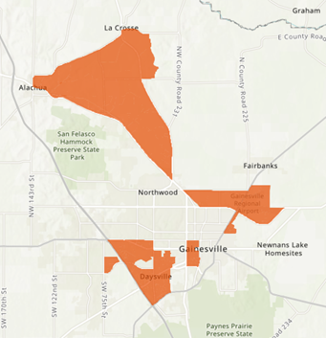
Figure 4: Map of 2022 Qualified Census Tracts
- Low-income households and communities are those with (i) income at or below 185 percent of the Federal Poverty Guidelines [FPG] for the size of its household based on the most recently published poverty guidelines…based on the most recently published data.
- Per Treasury guidance, “communities” as referenced above can be determined as a qualified community if the community as a whole has a median income below 185 percent of FPG.
- These guidelines allow Alachua County to expand the number of qualifying Census tracts to also include the following tracts (Figure 5): 3.01, 3.02, 4.00, 7.00, 8.08, 8.09, 10.00, 15.20 (i.e. part of 15.22), 19.08, 20.00 (i.e. 20.01 & 20.02), 21.02, 22.17.
- Rental houses located within these Census tracts and outside of the Gainesville municipal area are eligible for program participation and will be targeted for programmatic outreach.
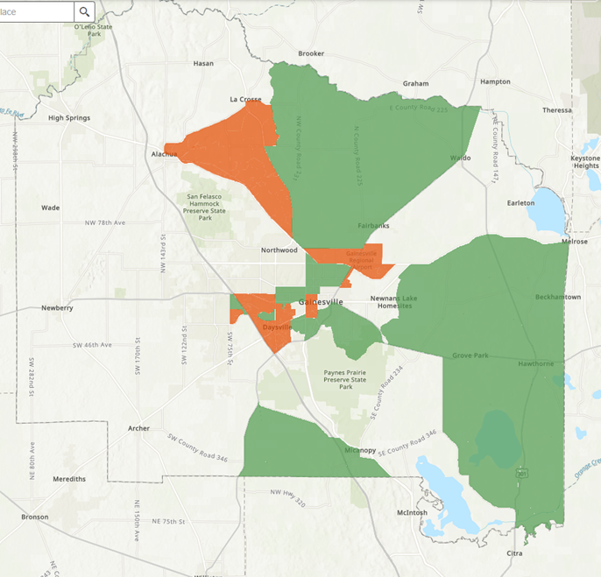
Figure 5: Map of otherwise qualified Census tracts (green), based on 185% FPG. QCTs are shaded orange.
- Low-income households and communities are those with…(ii) income at or below 40 percent of area median income [AMI] for its county and size of household based on the most recently published data. The Treasury’s final rule allows both low-income (40% AMI) and moderate-income (65% AMI) to qualify for assistance. However, the ACBoCC has chosen via policy to prioritize those households whose income is 50% AMI or less.
- Residents in communities which do not qualify under the above requirements can still be eligible to participate in the program if their income is 50% AMI or less.
- See Appendix 1 for information on qualifying AMI amounts for respective Census tracts.
- Finally, households can qualify for participation if they qualify for other federal benefits. These include:
- Temporary Assistance for Needy Families (TANF),
- Supplemental Nutrition Assistance Program (SNAP),
- Free- and Reduced-Price Lunch (NSLP) and/or School Breakfast (SBP) programs,
- Medicare Part D Low-Income Subsidies,
- Supplemental Security Income (SSI),
- Head Start and/or Early Head Start,
- Special Supplemental Nutrition Program for Women,
- Infants, and Children (WIC),
- Section 8 Vouchers,
- Low-Income Home Energy Assistance Program (LIHEAP), and
- Pell Grants

Community Engagement
This energy efficiency program benefits from years of prior community engagement and successful past projects. Project partnerships between Rebuilding Together North Central Florida and the CWC include the Gainesville Community Reinvestment Area (GCRA), the NAACP, and the CWC’s own work being visible in spaces where community members are having conversations about housing and/or utility affordability, as well as weatherization. The CWC has a history of community engagement and research, including an American Public Power Association (APPA) DEED Grant via Gainesville Regional Utilities (GRU), which allowed the organization to work closely with consultants and researchers from the University of Florida to measure impact and improve operations. As part of this two-year project, the CWC hosted multiple focus groups with their active volunteers, as well as with neighbors who resided in a community with limited financial resources, and implemented community-based social marketing to improve their program in regards to marketing and recruitment of future volunteers and clients.
The CWC actively targets applicants who face high utility burdens, and takes part in community meetings on these topics. The CWC attends public events, dispersing fliers at events where people are talking about sustainability, climate change, the environment, energy prices, utility rates, and more. The CWC and project partners are trusted voices in their communities with strong networks via word-of-mouth, social media, and websites.

Labor Practices
Rebuilding Together North Central Florida is experienced in the sort of work this work plan encompasses, with policies addressing wages and fair labor practices. The organization is fully compliant with Alachua County labor laws and best practices. This includes:
- A minimum $18/hour living wage for all internal employees working on the project
- Subcontracted activities will be performed in accordance with Rebuilding Together North Central Florida’s Procurement Procedures (Appendix 3)

Use of Evidence
The pilot program’s goal is to serve 15 households with energy efficiency upgrades. The upgrades will reduce the energy burden on energy-insecure households that have been impacted by the COVID-19 pandemic and have exhausted other means of reducing their energy costs. The program will provide a report that will highlight the approximate number of individuals that received energy efficiency upgrades as part of the program, as well as the types of upgrades elected by project participants. A maximum of $15,000 will be provided per household. Other demographic reporting may be available based on the Community Weatherization Coalition’s standard practices.
This program will target households in 2022 HUD Qualified Census Tracts and individuals and communities with limited financial resources that qualify per the ARPA Final Rule. Alachua County’s program partners, Rebuilding Together North Central Florida and the Community Weatherization Coalition, will assess households and work with subcontractors to identify qualified potential participants, and to see projects through to completion. These community partners will provide a demographic and outcome report that will include but is not limited to the number of individuals served, the addresses of these households for administration of the lien, how households were determined to be qualified for the program, and information regarding what sorts of energy efficiency improvements were ultimately installed.

Program Expenses
See Appendix 2 for full budget proposal.

Performance Report
The CWC and Rebuilding Together North Central Florida will collect contact information and record output measures. The CWC will use this contact information to follow up periodically over the next year to measure the following outcome and Treasury Required Performance Indicators.
Performance indicators output measures
- Number of homes assisted with total family members served
- Number and type of improvements made
- Number of time-sensitive utility housing concerns addressed by the services.
Performance indicators outcome measures
- Decrease in energy insecurity as reported by families, through a qualitative satisfaction survey post-upgrade
- Utility Consumption and Cost Reduction Post Intervention in kWh, kGals, Therms, and related metrics
- Estimated carbon offset resulting from 1) education and utility bill management awareness, and 2) home efficiency improvements.
- Increase in the safety and independence of elderly and or disabled residents served by the services
- Rental cost of home and post improvement verification that the rental cost is still affordable per the program terms
- Support for local, minority, and women-owned businesses via subcontracted services
For Treasury Required Programmatic Data, this additional information will be provided with every report.
- Brief description of structure and objectives of program(s) (i.e. energy efficiency assistance for low-income households)
- Number of individuals served (by the program if recipient establishes multiple separate household assistance programs)
- Brief description of recipient’s approach to ensuring that aid to households responds to a negative economic impact of Covid-19, as described in the Interim Final Rule

PROJECT INVENTORY
Project: Energy Efficiency & Weatherization of Affordable Housing: Pilot
Identification Number: TBD
Funding amount: $3,000,000 to be allocated over approximately four years
Project Expenditure Category: EC 2: Negative Economic Impacts: Household Assistance: Rent, Mortgage, and Utility Aid
Project Description
Bring affordable housing relief to communities with limited financial resources by addressing the high costs of utilities on renters through energy efficiency improvements and weatherization. For these residents, affordability struggles are compounded by differing incentives between the renters who pay utilities and the landlords with the ability to make energy-saving improvements.
$3 million in ARPA funding is budgeted for this program. From these funds, up to $15,000 per unit is available for eligible rental property owners within the unincorporated areas of Alachua County and smaller municipalities. This grant focuses on electricity efficiency and not natural gas. Alachua County is partnering with Rebuilding Together North Central Florida and the Community Weatherization Coalition to identify applicants, vet contractors, and complete individual projects.
This work plan covers the pilot project, which is scheduled for four months, the first three of these months being used to conduct the pilot testing and the fourth to analyze the data collected during the pilot project and update the work plan as appropriate. The program will continue to run according to the pilot project work plan until ACBoCC approval of the full work plan. The current timeline of the pilot runs from January 16, 2023 until August 18, 2023. The full work plan is scheduled, pending ACBoCC approval, from August 19, 2023 to December 31, 2026.

REFERENCES
Alachua County Board of County Commissioners. 2021. “Alachua County Strategic Guide FY2022.” AlachuaCounty.us. https://alachuacounty.us/Depts/OMB/Stategic%20Alignment/Board%20Level%20Strategic%20Guide%20Overview.pdf.
Alachua County Board of County Commissioners. 2022. 03.01.2022 Meeting Minutes, Affordable Housing Trust. https://alachua.legistar.com/Calendar.aspx.
Clay Electric Cooperative, Inc. 2022. “Rates rising again due to fuel costs.” Clay Electric. https://www.clayelectric.com/rates-rising-again-due-fuel-costs.
Duke Energy. 2022. “Duke Energy Florida continues to connect customers to financial assistance as fuel costs impact 2023 rates.” Duke Energy | News Center. https://news.duke-energy.com/releases/releases-20220902.
Gainesville Regional Utilities. n.d. “FY22 Budget & Rates.” GRU. Accessed November 15, 2022. https://www.gru.com/FY22Rates.aspx.
Office of the Assistant Secretary for Planning and Evaluation. 2022. “HHS Poverty Guidelines for 2022.” ASPE.hhs.gov. https://aspe.hhs.gov/topics/poverty-economic-mobility/poverty-guidelines.
Schmink, Marianne, Emily Ott, Lynn Jarrett, Anna Sampson, Matthew Bruce, and Alane Humrich. 2018. “Engaging Communities for Energy and Water Savings: Improving Measurement and Effectiveness of Energy/Water Audits for Low-Income Neighborhoods,” Final Report to the American Public Power Association (APPA) DEED Program (Demonstration of Energy and Efficiency Developments). CommunityWeatherization.org. https://communityweatherization.org/wp-content/uploads/2021/10/CWC-DEED-Grant-Final-Report-July-2018.pdf.
Shimberg Center for Housing Studies. n.d. “Rental and Owner-Occupied Cost Burden by Income, 2020 Estimate (Summary).” Florida Housing Data Clearinghouse. Accessed 15 November, 2022. http://flhousingdata.shimberg.ufl.edu/affordability/results?nid=199.
U.S. Department of the Treasury. 2021. “Coronavirus State and Local Fiscal Recovery Funds: Final Rule,” 31 CFR Part 35. Federal Registrar. https://home.treasury.gov/system/files/136/SLFRF-Final-Rule.pdf.
U.S. Department of the Treasury. 2022. “Coronavirus State & Local Fiscal Recovery Funds: Overview of the Final Rule.” https://home.treasury.gov/system/files/136/SLFRF-Final-Rule-Overview.pdf.
U.S. Energy Information Administration. 2015 data. “Fuels used and end uses in U.S. homes by housing unit type, 2015.” Energy Information Administration (EIA)- About the Residential Energy Consumption Survey (RECS). https://www.eia.gov/consumption/residential/data/2015/hc/php/hc11.1.php.
U.S. Energy Information Administration. 2019. “Use of Energy Explained: Electricity use in homes.” https://www.eia.gov/energyexplained/use-of-energy/electricity-use-in-homes.php.
U.S. Energy Information Administration. n.d. “Florida Custom Data and Map: Retail sales of electricity by end-use sector, monthly, residential.” EIA Beta. Accessed October 10, 2022. https://www.eia.gov/beta/states/states/fl/data/ dashboard/custom.

APPENDIX 1: Qualification Criteria for Alachua County Census Tracts
Census Tract,  Alachua County, FL | Qualified Census Tract | 185% FPG Qualifying Community | 50% AMI Qualifying Income Amount*
2.00  (i.e. 2.01 & 2.02) | Yes | Yes | $ 5,739
3.01 | No | Yes | $ 18,136
3.02 | No | Yes | $ 18,184
4.00 | No | Yes | $ 20,701
5.00 | No | No | $ 25,035
6.00 | Yes | Yes | $ 11,841
7.00 | No | Yes | $ 18,647
8.06 | Yes | Yes | $ 11,099
8.08 | No | Yes | $ 17,709
8.09 | No | Yes | $ 16,206
9.01 | Yes | No | $ 11,699
9.02 | No | No | -
10.00 | No | Yes | $ 18,707
11.00 | No | No | $ 44,093
12.01 | No | No | $ 27,604
12.02 | No | No | $ 35,053
12.03 | No | No | $ 22,091
14.00 | No | No | $ 23,991
15.14 | Yes | Yes | $ 13,969
15.15 | Yes | Yes | $ 10,117
15.16 | Yes | Yes | $ 10,959
15.17 | Yes | Yes | $ 14,150
15.19 | Yes | Yes | $ 11,552
15.22  (i.e. 15.20 & 15.21) | Partial (15.21) | Yes | $ 12,823
16.05  (i.e. 16.03 & 16.04) | Yes | Yes | $ 18,628
17.01 | No | No | $ 25,203
17.02 | No | No | $ 34,799
18.02 | Yes | Yes | $ 13,380
18.03 | No | No | $ 29,176
18.11 | No | No | $ 28,818
18.13 | No | No | $ 44,555
18.15 | No | No | $ 32,188
18.16 | No | No | $ 27,350
18.17 | No | No | $ 38,703
18.18 | No | No | $ 31,297
18.19 | No | No | $ 31,690
19.02 | Yes | Yes | $ 10,927
19.07 | No | No | $ 24,038
19.08 | No | Yes | $ 21,033
20.01  (i.e. part of 20.00) | No | Yes | $ 15,229
20.02  (i.e. Part of 20.00) | No | Yes | $ 19,449
21.01 | No | No | $ 33,509
21.02 | No | Yes | $ 15,382
22.01 | No | No | $ 35,910
22.02 | No | No | $ 35,143
22.04 | No | No | $ 40,176
22.07 | No | No | $ 54,297
22.08 | No | No | $ 53,750
22.09 | No | No | $ 45,660
22.10 | No | No | $ 33,188
22.17 | No | Yes | $ 20,199
22.18 | Yes | Yes | $ 18,207
22.19 | No | No | $ 27,322
22.20 | No | No | $ 29,430
22.21 | No | No | $ 37,045
22.22 | No | No | $ 67,735
1108.00 | No | No | $ 38,288
*Amount calculated using Area Median Income using data from Census data. The U.S. Census Bureau provides an interactive map: U.S. Census Bureau, Median Household Income State Selection Map, available at: https://data.census.gov/cedsci/map?q=Median%20Household%20Income&g=0100000US%2404000%24001&tid=ACSST5Y2019.S1901&cid=S1901_C01_012E&vintage=2019.
The U.S. Census Bureau also provides an interactive table: U.S. Census Bureau, Median Household Income In The Past 12 Months (In 2019 Inflation-Adjusted Dollars), available at: https://data.census.gov/cedsci/table?q=b19013&tid=ACSDT5Y2019.B19013&hidePreview=true.

APPENDIX 2: Pilot Project Budget
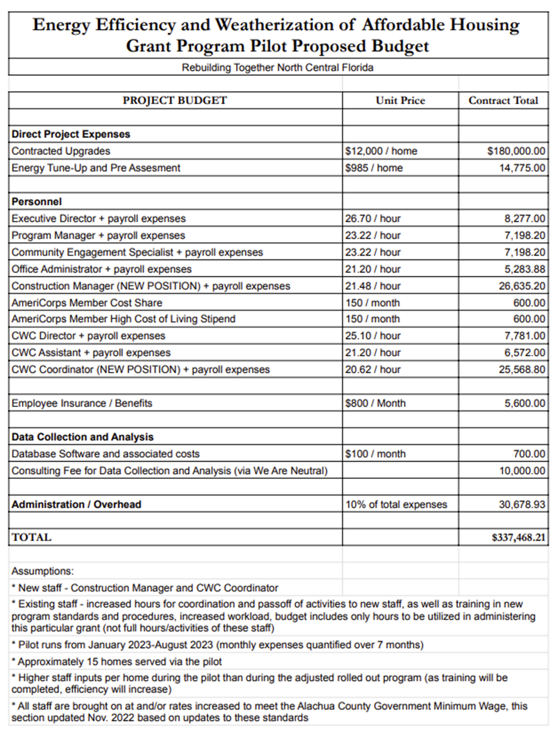

APPENDIX 3: Rebuilding Together Northern Central Florida Procurement
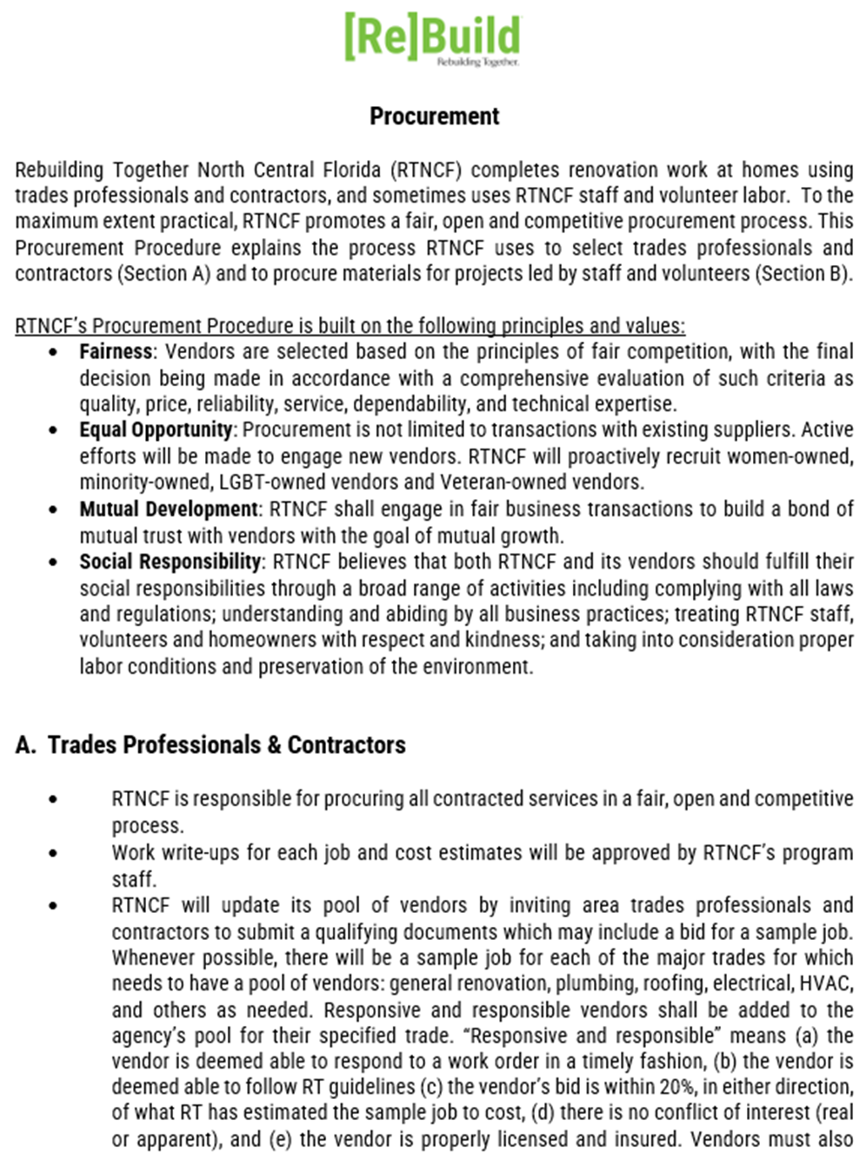
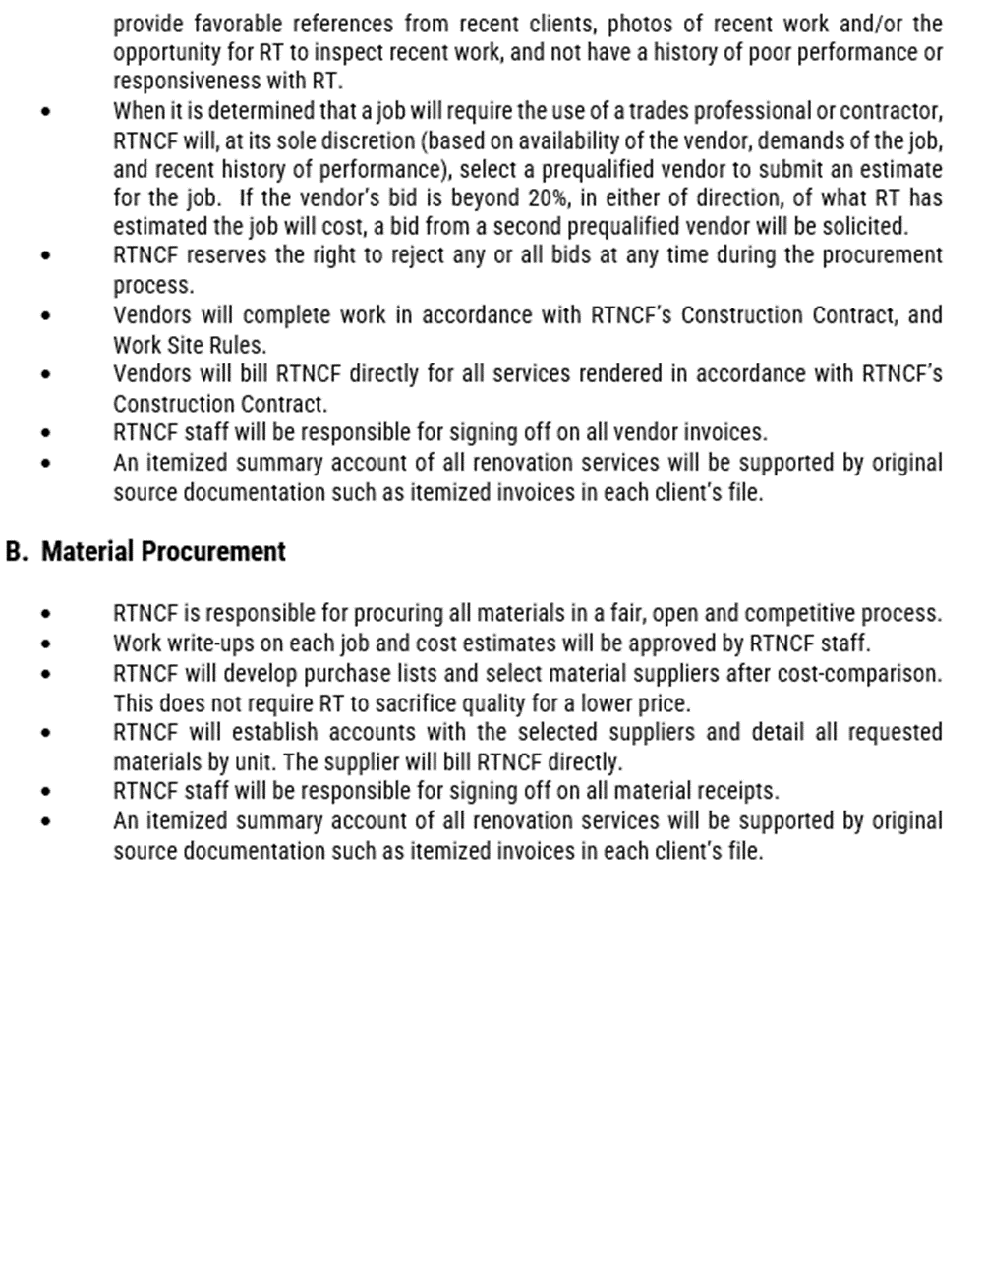

(U.S. Energy Information Administration 2015 data)
(Gainesville Regional Utilities, n.d.)
(Clay Electric Cooperative, Inc. 2022)
(Duke Energy 2022)
(Shimberg Center for Housing Studies, n.d.) Estimates and projections based on U.S. Department of Housing Development, Comprehensive Housing Affordability Strategy (CHAS) dataset and population projections by the Bureau of Economic and Business Research, University of Florida
(U.S. Department of the Treasury 2022, 19-20)
(Office of the Assistant Secretary for Planning and Evaluation 2022)
(U.S. Department of the Treasury 2021, 385-386)
(Alachua County Board of County Commissioners 2022, 5)
(U.S. Department of the Treasury 2022, 19-20)
(Schmink et al. 2018)

