Food System Equity Program: Meat Processing Facility for Workforce Training and Local Food Resilience
State and Local Fiscal Recovery Funds
2022-2026 Work Plan

Alachua County, Florida
2022-2023 Work Plan: Meat Processing Facility

TABLE OF CONTENTS
GENERAL OVERVIEW 3
Executive Summary 3
Uses of Funds 3
Promoting Equitable Outcomes 3
Goals 5
Awareness 5
Access and Distribution 5
Outcomes 6
Goals and Targets 6
Constraints and Challenges 9
Community Engagement 12
Rancher Stakeholder Surveys and meetings 12
Small-Producer Agriculture Capital Support Grant (SMAACA) 12
Community Redevelopment Fund Grant – Food System Workforce Development 12
Meetings with Stakeholders and Ranchers 12
Labor Practices 13
Use of Evidence 13
Food System Resilience and Local Food Demand 13
Support for Small and Mid-sized Ranchers 14
Facility Description and Productivity 15
Jobs and Workforce Development 16
Performance Report 18
Key Performance Indicators: Design to Construction 19
Key Performance Indicators: Post-Construction 19
PROJECT INVENTORY 20
Project Overview 20
Outcomes 20
Building Description 20
Standards of Operation 20
Equipment 21
Animals Processed 21
Facility Waste 21
Facility Operator 2
Project Timeline December 2022 – December 2026 3
Budget 4
Capital Expenditure Justification 4
REFERENCES 6
APPENDIX 1 – Humane Slaughter Entry Design 9
APPENDIX 2 – Example Waste Grinder 10
APPENDIX 3 – Facility Scope and Space 11

GENERAL OVERVIEW

Executive Summary
In response to the COVID-19 Pandemic, the Federal government has provided Alachua County Board of County Commissioners (ACBoCC) funding through the American Rescue Plan – State and Local Fiscal Recovery Funds (SLFRF). Alachua County will use $2.5 million in SLFRF funds to construct a USDA-certified meat processing facility (Facility) that will act as a job and workforce training center.
The Facility supports and remedies two types of communities/populations experiencing Covid-based inequities: The first is for COVID-impacted, marginalized communities that could benefit from vocational training in the meat processing field. The second is small, rural ranchers that are being pushed out of the marketplace by COVID impacts and ongoing systemic biases toward bigger producers. Both groups have faced challenges connected to inequitable market forces, resulting from consolidation and industrialization of processing and distribution channels and inequitable, racially based policies related to the distribution of resources and opportunities.

Uses of Funds
Alachua County will use $2.5 million SLFRF funds to first design and (later with other matching funds) complete the construction of a USDA-inspected meat processing facility and workforce training site in Newberry, Florida. This work will be done under the expenditure category Public Health-Negative Economic Impact: Public Sector Capacity EC 3.3 Public Sector Workforce: Other, for capital expenditure.
The ACBoCC will allocate $2.5 million of SLFRF funds from January 2023 through December 2026 to work with the City of Newberry, the University of Florida Institute for Food and Agricultural Science (UF-IFAS), and Santa Fe College in the design, construction, and operation of the Facility. These institutional partners will participate in the collaborative planning, operational function, local rancher engagement, and workforce training plans.
In the food sector, the COVID-19 pandemic showed a lack of resilience in the US food system which was designed primarily for efficiency. The consumer paid a heavy price for this brittle system that saw the retail price of beef increase by 125% due to supply impacts (Prevatt et al. 2020). Pandemic-induced problems for ranchers are ongoing. A research paper shows that over the next ten years, 15% of cattle ranchers may stop producing. Cited issues leaving include revenue concerns and more costly cattle feed (Prevatt et al. 2020).
At that same time that ranchers are facing COVID impacts so are underserved communities.

Promoting Equitable Outcomes
In 2018, before the pandemic, Alachua County was estimated to have 3.3% unemployment; however, in marginalized communities, unemployment for some ethnic groups was over twice this rate at 7%. At the same time, 36,000 or 13.9% of the population were food insecure or have inconsistent access to affordable foods that promote well-being and prevent disease in quantity and quality. Pre-COVID, these marginalized populations were also stressed with healthcare inequities. Pre-COVID, these marginalized populations were also stressed with healthcare inequities.
Since the pandemic, these communities face covid-based inequities that entrench or exacerbate conditions of disproportionate unemployment levels and food insecurity. Employment with a livable wage and access to nutritious food are critical factors in maintaining health and preventing disease. Food system-related diseases for marginalized communities increased nationally because of COVID. This can be seen in the surge of demand for 2021 SNAP benefits which increased by 15% in January and 21% in October 2021.
Food insecurity in black communities is compounded by unemployment trends that run at 5.3% in 2022 first quarter, almost double that of white populations in Florida, at 2.8% in the same quarter. The Centers for Disease Control has highlighted the nexus between the disproportionate impacts of COVID on health outcomes based on employment and food insecurity. A 2022 article, Employment Loss and Food Insecurity — Race and Sex Disparities in the Context of COVID-19, highlights the economic disparities around problems of aggravating chronic unemployment and the lack of food security for marginalized and low-income communities. Interventions such as those proposed by this program may bring better employment opportunities in food system occupations to address access to food that in turn can reduce health impacts due to COVID in at-risk communities.
Meat processing and butchery requires a high degree of skill and can be a gateway for marginalized communities to stable employment and improved income opportunities. A small-scale USDA-inspected meat processing facility can serve as a jobs and workforce training center. A facility of this size will also address the market demand from small-scale ranchers that have difficulty accessing processing plants and retail opportunities for their products.
COVID has impacted many meat processing facilities which has contributed to an increase in the cost of food and economic harm to small ranchers. COVID also disproportionately impacts small agricultural producers. Small ranchers are already constrained in their access to USDA-certified processing facilities. In addition to the economic problems, COVID also placed additional psychologic stressors on small ranchers which also may be from marginalized communities. This COVID-compounded producer and processor problems have contributed to higher food costs that disproportionally impact marginalized communities, who report being food insecure more often (between 16-19%) than non-marginalized communities (at 6%) when asked if their household had had enough to eat in the last 7 days.
The United States has a food system that is biased toward large-scale producers and processors. This system is vulnerable to the disruptive effects of emergencies like COVID. Large systems lose their efficiency and effectiveness in health emergencies like COVID. These large processing facilities have also struggled to maintain an adequate workforce to meet consumer demand. This project seeks to address both concerns, by catering directly to small ranchers.
These COVID-compounded producer and processor problems have contributed to higher food costs that disproportionally impact marginalized communities.

Goals
This proposal targets the creation of a food system as a job and workforce center for historically underserved, marginalized, or adversely affected ranchers and related workforce who experienced COVID impacts to provide:
- A jobs pipeline for meat processing and related culinary arts
- A USDA-certified meat processing facility to aid small ranchers in our region.
- And a more resilient localized supply chain for meat processing and distribution.

Awareness
Alachua County piloted several programmatic responses using local funds in 2020-2021 with high participation of marginalized communities and great success. These programs align to the current proposal in that they laid the groundwork for the promotion of workforce training in marginalized communities and provided support to similar communities that are small farm operations. It has also conducted surveys in 2021 and stakeholder meetings through 2022 with the regional ranchers to develop the program of the proposed meat processing facility. The combination of pilot program experience, survey work, and stakeholder meetings ensures that the project will be equitable and practical in enabling these communities to be aware of the services funded by the SLFRF.

Access and Distribution
The two programmatic goals target services to different eligible populations based on their needs as jobs pipeline and for small-scale ranchers. These responses recognize the differences in levels of access to benefits and services across groups. A partnership with the UF-IFAS and Santa Fe College will be instrumental in setting vocational training requirements and certification. In addition, the management of the Facility will cater to small ranchers, that are represented by disenfranchised populations. Both workers and producers will be given a voice in the administration of the Facility to maximize access to benefits and services across groups.

Outcomes
These three programmatic goals, as previously stated, target services to different eligible populations, but it also addresses problems with the underlying food system of the community at a holistic level, from workforce and talent development to producer.
A small-scale USDA-certified meat processing facility can address the disproportionate impacts for a region by creating:
- Food system resilience and local food demand. A facility will be a local source of government-inspected meat products
- Support for Small and Mid-Sized Ranchers Provide a critical processing outlet dedicated to serving smaller producers
- Jobs and Workforce Development. Create a job and workforce center for butchery skills

Output Measures of Success
A small-scale USDA-certified meat processing facility should generate the following output measures:
- Carcasses processed per day: 4-15
- Direct jobs generated by the facility: 8-12
- Organic nutrient recycling. Tonnage of waste diverted from landfill for compost per day: 1.3 – 4.7 tons

Output Measures of Success that are – TBD based on the operations and curriculum plan.
- Value-added products number and value from meat processing
- Number of workers enrolled in job training programs
- Number of workers completing job training programs
- Demographic breakout of job training workers
- Employment of certified and trained workers at other facilities
- Facility gross and net income.
- Number of small farmers served

Goals and Targets

Efforts to Date to Support Economic and Racial Equity
The U.S. Department of the Treasury issued Guidance for use of Coronavirus State and Local Fiscal Recovery Funds which includes a requirement that economic and racial equity be considered in funded programming. This requirement aligns with ACBoCC’s broader priorities for economic and racial equity, which recognize that inequities occur across multiple sectors and must be targeted intentionally to produce meaningful equity results at scale. The proposed facility, for example, directly addresses unemployment and under-employment, which Alachua County has identified as equity issues that have been exacerbated in marginalized communities during emergencies such as the COVID-19 pandemic.
Equity was placed at the forefront of Alachua County’s policymaking through a November 2020 voter-approved charter amendment that directed “(an) examination of policies for all County operations for elements of racial, economic, and gender bias in the design and delivery of County programs and services. The County will identify and act to mitigate and improve upon the effects, patterns, and disparities imposed by said biases.” Since the ballot initiative, the ACBoCC has made significant investments in creating an overall Equity Plan for County operations and community engagement, hired talented leadership to spearhead this effort, and engaged in pilot projects to support food system equity outcomes.
The ACBoCC prominently includes equity goals within their adopted Fiscal Year 2022 Strategic Guide which defines equity as: “…striving to treat everyone justly according to their circumstances, providing opportunity and access for everyone, while focusing on closing existing equity and access gaps.” It also sets Guiding Principles to address root causes, utilize a collaborative approach, and operate in a transparent, accountable, efficient, and effective manner in service delivery. The Guide’s directives on Social and Economic Opportunity are fully addressed in this proposal, as seen in Table 1.
Alachua County’s Strategic Goals for Social and Economic Opportunity for All | Proposed Facility
Build equitable access to health (physical and mental), safety, and opportunity, especially for people who haven’t traditionally had access to those systems. | CDC findings have shown a correlation between employment and food security. Creating more jobs and marketing them towards underserved areas will create economic development in these communities.
Focus our Economic Development efforts on local businesses and removing barriers to economic opportunity. | The proposed facility will be designed to provide services to small-scale, local producers. With over half of Alachua County’s agricultural producers working on farms of less than 22 acres, the facility is designed to support local businesses by removing barriers to food processing.
Work with private and public partnerships, including farms and local food entrepreneurs, to build a community food system. | The 2020-2021 pilot project efforts demonstrate a strong interest in the program by local agricultural business owners, many of whom are suppliers for other local businesses in the Alachua County food system.
Table 1. Proposal’s response to ACBoCC equity priorities in Strategic Guide
Finally, the County has set related objectives in its Comprehensive Plan Community Health and Economic Element, that inform this project proposal and justify the ARPA funds.

Comprehensive Plan: Community Health Element
Policy 1.2.2. Develop and encourage civic engagement and volunteer opportunities in community projects that promote community health.
Policy 1.2.3. Increase access to health-promoting foods and beverages in the community. Form partnerships with organizations or worksites, such as employers, health care facilities and schools, to encourage healthy foods and beverages.
Policy 1.3.1.1. Promote food security and public health by encouraging locally-based food production, distribution, and choice in accordance with the Future Land Use Element.
Policy 1.3.1.3. Continue to offer support for home and community gardening through programs offered by USDA Farm to School Programs and the Alachua County Extension Office and target low-income and populations at high-risk for health disparity for programs promoting gardening, healthy food access and nutrition improvement.
Policy 1.3.2.6. Alachua County community planning efforts and community support programs will encourage participation by health coalitions and networks to create environments that support enjoyable, healthy eating, physical activity and a positive self-image.

Comprehensive Plan: Economic Element
Policy 1.1.5. Alachua County shall expand its economic base by creating an environment which encourages job skills training, education and entrepreneurship through strong partnerships with CareerSource North Central Florida, the University of Florida, Santa Fe College, the School Board of Alachua County, YouthBuild/Institute for Workforce Innovation, and related organizations that provide education and training to the community.
Policy 1.2.1. Alachua County shall encourage the allocation of resources for the retention, expansion and development of local business and the recruitment of businesses and industries. Priority shall be given to the retention, expansion and development of local businesses. This strategy shall include support for efforts to provide expanded opportunities for education, including jobs-related skills training, to increase workforce participation and better employment opportunities for populations that are experiencing economic disparities identified in the 2018 “Understanding Racial Inequity in Alachua County” Report.
Policy 1.7.1. Partner with community groups and other local governments in the region to delineate and promote a local food shed for the development of a sustainable local food system. Alachua County will participate in a study to establish baseline measures and measurable targets towards the increase of local food use by Alachua County institutions, including: (a) Identify and partner with relevant agencies and organizations, such as the City of Gainesville, area retailers, UF IFAS Extension, Florida Farm Bureau, Florida Organic Growers, UF Field to Fork, Working Food, Alachua County School Board, UF, UF Health, and SFC. (b) Identify components of the local food economy, such as appropriate food shed, distribution system, and local food segment of retail purchases. Set target goals and develop methodology to identify and track local food use by Alachua County institutions.
Policy 1.10.4. Partner with IFAS, local farmers, and community groups to develop and implement educational strategies on the benefits of purchasing locally grown and/or processed foods.

Constraints and Challenges
Because the proposal is multi-faceted and geared toward differentiated communities, recruitment, and training cohorts, subsequent reporting will be highly dependent on their availability and willingness to participate. This challenge highlights the need to rely on our community partners in the non-profit food system, Workforce Board, and higher education certification programs to continue their community engagement work to reach eligible participants. The SEEDS Office will manage the County’s responsibilities in conjunction with a related partner agencies through MOU, professional service agreements, or contract to design, construct and operate the facility.
Because of the time constraints around ARPA funding (the funding must be obligated by December 31, 2024, and expended by December 31, 2026), it is recommended that we proceed with the program despite this shortcoming.

Project Demographic Distribution
Project demographic engagement will be encouraged on the producer side (ranchers) and in workforce vocational program recruitment. At the completion of the capital project and moving into the operations phase, the facility will be able to recruit from communities in zip codes that have experienced COVID-based inequities, are generally low-income communities, and can be further defined as part of HUD’s Qualified Census Tract (QCT). See Figure 1. These specific engagement opportunities will be coordinated with our local workforce board and Santa Fe College. For this program, eligible residents and communities will be identified by meeting one or more of the following Treasury guidance points:
- “A program or service is provided at a physical location in a Qualified Census Tract [QCT] (for multi-site projects, if a majority of sites are within Qualified Census Tracts)” and “A program or service where the primary intended beneficiaries live within a Qualified Census Tract;”
  - Households located within QCTs area are eligible for program participation and will be targeted for programmatic outreach.
  - The following are QCTs in Alachua County in 2022 (Figure 1): 2.00 (i.e. 2.01 & 2.02), 6.00, 8.06, 9.01, 15.14, 15.15, 15.16, 15.17, 15.19, 15.21 (i.e. part of 15.22), 16.05 (i.e. 16.03 & 16.04), 18.02, 19.02, 22.18.
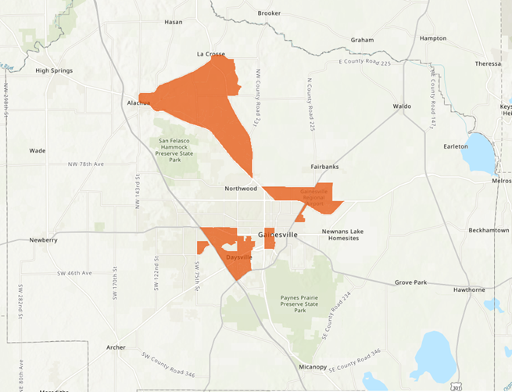
Figure 1: Map of 2022 Alachua County FL Qualified Census Tracts
- Low-income households and communities are those with (i) income at or below 185 percent of the Federal Poverty Guidelines [FPG] for the size of its household based on the most recently published poverty guidelines…based on the most recently published data.
  - Per Treasury guidance, “communities” as referenced above can be determined as a qualified community if the community as a whole has a median income below 185 percent of FPG.
  - These guidelines allow Alachua County to expand the number of qualifying Census tracts to also include the following tracts (Figure 2): 3.01, 3.02, 4.00, 7.00, 8.08, 8.09, 10.00, 15.20 (i.e. part of 15.22), 19.08, 20.00 (i.e. 20.01 & 20.02), 21.02, 22.17.
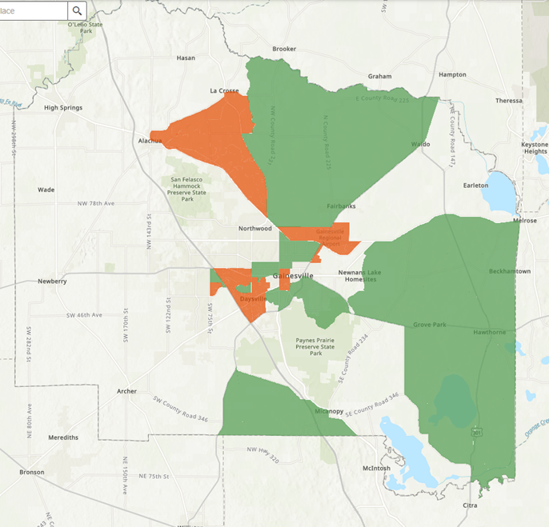
Figure 2: Map of Alachua County FL Otherwise Qualified Census Tracts (green), based in 185% FPG. QCTs are shaded orange.
- Low-income households and communities are those with…(ii) income at or below 40 percent of area median income [AMI] for its county and size of household based on the most recently published data. The Treasury’s final rule allows both low-income (40% AMI) and moderate-income (65% AMI) to qualify for assistance. Residents in communities which do not qualify under the above requirements can still be eligible to participate in the program if their income is 50% AMI or less.
- Finally, households can qualify for participation if they qualify for other federal benefits. These include:
  - Temporary Assistance for Needy Families (TANF),
  - Supplemental Nutrition Assistance Program (SNAP),
  - Free- and Reduced-Price Lunch (NSLP) and/or School Breakfast (SBP) programs,
  - Medicare Part D Low-Income Subsidies,
  - Supplemental Security Income (SSI),
  - Head Start and/or Early Head Start,
  - Special Supplemental Nutrition Program for Women,
  - Infants, and Children (WIC),
  - Section 8 Vouchers,
  - Low-Income Home Energy Assistance Program (LIHEAP), and
  - Pell Grants

Community Engagement
Alachua County’s proposed use of funds incorporates several years of community engagement around food system workforce development for low-income households and small-scale ranchers. ACBoCC’s programmatic feedback was achieved through surveys, pilot grants, and direct feedback through community meetings, issue-specific listening sessions, and stakeholder interviews. These engagement strategies were directly aligned to the ACBoCC’s Strategic Guide and Comprehensive Plan policies that support equity goals and include engagement with communities that have historically faced significant barriers to services, such as people of color, people with low incomes, and other traditionally underserved groups.

Rancher Stakeholder Surveys and meetings
2021 Meat Processing Survey. In September 2021, Alachua County reached out to the regional ranching community to determine what challenges producers faced to the direct marketing of their products. In total, the County received 82 responses. The top three highest responses included: 1. Access to USDA-inspected facilities; 2. Access to processing capacity; and 3. Access to processing availability. Over 68% of respondents said they are traveling between 25 and 100 miles to process their animals. Over 81% of respondents were interested in the direct marketing and selling of meat products. Out of that same group, a majority, 61%, are not able to use a USDA inspected facility for processing animals.

Small-Producer Agriculture Capital Support Grant (SMAACA)
2021 SMAACA grant capital funding for Alachua County farmers and ranchers. For the purposes of the grant, a small producer (farm) is defined as a commercial operation with an established gross cash income of at least $1,000 but no more than $250,000 per year from the regular harvest and sale of crop, livestock, or aquaculture products meant for human consumption. To reduce inequity in marginalized communities, the grant prioritized small-producer operations that are owned by black, indigenous, and other persons-of-color and/or women. Out of 48 applications, 37 met all criteria but due to funding limitations, only three could be awarded their grant requests.

Community Redevelopment Fund Grant – Food System Workforce Development
2021 Working Food County Final Report. Alachua County awarded $50,000 to Working Food to address COVID impacts in low-income communities within the Gainesville Metropolitan area. The project developed youth education, entrepreneurship, and certification programs in the culinary arts.

Meetings with Stakeholders and Ranchers
Since 2021 and over 2022, Alachua County has convened multiple presentations on the prospect of new, local meat processing with stakeholders in community groups that have a potential interest in such a facility. These groups include the Farm Bureau, Santa Fe College, UF-IFAS, Cattleman’s Association, and local ranchers.

Labor Practices
ACBoCC supports quality workforce practices through the capital expenditures of this project and through the facility’s programmatic operation after construction. Alachua County sets an aggressive minimum wage requirement over State and Federal requirements, including for contracting related to capital improvements. In 2016, ACBoCC established Ordinance #16-05 of the County’s Purchasing Code the Alachua County Government Minimum Wage (GMW) requirement for certain contractors and subcontractors providing selected services to Alachua County Government. A contractor or subcontractor providing a covered service to the County shall pay to all its covered employees the established GMW. For fiscal year 2022, the GMW is $16 per hour with qualifying health benefits amounting to at least $2 per hour. For contractors not offering health benefits, the GMW is $18 per hour. This represents a living wage in Alachua County.
ACBoCC also supports small businesses through the Small Business Enterprise Assistance Program which encourages the growth of small businesses by helping them to participate in the Alachua County purchasing and procurement system.

Use of Evidence
ACBoCC commissioned a meat processing facility analysis in 2022 with the University of Florida Economic Impact Analysis Program. This work in conjunction with the community outreach throughout 2021-2022 provides the background for evidence-based interventions and is incorporated into the methodology of the SLFRF program. The facility size was scaled, and the productivity modeled in the IMPLAN analysis reflected recommendations from industry consultants, rancher stakeholders, and end users.

Food System Resilience and Local Food Demand
Covid-19 highlighted a critical need in our communities to build robust support and infrastructure for our local food system. When national and global supply chains faltered, local producers proved nimbler and more resilient to the changes in demand and the processing backlogs, working through farmers’ markets and ad hoc distribution. As a result, demand for local food and farmers’ markets has expanded across the country. Direct sales to consumers have soared, with demand for fresh, local, and sustainably grown food now exceeding supply.
The pandemic amplified an existing trend. A 2018 survey by The Packer found 55 percent of consumers made a conscious effort to buy locally-grown food, and 48 percent purchased more local produce compared to their previous buying habits in 2013. Consumers’ motivations for purchasing local foods included supporting small farms, supporting the local economy, an interest in freshness, taste, health, and food safety, and concern for the environment.
Consumers also value relationships with producers and information about the origin of their food. Supermarkets consider local food a top consumer trend. USDA numbers also show that local food sales drive job growth in agriculture, increase entrepreneurship, and expand food access and choice. In Florida, one survey of consumers found the total annual value of local food purchases averaged $1,114 per household and represented 20.1% of food purchased for at-home consumption. The total economic impacts of local food purchases in Florida were estimated at 183,625 jobs and $10.47 billion in value-added, including regional multiplier effects for agricultural production and wholesale and retail distribution.

Support for Small and Mid-sized Ranchers
Small and mid-size livestock ranchers raising cattle, sheep, goats, and hogs make up a significant portion of the farms in North Central Florida (USDA Census of Agriculture). Alachua County and its seven surrounding counties collectively represent 3 of the top 10 livestock-producing counties in Florida. We produce over $67 million in cattle, $566 thousand in hogs, and $1.1 million in sheep and goats. Surveys and dialogue with our local ranchers have exposed meat processing as a critical bottleneck. This lack of access hinders their ability to bring sustainably and humanely raised meat to local and regional markets, as animals must be processed in a USDA-inspected facility to legally sell packaged red meat products directly to customers or wholesale. There are few USDA facilities available, and even the custom shops that allow ranchers to sell whole animals or offer their meat as pet-food are reported by ranchers to have up to 6-month delays.
Figure 3 Meat processing facilities and livestock populations within 100 miles of the center of Alachua County, Florida.

Facility Description and Productivity
Based on the total number of carcasses processed per year (1,040 to 3,900 carcasses) and the total employment (8-12 staff), this facility would be classified as a small to a very-small meat processor. A conceptual facility layout is provided in Figure 4 below. In a national context, 51% of processing facilities are at a similar scale as is envisioned in this proposal A full breakout of the facility space and approximate room dimension sizes are included in Appendix 3.
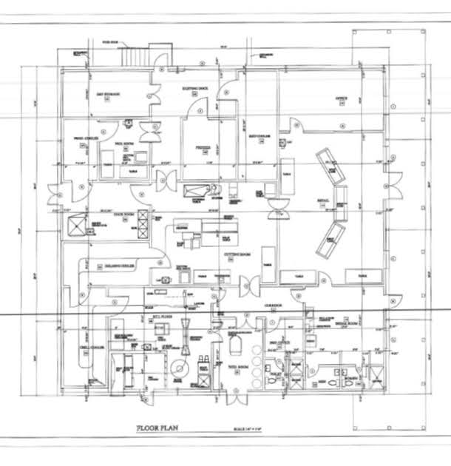
Figure 4 Conceptual plan for a 10,000-square-foot meat processing facility.

Jobs and Workforce Development
Meat processing is high-skilled work. Workers need to learn how to use multiple pieces of equipment, the anatomy of each animal, and how to cut grind, smoke, package, and display meat all while following health and USDA guidelines. Butchering takes skill to process animals respectfully and produce top-quality meat products, and much of this art and science has been waning, with processors and groceries alike, in need of qualified professionals for the job. Further, processors take measurements and conduct analyses that are then later passed on to ranchers to inform their feeding and raising habits, and there are several industries that can be developed that are complementary to a processing facility, such as pet food, bone broth and bone meal, tallow products (e.g. candles, lubricants, and cosmetics), and tanning (vegetable tanning is done with Chestnut, which is a growing crop in FL) that can support research, business development, and entrepreneurship curricula as well.
As has happened in other parts of the country (e.g., Wisconsin, Idaho, and North Carolina), investment in a meat processing facility that can serve as a training facility would provide opportunities for partnerships with UF-IFAS, Santa Fe College, high school culinary and agriculture programs, community organizations, and CareerSource to create workforce curriculum and certificate program that can help to alleviate worker shortages and increase economic development in this sector. By investing in education and training spaces for students and the local community, a processing facility can provide a safe space for training individuals for working in a multi-species facility, and for visiting school groups and apprentices to learn more about humane and safe animal handling and processing, meat cutting, and value-added products (e.g., smoking, curing and sausage making).

Operations and Maintenance Expenditures
As part of the economic impact analysis, the ongoing costs of operations and maintenance at a meat processing facility of this size was calculated. Table 2 summarizes the estimated revenue associated with operations and maintenance of the Facility. These estimates are broken out into scenarios of productivity which will vary depending on the number of carcasses processed per day. Direct employment of (full-time and part-time jobs) was provided by processing facility consultants.

Wage Estimates
Based on current market trends, employment in Scenario 1 includes one (1) plant manager (~$85,000/year in salary/wages), one (1) Quality Assurance/Quality Control manager ($75,000/year in salary/wages), four (4) skilled labor positions ($55,000/year each in salary/wages), and two (2) unskilled labor positions ($40,000/year each in salary/wages). Scenarios 2 – 5 use the same baseline employment configuration as Scenario 1 but each scenario increases by one (1) skilled labor position as the carcass count increases. Corresponding values of sales revenue, labor income, and value-added were imputed by IMPLAN©. Estimated sales revenues of a facility processing 4 – 15 animals/day range from nearly $5.53 million to over $8.29 million with corresponding labor income and value-added ranges of $741,000 - $1.11 million and $976,000 - $1.464 million, respectively.
Scenario | Carcasses  /day | Industry Sales (2022 USD) | Employment (jobs) | Labor income (2022 USD) | Value-added (2022 USD)
1 | 4 | $5,526,997 | 8 | $740,995 | $976,135
2 | 6 | $6,217,871 | 9 | $833,619 | $1,098,152
3 | 8 | $6,908,746 | 10 | $926,243 | $1,220,168
4 | 10 | $7,599,620 | 11 | $1,018,868 | $1,342,185
5 | 15 | $8,290,495 | 12 | $1,111,492 | $1,464,202
Table 2: IMPLAN events for economic impact analysis of meat processing facility operation phase in Alachua County, Florida (Court, et al. 2022). All Scenarios are in IMPLAN Industry Sector 89—Animal, except for poultry, slaughtering

Table 3 represents the per economic scenario calculated direct, indirect, and induced employment, labor income, value added and total industry output per the IMPLAN model. Calculated employment impacts range from processing scenario 1 at 48 jobs to scenario 5 at 72 jobs.
Scenario | Impact Type (Multiplier) | Employment (Job-Years) | Labor Income (2022 USD) | Value Added (2022 USD) | Industry Output (2022 USD)
1 | Direct Effect | 8 | $740,995 | $976,135 | $5,526,997
1 | Indirect Effect | 35 | $475,726 | $1,866,085 | $3,979,976
1 | Induced Effect | 5 | $201,740 | $411,016 | $706,798
1 | Total Effect | 48 | $1,418,461 | $3,253,236 | $10,213,771
2 | Direct Effect | 9 | $833,619 | $1,098,152 | $6,217,871
2 | Indirect Effect | 40 | $535,192 | $2,099,346 | $4,477,473
2 | Induced Effect | 5 | $226,958 | $462,393 | $795,148
2 | Total Effect | 54 | $1,595,769 | $3,659,890 | $11,490,492
3 | Direct Effect | 10 | $926,243 | $1,220,168 | $6,908,746
3 | Indirect Effect | 44 | $594,658 | $2,332,606 | $4,974,970
3 | Induced Effect | 6 | $252,175 | $513,770 | $883,497
3 | Total Effect | 60 | $1,773,076 | $4,066,545 | $12,767,213
4 | Direct Effect | 11 | $1,018,868 | $1,342,185 | $7,599,620
4 | Indirect Effect | 48 | $654,124 | $2,565,867 | $5,472,467
4 | Induced Effect | 7 | $277,393 | $565,147 | $971,847
4 | Total Effect | 66 | $1,950,384 | $4,473,199 | $14,043,935
5 | Direct Effect | 12 | $1,111,492 | $1,464,202 | $8,290,495
5 | Indirect Effect | 53 | $713,589 | $2,799,128 | $5,969,964
5 | Induced Effect | 7 | $302,611 | $616,524 | $1,060,197
5 | Total Effect | 72 | $2,127,692 | $4,879,854 | $15,320,656
Table 3: Summary of economic impacts of operations and maintenance spending for the new meat processing facility in Alachua County, Florida (Court, et al. 2022)

Performance Report
ACBoCC will track the performance goals of the allocated funds through regular projects reports during the construction of the facility. Post construction, performance goals related to workforce training and certification and service to small ranchers will be tracked through an operations and management agreement with a third-party operator of the facility. The operator will be responsible for reporting back both output and outcome measures. The section below outlines a high-level approach to performance management and key performance indicators per expenditure category 3.3 Public Sector Workforce: Other, for capital expenditure.

Key Performance Indicators: Design to Construction
- Construction Documents Completion
- Operator Agreement Completion
- Construction Start
- Substantial Completion and Certificate of Occupancy
- Construction Complete

Key Performance Indicators: Post-Construction
- Number of workers enrolled in job training programs
- Number of workers completing job training programs
- Demographic breakout of job training workers
- Employment of certified and trained workers at other facilities
- Number and type of animals processed
- Amount of waste material recycled – composted
- Facility gross and net income.
- Value-added product’s dollar value and description
- Number of small farmers served

PROJECT INVENTORY
Project [Identification Number TBD]: [Food System Equity Program: Meat Processing Facility for Workforce Training and Local Food Resilience]
Funding amount: [$2.5 million]
Project Expenditure Category: [Public Health-Negative Economic Impact: Public Sector Capacity EC 3.3 Public Sector Workforce: Other, for capital expenditure]

Project Overview
This section provides a detailed description of the project that includes an overview of the main components of the project, the approximate timeline, partners, budget, and intended outcomes.
Food System Equity Program: Meat Processing Facility for Workforce Training and Local Food Resilience
Cost: $5.25 million total estimated capital costs with $2.5 million of costs coming from ARPA sources. See Budget section below for cost breakout.
Timeframe: Fall 2022 – December 2026. See Project Timeline section below.
Project Description: Alachua County will use $2.5 million in SLFRF funds to construct a USDA-certified meat processing facility (Facility) that will act as a job and workforce training center for marginalized communities. The Facility will service small ranchers from the surrounding region that have experienced impacts due to COVID.

Outcomes
At the completion of construction this Facility will:
- Be a resource efficient operation that is self-supporting in revenue generation.
- Provide humane slaughter facilities comporting to nationally recognized best practices and State statutes.
- maximize energy efficiency and waste product recycling.
- Service marginalized small to mid-scale ranchers.
- Provide vocational and certification training space for meat cutters.

Building Description
- Slab on grade, high-bay metal building.
- Site size 10 acres.
- Facility size under 10,000 square feet.
- Modular design to allow for future expansion of classroom, freezer, and value-add processing equipment and station spaces.

Standards of Operation
The standards of operation will guide the design of the Facility and be integrated into the agreement with the third-part Operator.

USDA Certified Inspection
The facility will be designed to support USDA inspection of all processed animals.

Humane Animal Treatment and Slaughter
The facility will be run pursuant to the requirements of Florida Statute 828.22
Livestock handling systems and slaughter procedures will comport themselves to the best practices as enumerated by Temple Grandin, PhD, An example slaughter plant layout is included in Appendix 1. Curved chutes and round geometric forms will be used to move animals to the slaughter floor. These forms are calming to herd animals in that they work with the animal’s natural behavior and the form also serves to obscure the line of site to humans.

Sustainable Building Practices
The facility will be constructed to Alachua County standards for sustainability, utility efficiency, and Zero Waste goals.

Equipment
Meat processor facilities have specialized equipment needs such as but not limited to the following.
See the equipment list as outlined by the Niche Meat Processor Assistance Network.

- Wellsaws
- Water Activity Meter
- Fat Analyzer
- Sanitation Swabs
- Rollstock Machines
- POS System
- Steam Boiler
- Label Machines/ Inventory Management
- Smokers
- Rail Height
- Scales
- Slicers
- Partners
- Newberry
- Santa Fe College
- UF IFAS
- Life Soils Compost
- Waste Generation and Handling

Animals Processed
The Facility will focus on servicing ranchers producing cattle, pigs, sheep, and goats. No poultry, fowl, or game will be processed at this facility. Processing runs will depend upon the operator’s business plan, but it is assumed that during hours of operation, singular species will be slaughtered and processed daily.

Facility Waste
Facilities like this have unique sewer and waste demands. The project partnership benefits from the City of Newberry’s (City) support and site location at the Newberry Environmental Park. The City will provide both the land and utility connections that include up-to-date wastewater treatment. Waste handling is an integrated solution of wastewater treatment and composting to achieve odor and nutrient recycling.
Carcass waste will be processed and sent to a next-door composting operation. This will allow the Facility to achieve Zero Waste goals for agricultural nutrient recycling. The composted material will be suitable for agricultural operations on regional farms.

Waste Carcass Pre-Processing
Once a carcass is sufficiently butchered, waste material will be shredded and gathered into a climate-controlled cooler space before delivery to the close by composting operation.
A shredder, such as a Ceron Type 256, will be used for processing the carcass. The waste material will be ground to a specification acceptable for composting.
Table 4 provides estimated waste production on a daily and weekly basis depending upon the economic scenarios modeled by the UF-IFAS Economic Impact Analysis Program. The estimates assume all animals processed are on average 1,000 lbs. This figure assumes that the wastage from processing runs about 63%. On the low side of carcass processing, the Facility will produce 1.26 Tons of waste/day or 6.3 Tons/week. On the high side of carcass processing, the Facility will max out at 4.725 Tons of waste/day or 23.625 Tons/week.
Scenario | Carcasses/day | Lbs. Waste/day | tons/day | tons/week
1 | 4 | 2,520 | 1.26 | 6.3
2 | 6 | 3,780 | 1.89 | 9.45
3 | 8 | 5,040 | 2.52 | 12.6
4 | 10 | 6,300 | 3.15 | 15.75
5 | 15 | 9,450 | 4.725 | 23.625
Table 4 Waste Estimations Based on Carcass Scenarios

Facility Operator
The facility will be County-owned but managed by a qualified third-party operator, who the county will solicit to run the facility under an operating agreement.
The operator may be a private or non-profit entity that will be incentivized to maximize the productivity of the facility and service to the targeted community groups. It must meet performance requirements for serving small to mid-size ranchers from marginalized communities and must coordinate with higher education partners in workforce training opportunities with meat processing.
The operator will be responsible for the facility operations budget, utilities, administration, staffing, taxes, insurance, waste management, odor & nuisance abatement, equipment maintenance, and care.
The County shall be responsible for the building envelope.

Project Timeline December 2022 – December 2026
Activity | Start | End |  | Notes
Project Start | 12/7/2022
Project Partner Agreements | 12/7/2022 | 12/31/2023
Institutional Letters of Support | 12/7/2022 | 1/21/2023 |  | Finalize acquisition of institutional letters of support.
Site Use Interlocal Agreement | 12/12/2022 | 3/7/2023 |  | Establish an agreement with the City of Newberry for 10 acres at the Newberry Environmental Park
MOU - UF IFAS and Santa Fe College | 12/22/2022 | 3/7/2023 |  | MOU with UF IFAS and Santa Fe College for workforce training and curriculum & certification development
Matching Funds | 12/7/2022 | 12/31/2023 |  | Outreach for State and private sector matching funds
Construction Documents | 12/7/2022 | 10/3/2023
RFP for A/E Services | 12/7/2022 | 4/6/2023 |  | Solicit Architectural and Engineering Services
Design | 4/6/2023 | 10/3/2023 |  | Estimate six months to create construction documents.
Operator | 12/7/2022 | 12/31/2023
RFQ for Facilities Operator | 12/7/2022 | 4/6/2023 |  | Solicit a facility operator.
Operator Business Plan, Budget, and Outreach Plan | 4/11/2023 | 12/31/2023 |  | Facility operator prepares their business plan, pro forma budget, and marketing & outreach plan. Presented for Board approval.
Construct Facility | 1/1/2024 | 12/31/2026
Substantial Completion | 11/1/2026
Begin Operations | 12/31/2026
Project End | 12/31/2026

Budget
Per SLFRF Compliance and Reporting Guidance Document Section 5.J.2: Capital Expenditures, this project is a capital expenditure project. The total expected capital is estimated to be $5.25 million including predevelopment costs. The type of capital expenditure will be for a job and workforce training center enumerated use.
Total Estimated Project Cost | $ 5,250,000
Hard Costs
Facility | $ 994,000
FF&E (Equipment) | $ 2,982,000
Hard Costs Sub-Total | $ 3,976,000
Soft Costs
Art in Public Places | $ 100,000
A/E, Surveys, Inspections | $ 525,000
Permits | $ 315,000
Utility Connections and Fees | $ 84,000
Consultant | $ 10,000
County Project Coordinator | $ 240,000
Soft Costs Sub-Total | $ 1,274,000
Source of Funds
ARPA Funds | $ 2,500,000
Private Sector Contributions | $ 275,000
State and Federal Sources | $ 2,475,000
Total Funds | $ 5,250,000

Capital Expenditure Justification
Meat processing and butchery require a high degree of skill and can be a gateway for marginalized communities to stable employment and improved income opportunities. A small-scale, USDA-inspected meat processing facility can serve as a jobs and workforce training center. At the same time, a facility of this size will address the market demand from small-scale ranchers that have difficulty accessing processing plants and retail opportunities for their products.
COVID has impacted many meat processing facilities which has contributed to an increase in the cost of food and economic harm to small ranchers. The United States has a food system that is biased toward large-scale producers and processors, which can increase efficiencies during normal times but is vulnerable to the disruptive effects of health emergencies like COVID. These large processing facilities have also struggled to maintain an adequate workforce to meet consumer demand.
At the same time, COVID disproportionately impacts small agricultural producers. Small ranchers are already constrained in their access to USDA-certified processing facilities and are not prioritized by these facilities during national emergencies. In addition to the economic problems, COVID also placed additional psychologic stressors on small ranchers which also may be from marginalized communities. These COVID-compounded producers and processor problems have contributed to higher food costs that disproportionally impact marginalized communities.
A small-scale USDA-certified meat processing facility can address the disproportionate impacts for a region by creating:
- Food system resilience and local food demand. A facility will be a local source of safe, government-inspected meat products.
- Support for small- and mid-sized ranchers. Provide a critical processing outlet dedicated to serving smaller producers.
- Jobs and workforce development. Create a job and workforce center for butchery skills.

REFERENCES
National Agricultural Statistics Service. 2017 data. "2017 Census of Agriculture - County Data." County Summary Highlights: 2017. Accessed November 16, 2022. https://www.nass.usda.gov/Publications/AgCensus/2017/Full_Report/Volume_1,_Chapter_2_County_Level/Florida/st12_2_0001_0001.pdf.
Alachua County. 2021a. "Alachua County Meat Processing Facility Survey." Survey Monkey. September.
—. 2021b. "Award of Small-Producer Agriculture Capital Support Pilot Grants." Alachua County Agenda Items. August 24. Accessed November 16, 2022. https://alachua.legistar.com/LegislationDetail.aspx?ID=5090169&GUID=713E5A7C-447F-4913-BBC1-6B471D8C8951.
Alachua County Board of County Commissioners. 2021. "Alachua County Strategic Guide - FY 2022." Alachua County Office of Management and Budget. May 25. Accessed November 16, 2022. https://alachuacounty.us/Depts/OMB/Stategic%20Alignment/Board%20Level%20Strategic%20Guide%20Overview.pdf.
—. 2016. "Ordinance No. 16-05." Florida Department of State, April 12. Accessed November 16, 2022. https://www.alachuacounty.us/Depts/Procurement/Pages/MinimumWage.aspx.
Alachua County Equal Opportunity Office. n.d. "Small Business Enterprise Program." Accessed November 16, 2022. https://alachuacounty.us/Depts/EO/Documents/ADACompliant/Small%20Business%20Enterprise%20Program22.pdf.
Balagtas, Joseph, and Joseph Cooper. 2021. The Impact of Coronavirus COVID-19 on U.S. Meat and Livestock Markets. OCE Working Paper, U.S. Department of Agriculture, Office of the Chief Economist. Accessed November 16, 2022. https://www.usda.gov/sites/default/files/documents/covid-impact-livestock-markets.pdf.
Carlson, Andrew, Daniel Rubenstein, and Simon Levin. 2020. "New Jersey’s small, networked dairy farms are a model for a more resilient food system." The Conversation, June 3. Accessed November 16, 2022. https://theconversation.com/new-jerseys-small-networked-dairy-farms-are-a-model-for-a-more-resilient-food-system-137881.
Center on Budget and Policy Priorities. 2021. COVID Hardship Watch. October. https://www.cbpp.org/research/poverty-and-inequality/tracking-the-covid-19-economys-effects-on-food-housing-and.
Centers for Disease Control and Prevention. 2021. Centers for Disease Control and Prevention. October 22. https://www.cdc.gov/nutrition/resources-publications/food-and-food-system-resources-during-covid-19-pandemic.html.
Coats, Jacquelyn V., Sarah Humble, Kimberly J. Johnson, Havisha Pedamallu, Bettina F. Drake, Elvin Geng, Charles W. Goss, and Kia L. Davis. 2022. "Employment Loss and Food Insecurity — Race and Sex Disparities in the Context of COVID-19." Preventing Chronic Disease 19 (52): 1-11. Accessed November 16, 2022. doi:10.5888/pcd19.220024.
Court, Christa D., Joao-Pedro Ferreira, Xiaohui Qiao, Eyrika Orlando, and Ethan Lantzy. 2022. Potential Economic Impacts of the Proposed Alachua County Meat Processing Facility. Gainesville: University of Florida/IFAS, Food & Resource Economics Department: Economic Impact Analysis Program.
Dimitri, Carolyn, and Anne Effland. 2018. "From farming to food systems: The evolution of US agricultural production and policy into the 21st century." Renewable Agriculture and Food Systems.
Dimperio, Diane. 2021. Health Equity and Access for East Side Residents. Gainesville: Diane Dimperio.
Feeding America. 2018 data. Food Insecurity among Overall (all ages) Population in Alachua County: Before COVID-19. Accessed November 16, 2022. https://map.feedingamerica.org/county/2018/overall/florida/county/alachua.
Florida Department of Health. 2022. Florida Health Charts. September 28. https://www.flhealthcharts.gov/ChartsReports/rdPage.aspx?rdReport=NonVitalIndRateOnly.Dataviewer&cid=0472.
Glasmeier, Amy K. 2022. Living Wage Calculation for Alachua County, Florida. May 10. Accessed November 16, 2022. https://livingwage.mit.edu/counties/12001.
Grandin, Temple. n.d. Livestock Handling Systems, Cattle Corrals, Stockyards, and Races. Accessed November 16, 2022. http://grandin.com/design/design.html.
—. n.d. "Very small beef slaughter plant layout." CAD Drawings of Cattle Corral Designs for Ranchers, Feedlots, and Meat Plants. Accessed November 16, 2022. http://grandin.com/design/cad/cad-16.html.
Grebitus, Carola, Jayson L. Lusk, and Rodolfo M. Nayga Jr. 2013. "Effect of Distance of Transportation on Willingness to Pay for Food." Ecological Economics 88: 67-75. Accessed November 16, 2022. doi:10.1016/j.ecolecon.2013.01.006.
Hodges, Alan W., Thomas J. Stevens, and Allen F. Wysocki. 2014. "Local and Regional Food Systems in Florida: Values and Economic Impacts." Journal of Agricultural and Applied Economics 46 (2): 285-298. Accessed November 16, 2022. doi:10.1017/S1074070800000791.
Jablonski, Becca B.R., Martha Sullins, and Dawn Thilmany McFadden. 2019. "Community-Supported Agriculture Marketing Performance: Results from Pilot Market Channel Assessments in Colorado." Sustainability 11 (10): 1-14. Accessed November 16, 2022. doi:10.3390/su11102950.
Kresin, Janice M. 2019. "Take a World View & Focus on Fundamentals." The Packer. April 17. Accessed November 16, 2022. https://www.thepacker.com/markets/fruit/take-world-view-and-focus-fundamentals.
Moore, Kyle K. 2022. Economic Indicators: State unemployment by race and ethnicity. May. Accessed November 16, 2022. https://www.epi.org/indicators/state-unemployment-race-ethnicity/.
National Equity Atlas. 2022. National Equity Atlas. September 28. https://nationalequityatlas.org/indicators/Unemployment#/?breakdown=1&geo=04000000000012001.
Niche Meat Processor Assistance Network. 2022. Meat Processing Equipment. Accessed November 16, 2022. https://www.nichemeatprocessing.org/meat-processing-equipment/.
Pappas, Stephanie. 2020. "COVID-19 fallout hits farmers." American Psychological Association. September 24. Accessed November 16, 2022. https://www.apa.org/topics/covid-19/farming-communities-stress.
State of Florida. 2012. "Humane Slaughter Act; humane slaughter and livestock euthanasia; requirements." 2012 Florida Statutes. Accessed November 16, 2022. https://www.flsenate.gov/Laws/Statutes/2012/828.22.
Thistlethwaite, Rebecca. 2020. Report on United States Department of Agriculture Food Safety and Inspection Service: Guidance and Outreach to Small and Very Small Meat Processors. 2018 Farm Bill, Section 12107, U.S. Department of Agriculture, Food Safety and Inspection Service. Accessed November 16, 2022. https://www.fsis.usda.gov/sites/default/files/media_file/2021-06/2020%20Report%20on%20Small-Very%20Small%20Processor%20Outreach.pdf.
U.S. Department of Treasury. 2022. "Compliance and Reporting Guidance: State and Local Fiscal Recovery Funds." Vers. 5.0. September 20. Accessed November 16, 2022. https://home.treasury.gov/system/files/136/SLFRF-Compliance-and-Reporting-Guidance.pdf.
UF Bureau of Economic and Business Research. 2018. "Understanding Racial Inequity in Alachua County." January. Accessed November 16, 2022. https://www.bebr.ufl.edu/sites/default/files/Research%20Reports/ri1_baseline_report.pdf.
UF/IFAS Extension Alachua County. 2021. "Ag Row Crops." UF/IFAS Extension. Accessed November 16, 2022. https://sfyl.ifas.ufl.edu/alachua/agriculture--natural-resources/agriculture--natural-resources-special-topics/ag-row-crops/.
Working Food. 2021. 2021 Working Food County Final Report. Gainesville: Working Food, 1-44. Accessed November 16, 2022. https://givegab.s3.amazonaws.com/uploads/custom_documents/60519/1646778874_2021_Working_Food_Final_Report_Alachua_County.pdf.

APPENDIX 1 – Humane Slaughter Entry Design

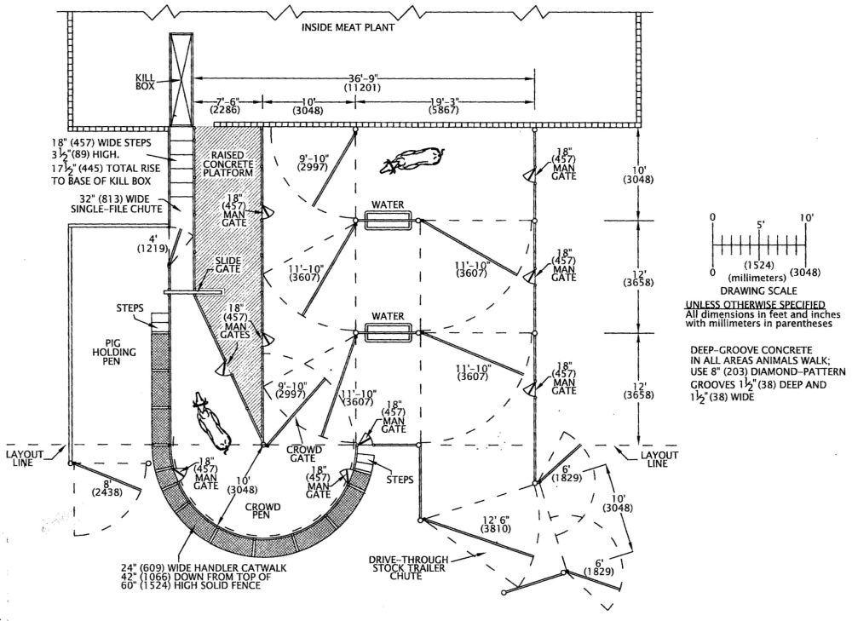
Figure 2 Slaughter Plant Layout for a Very Small Beef Processor by Temple Grandin (Grandin n.d.)

APPENDIX 2 – Example Waste Grinder

APPENDIX 3 – Facility Scope and Space
Space Allocation | Space Type | SF
Total Floor Area |  | 9760
Under Roof -Unconditioned Total |  | 3000
Under Roof -Conditioned Total |  | 6760
Under Roof -Conditioned | Office | 300
Under Roof -Conditioned | Dry Storage | 200
Under Roof -Conditioned | Breakroom, Bathroom Locker-Shower Area | 400
Under Roof -Conditioned | Kill Floor | 350
Under Roof -Conditioned | Smoke and Sausage | 400
Under Roof -Conditioned | Commercial Kitchen | 500
Under Roof -Conditioned | Curing Room | 120
Under Roof -Conditioned | Cold Room - Custom Processing Area | 300
Under Roof -Conditioned | Meeting/Teaching Space | 2000
Under Roof -Conditioned | Public Bathrooms | 120
Under Roof -Conditioned | Mechanical Room | 300
Under Roof -Conditioned | Janitorial & Utility Space | 200
Under Roof -Conditioned | Pre Cool & Hanging | 150
Under Roof -Conditioned | Holding Cold Storage | 300
Under Roof -Conditioned | Finished Product Storage | 120
Under Roof -Conditioned | Freezer/Blast Freezer Storage | 700
Under Roof -Conditioned | Interior Refrigerated Waste Storage | 200
Under Roof -Conditioned | Hide Storage Area | 100
Under Roof -Unconditioned | Warehouse/Loading Dock | TBD
Other | Parking | TBD
Under Roof -Unconditioned | Animal Unloading Covered Pens | 3000

(Florida Department of Health 2022)
(National Equity Atlas 2022)
(Feeding America 2018 data)
(Dimperio 2021)
(Moore 2022)
(Centers for Disease Control and Prevention 2021)
(Coats, et al. 2022)
(Pappas 2020)
(Center on Budget and Policy Priorities 2021)
(Balagtas and Cooper 2021)
(Center on Budget and Policy Priorities 2021)
(Working Food 2021)
2021 Small-Producer Agriculture Capital Support Grant (SMAACA) capital funding for Alachua County farmers and ranchers.
2021 Meat Processing Survey - In September 2021, Alachua County reached out to the regional ranching community to determine the interest in a niche meat processing facility.
(U.S. Department of Treasury 2022)
(Alachua County Board of County Commissioners 2021)
(Coats, et al. 2022)
( National Agricultural Statistics Service 2017 data)
(Alachua County Board of County Commissioners 2021)
(UF Bureau of Economic and Business Research 2018)
For a full description see Promoting Equitable Outcomes Efforts to Date to Support Economic and Racial Equity in this document.
(Alachua County 2021a)
(Alachua County 2021b)
(Working Food 2021)
(Alachua County Board of County Commissioners 2016)
(Glasmeier 2022)
Defined as businesses with fewer than 25 employees, with a maximum net worth of $1 million.
(Alachua County Equal Opportunity Office n.d.)
(Carlson, Rubenstein and Levin 2020)
(Kresin 2019)
(Grebitus, Lusk and Nayga Jr. 2013)
(Jablonski, Sullins and McFadden 2019)
(Dimitri and Effland 2018)
(Hodges, Stevens and Wysocki 2014)
(Thistlethwaite 2020)
(Court, et al. 2022)
(State of Florida 2012)
(Grandin, Livestock Handling Systems, Cattle Corrals, Stockyards, and Races n.d.)
An example slaughter plant layout is included in the Appendix 1.
(Grandin n.d.)
(Niche Meat Processor Assistance Network 2022)
The City is has a State-funded expansion to their wastewater treatment facility that will come online on or before in 2026.
See Appendix 2 for an example shredder specification sheet.
(U.S. Department of Treasury 2022, 27)
This cost estimate is limited to the structure itself and does not include the value of land and utility connections the City of Newberry is providing in support of the project.
(U.S. Department of Treasury 2022, 28)
Per SLFRF Compliance and Reporting Guidance Document Section 5.J.2: Enumerated Use Justification for “other” projects of $1M or more (U.S. Department of Treasury 2022, 28)
(Balagtas and Cooper 2021)
(Pappas 2020)
(Center on Budget and Policy Priorities 2021)

