Alachua County, Florida
Recovery Plan

State and Local Fiscal Recovery Funds
2022 Food System Equity Program: Food System Workforce Development and Jobs Pipeline for Disadvantaged Communities Proposal

Alachua County, FL
2022 Recovery Plan

Table of Contents

GENERAL OVERVIEW 2
Executive Summary 2
Uses of Funds 2
Promoting equitable outcomes 3
Program Goals, Awareness, Access, and Distribution 3
Efforts to Date to Support Economic and Racial Equity 4
Constraints and Challenges 6
Community Engagement 8
Pre-Pandemic Efforts & Pre-ARPA Funding 8
Working Food 2020-2021 Pilot Project 8
Labor Practices 9
Use of Evidence 9
Young Chefs Program Summary 9
Workforce and Local Food Economic Development Summary 10
Working Food Community Kitchen Summary 10
Application of Pilot Program Results 11
Performance Report 11
PROJECT INVENTORY 11
WORKS CITED 13
APPENDICIES 15

GENERAL OVERVIEW

Executive Summary
In response to the COVID-19 Pandemic, the Federal government has provided the Alachua County Board of County Commissioners (ACBoCC) funding through the American Rescue Plan – State and Local Fiscal Recovery Funds. Many low-income and disenfranchised communities were disproportionately impacted in their employment opportunities by COVID. This project supports marginalized communities with the expansion of high-quality vocational opportunities in Alachua County’s local food system. Vocational work in areas such as custom meat processing and culinary arts represents a unique opportunity for those in the workforce and youth looking for future career opportunities.
This project builds off evidence for food system workforce programs developed by the ACBoCC through their 2020-2021 locally funded Community Redevelopment Food System Grants. Project partners will include workforce board, institutional, and local non-profits engaged in food system economic development, farmers’ markets, and ethnic-culturally specific food/meat producers. The partnership will build quality job opportunities for communities facing covid-based inequities in this sector and will also increase the local resilience of the food system. By creating better employment opportunities in our food system, we can bring greater economic stability to these disadvantaged communities. Culinary arts professionals may also act as ambassadors in their communities for healthier food choices.

Uses of Funds
The ACBoCC will allocate $250,000 over two years ($125,000 per year) to expand high-quality vocational opportunities in the food system targeting communities facing covid-based inequities. Approximately 100 individuals will be assisted with food-related vocational training over this time period. This workforce development will increase the local resilience of the food system in our community per Treasury guidance under Negative Economic Impacts (EC 2.10) Assistance to Unemployed or Underemployed Workers by creating a Youth Leadership culinary arts jobs pipeline for youth in disadvantaged communities and the expansion of a jobs training opportunities through an existing Community Kitchen space.
These programs will provide assistance to individuals who want and are available for work, via job training, assistance to individuals to start small businesses & development of job and workforce training centers focused on food system occupations from farmers to culinary arts professionals.
Disadvantaged communities in Alachua County have experienced ongoing job insecurity and a lack of upward income mobility which has also been exacerbated by COVID. Workforce development in the high-demand food system sector will promote greater equitable outcomes in these communities.

Promoting equitable outcomes
In 2018, before the pandemic, Alachua County was estimated to have 3.3% unemployment (Florida Department of Health, 2022) however, in marginalized communities’ unemployment was in some ethnic groups twice this rate at 7%. (National Equity Atlas, 2022) In the same time period, 36,000 or 13.9% of the population were food insecure or have inconsistent access to affordable foods that promote well-being and prevent disease in quantity and quality.
Pre-COVID, these marginalized populations were also stressed with healthcare inequities. (Dimperio, 2021)
Since the pandemic, these communities face covid-based inequities that entrench or exacerbate conditions of disproportionate unemployment levels and food insecurity. Employment with a livable wage and access to nutritious food are critical factors in maintaining health and preventing disease. Food system-related diseases for marginalized communities increased nationally because of COVID. This can be seen in the surge of demand for 2021 SNAP benefits which increased by 15% in January and 21% in October 2021.
Food insecurity in black communities is compounded by unemployment trends that run almost double that of white populations in Florida. The Centers for Disease Control (CDC) has highlighted the nexus between the disproportionate impacts of COVID on health outcomes based on employment and food insecurity. The CDC Employment Loss and Food Insecurity — Race and Sex Disparities in the Context of COVID-19 report highlights the economic disparities around problems of aggravating chronic unemployment and the lack of food security for marginalized and low-income communities. (Coats)
Interventions such as proposed by this program may bring better employment opportunities in food system occupations may to address access to food that in turn can reduce health impacts due to COVID in at-risk communities.

Program Goals, Awareness, Access, and Distribution
- Goals: This proposal targets food system employment opportunities for historically underserved, marginalized, or adversely affected groups in qualified census tracts or combination of underlying income, employment, and COVID impacts to provide:
  - A youth jobs pipeline for culinary arts and healthy food outcomes
  - And a community kitchen space supporting workforce training with certificate opportunities for a culinary arts program
- Awareness: Alachua County piloted these programmatic responses using local funds in 2020-2021 with high participation of marginalized communities and great success. That pilot program has ensured that the 2022 expansion will be equitable and practical in enabling these communities to be aware of the services funded by the SLFRF.
- Access and Distribution: The two programmatic responses target services to different eligible populations based on their needs as youth entering a jobs pipeline and certification training for unemployed and underemployed workers. These responses recognize the differences in levels of access to benefits and services across groups. A sub-recipient agreement or contract with an administrative entity with food system expertise requirements will assist in promoting the program and completing applications that meet eligibility criteria.
- Outcomes: Having two programmatic responses, as previously stated, targets services to different eligible populations, but it also addresses problems with the underlying food system of the community at a holistic level from youth, workforce, and talent development to producer.
    - Youth jobs pipeline for culinary arts and healthy food outcomes:
      - Youth career awareness and exposure, marketable trade skills, better home nutrition outcomes, jobs pipeline creation.
    - Community Kitchen space as a location for workforce training with certificate opportunities for culinary arts outcomes:
      - Culinary arts certification, food-related farmer support, better employment opportunities with higher incomes. Stability of income and employment contribute to greater food security and health outcomes, small farmer and rancher profitability, market access, food safety, greater resilience for the entirety of the local food system

Promotion of the program and participation will be tracked by disaggregating outcomes by race, ethnicity, and other equity dimensions as part of the reporting requirements. These reporting requirements build upon the qualitative and quantitative reporting developed by the 2020-2021 pilot program.

Efforts to Date to Support Economic and Racial Equity
The ACBoCC supports and protects at-risk communities through its Strategic Vision that integrates equity, vital programs supporting housing and health, alongside non-profit sector service partners.
Equity was placed at the forefront of Alachua County through a November 2020 voter-approved charter amendment that directed “(an) examination of policies for all County operations for elements of racial, economic, and gender bias in the design and delivery of County programs and services. The County will identify and act to mitigate and improve upon the effects, patterns, and disparities imposed by said biases.”
Unemployment and under-employment are equity issues for Alachua County. It is felt most acutely in marginalized communities during emergencies such as the COVID-19 pandemic and aligns with Treasury Guidance for Coronavirus State and Local Fiscal Recovery Funds. ACBoCC detailed related equity goals within their adopted Fiscal Year 2022 Strategic Guide.
This guide defines equity: “Equitable means striving to treat everyone justly according to their circumstances, providing opportunity and access for everyone, while focusing on closing existing equity and access gaps.” It also sets Guiding Principles to address root causes, utilize a collaborative approach, and operate in a transparent, accountable, efficient, and effective manner in service delivery. Within the Guide’s “Achieve Social and Economic Opportunity for All” header there are several the goals related to the programmatic response of this proposal:
- “Build[ing] equitable access to health (physical and mental), safety, and opportunity, especially for people who haven’t traditionally had access to those systems,” which correlates to the CDC findings of employment and food security.
- “Focus our Economic Development efforts on local businesses and removing barriers to economic opportunity,” which ties to the workforce development efforts of the proposal.
- “Work with private and public partnerships, including farms and local food entrepreneurs, to build a community food system,” which ties back to the overall programmatic response of this proposal based on the 2020-2021 pilot project efforts.
ACBoCC also made significant investments in creating an overall Equity Plan for County operations and community engagement, hired talented leadership to spearhead this effort, and engaged in pilot projects to support food system equity outcomes since the ballot initiative. Efforts are ongoing.
In addition, the County has set related objectives in its Comprehensive Plan Community Health and Economic Element, that inform this project proposal and justify the ARPA funds.
Community Health Element:
Policy 1.2.2 Develop and encourage civic engagement and volunteer opportunities in community projects that promote community health.
Policy 1.2.3 Increase access to health-promoting foods and beverages in the community. Form partnerships with organizations or worksites, such as employers, health care facilities and schools, to encourage healthy foods and beverages.
Policy 1.3.1.1 Promote food security and public health by encouraging locally-based food production, distribution, and choice in accordance with the Future Land Use Element.
Policy 1.3.1.3 Continue to offer support for home and community gardening through programs offered by USDA Farm to School Programs and the Alachua County Extension Office and target low-income and populations at high-risk for health disparity for programs promoting gardening, healthy food access and nutrition improvement.
Policy 1.3.2.6 Alachua County community planning efforts and community support programs will encourage participation by health coalitions and networks to create environments that support enjoyable, healthy eating, physical activity and a positive self-image.
Economic Element:
Policy 1.1.5 Alachua County shall expand its economic base by creating an environment which encourages job skills training, education and entrepreneurship through strong partnerships with CareerSource North Central Florida, the University of Florida, Santa Fe College, the School Board of Alachua County, YouthBuild/Institute for Workforce Innovation, and related organizations that provide education and training to the community.
Policy 1.2.1 Alachua County shall encourage the allocation of resources for the retention, expansion and development of local business and the recruitment of businesses and industries. Priority shall be given to the retention, expansion and development of local businesses. This strategy shall include support for efforts to provide expanded opportunities for education, including jobs-related skills training, to increase workforce participation and better employment opportunities for populations that are experiencing economic disparities identified in the “Understanding Racial Inequity in Alachua County” Report (2018).
Policy 1.7.1 Partner with community groups and other local governments in the region to delineate and promote a local food shed for the development of a sustainable local food system. Alachua County will participate in a study to establish baseline measures and measurable targets towards the increase of local food use by Alachua County institutions, including: (a) Identify and partner with relevant agencies and organizations, such as the City of Gainesville, area retailers, UF IFAS Extension, Florida Farm Bureau, Florida Organic Growers, UF Field to Fork, Working Food, Alachua County School Board, UF, UF Health, and SFC. (b) Identify components of the local food economy, such as appropriate food shed, distribution system, and local food segment of retail purchases. Set target goals and develop methodology to identify and track local food use by Alachua County institutions.
Policy 1.10.4 Partner with IFAS, local farmers, and community groups to develop and implement educational strategies on the benefits of purchasing locally grown and/or processed foods.

Constraints and Challenges
Because the proposal is multi-faceted and geared toward differentiated communities, recruitment, training cohorts, and subsequent reporting will be highly dependent on their availability and willingness to participate, in some cases, a multi-year effort. Because of the time constraints around ARPA funding, however (the funding must be obligated by December 31, 2024, and expended by December 31, 2026), it is recommended that we proceed with the program despite this shortcoming.
This challenge highlights the need to rely on our community partners in the non-profit food system, Workforce Board, and higher education certification programs to continue their community engagement work to reach eligible participants. The SEEDS Office will manage the County’s responsibilities in conjunction with a related non-profit partner through a sub-recipient agreement or contract to devise methods of identifying potential participants using procedures developed over the 2020-2021 pilot program for outreach.
Project Demographic Distribution
Per Treasury guidance, the program funds are targeted to communities in zip codes that have experienced COVID-based inequities, are generally low-income communities, and can be further defined as part of HUD’s Qualified Census Tract (QCT). For this program, these residents and communities will be identified by meeting one or more of the following Treasury guidance points:
A program or service is provided at a physical location in a Qualified Census Tract [QCT] (for multi-site projects, if a majority of sites are within Qualified Census Tracts) and A program or service where the primary intended beneficiaries live within a Qualified Census Tract;
- Households located within QCTs area are eligible for program participation and will be targeted for programmatic outreach.
- The following are QCTs in Alachua County in 2022: 2.00 (i.e. 2.01 & 2.02), 6.00, 8.06, 9.01, 15.14, 15.15, 15.16, 15.17, 15.19, 15.21 (i.e. part of 15.22), 16.05 (i.e. 16.03 & 16.04), 18.02, 19.02, 22.18.
Low-income households and communities are those with (i) income at or below 185 percent of the Federal Poverty Guidelines [FPG] for the size of its household based on the most recently published poverty guidelines…based on the most recently published data.
- Per Treasury guidance, “communities” as referenced above can be determined as a qualified community if the community as a whole has a median income below 185 percent of FPG.
- These guidelines allow Alachua County to expand the number of qualifying Census tracts to also include tracts: 3.01, 3.02, 4.00, 7.00, 8.08, 8.09, 10.00, 15.20 (i.e. part of 15.22), 19.08, 20.00 (i.e. 20.01 & 20.02), 21.02, 22.17.
Low-income households and communities are those with…(ii) income at or below 40 percent of area median income [AMI] for its county and size of household based on the most recently published data.
The Treasury’s final rule allows both low-income (40% AMI) and moderate-income (65% AMI) to qualify for assistance.
- Residents in communities which do not qualify under the above requirements can still be eligible to participate in the program if their income is 40% AMI or less.
Finally, households can qualify for participation if they qualify for other federal benefits. These include:
- Temporary Assistance for Needy Families (TANF),
- Supplemental Nutrition Assistance Program (SNAP),
- Free- and Reduced-Price Lunch (NSLP) and/or School Breakfast (SBP) programs,
- Medicare Part D Low-Income Subsidies,
- Supplemental Security Income (SSI),
- Head Start and/or Early Head Start,
- Special Supplemental Nutrition Program for Women,
- Infants, and Children (WIC),
- Section 8 Vouchers,
- Low-Income Home Energy Assistance Program (LIHEAP), and
- Pell Grants

Community Engagement
This Food System Workforce Development and Jobs Pipeline proposal benefits from years of prior County Commission strategic commitment with community engagement on successful past projects.

Pre-Pandemic Efforts & Pre-ARPA Funding
Several years before and immediately following the COVID pandemic the ACBoCC sponsored programmatic work for aspiring entrepreneurs, food service professionals, restaurateurs, and farmers. These early efforts highlighted the extreme need for robust training programs that can support low-income and under-employed people to gain the skills they need to pursue careers or business ideas in the food industry. While there is no lack of demand for services, the lack of baseline skills in the aspiring farmers and a lack of coordinated resources to facilitate their success in our community has caused County-sponsored incubation programs to struggle.

Working Food 2020-2021 Pilot Project
In response to the food system demand for services and entrepreneurship skills, a 2020-2021 pilot project with Working Food, a local food non-profit. This pilot project focused on critical work with institutions and community partner stakeholders. Pilot project partners included UF Entrepreneurship and Professional Development Programs, Greater Duval Neighborhood Association, Chef Empowerment, and CareerSource. Working Food’s efforts developed working groups exploring the wide-ranging needs of the food community and economy. Working Food also developed a curriculum through these groups and discussions and implemented culinary training, nutrition education, and food-related job skills to address these needs. Through these partnerships, Working Food was also able to pilot a Young Chefs program to build educated eaters, cultural identity, and community understanding of local food, nutrition, and food safety with youth. By working with multicultural chefs that provide fun, age-appropriate activities and education on cooking skills, cultural food identity, nutrition, and food safety, they created a program that built a strong foundation of food literacy with the next generation of citizens and leaders.
ACBoCC’s ARPA proposal builds off the pilot project’s community engagement strategy, neighborhood relationships, and institutional partnerships to provide direct feedback on the relevance and efficacy of program delivery. The ACBoCC’s creation of a dedicated Office of SEEDS, outreach strategies, and policy framework support equity goals and engagement with communities that have historically faced significant service barriers.

Labor Practices
Not Applicable.

Use of Evidence
The proposal aims to serve approximately 100 individuals with food-related vocational training over the next two years. These services will improve employment opportunities for marginalized communities that may be facing food insecurity and unemployment/underemployment that the COVID-19 pandemic has impacted. The program will provide a report highlighting the approximate number of individuals that received services as part of the program, as well as post-participation surveys.
In September 2020, ACBoCC awarded a COVID relief food system workforce grant to Working Food’s Seed to Plate program. This pilot project and its results are the evidence-based interventions incorporated into the proposed SLFRF program.
Running from 2020-2021 the Seed to Plate pilot program’s goal was to increase education and demand for local food, develop a plan for needed culinary skills training, and accelerate food system innovation in Alachua County to address healthy food access and local food systems development. The project focused on two key areas: 1) planning projects that will guide how we can stimulate local food industries and protect public health by improving food access and expanding workforce opportunities and 2) expanding opportunities for education on cooking, food safety, and nutrition, including life and jobs-related skills to increase better eating habits, community engagement in our local food system, and better employment opportunities in our food system. The three main program components of the pilot included a Young Chefs Program, Workforce Development Program and Community Kitchen Program.

Young Chefs Program Summary
By increasing children's knowledge of the local food system, the community develops workforce capacity and leadership. Programs that deeply engage with youth are critical to ensuring economic success but also help address issues of access, consumption, and food sovereignty. The pilot program was a collaboration with the Greater Duval Neighborhood Association, led by Mr. Andrew Miles, and the Chef Empowerment Program, led by Chef Carl Watts, to offer the Young Chefs Program. The youth program provided exposure to gardens, and cooking classes, increased access to fresh and healthy foods and built confidence, and skills in youth. It inspired a lifelong behavior shift and future food-related opportunities in the food system. It also allowed Working Food to build trust and relationships with Black-led organizations. This empowered the organizations to be co-leaders in creating a vision for a healthy, local food community. Community trust allowed for the development of a culturally competent youth culinary program providing cooking, nutrition, and food safety skills while also connecting students to the heritage of their food and future career opportunities.
This program supported five Young Chefs in the initial classes in the 2020-21 school year. Students ranged from 12-17 years old. The Young Chefs celebrated their graduation from the class with the Pop-Up Restaurant (Appendix_1) which they hosted for their families and community members at Working Food in early summer 2021. Students cooked, plated, and served a three-course farm-to-table meal (Appendix_ 2) and learned how to work in a commercial kitchen. Families and students alike beamed with pride at the beauty of the food and the students' hard work. For the 2021-22 school year the program grew to seven Young Chefs. In all, 20 classes were completed in a mixture of commercial and home kitchen settings.

Workforce and Local Food Economic Development Summary
Working Food supported workforce development and technical training as part of a working group with Alachua County, the City of Gainesville, CareerSource, Santa Fe College, and the University of Florida. This team created a cross-institutional food system workforce plan. Several partnerships and programs have developed from these meetings. The Working Food Community Kitchen provided the infrastructure support for local food business development, focusing on assisting women, disenfranchised, and disadvantaged entrepreneurs.
One tangible collaboration from the community discussions is a new Culinary Arts Certificate course from the UF Office of Professional and Workforce Development. This 16-week course combines online and in-person education and externships with local businesses. The in-person instruction was held at Working Food’s kitchen. CareerSource, Alachua County’s workforce board, also partnered with UF and is offered ten full scholarships to cover the cost of the course for eligible students. This affordable education and certification can provide a unique opportunity for individuals in the local community to gain skills and contacts in the local restaurant and hospitality industry or to start their own food-based business and build their personal and family wealth. The first pilot cohort of this program began in January 2022 with 6 participants, and with the additional support of a WIOA grant from CareerSource Working Food was able to offer full scholarships for 4 participants (See Appendicies Video Links).

Working Food Community Kitchen Summary
COVID shuttered the operations of the Working Food Community Kitchen Space. In September 2021, under pandemic safety protocols, it reopened with a renewed focus on restarting and refreshing processes and procedures for client intake, onboarding, and ongoing standard operating procedures for kitchen and storage clients. In the last six months of 2021, there was a steady increase in inquiries. During this period, they accepted 17 clients. These clients included new food trucks, producers of value-add products, and a local woman-owned and operated meat processing co-operative. In addition to the direct entrepreneurial support, the kitchen has been a critical space for new education and workforce development efforts. Access to the kitchen remains critical for storing and preparing ingredients for the Young Chefs classes. In addition, the team hosted a large pop-up event at the kitchen in the summer to wrap up and celebrate the end of the winter/spring curriculum and classes. Additionally, the kitchen serves as instructional space for the UF Culinary Certificate Program.

Application of Pilot Program Results
This program builds off the pilot initiative and will target households in 2022 HUD Qualified Census Tracts and individuals and communities with limited financial resources that qualify per the ARPA Final Rule. Alachua County’s program will issue a sub-recipient agreement or contract with a non-profit entity to develop the reporting and budget detail, recruit community participation, coordinate the program delivery, and prepare reports.

Performance Report
ACBoCC will track the performance goals of the allocated funds through regular reports and surveys developed under the 2020-2021 pilot program. The section below outlines a high-level approach to performance management and key performance indicators per expenditure category 2.10.
Key Performance Indicators
- Number of workers enrolled in sectoral job training programs
- Number of workers completing sectoral job training programs
- Number of people participating in summer youth employment programs

PROJECT INVENTORY
Project [Identification Number TBD]
Project Name: Food System Equity Program: Food System Workforce Development and Jobs Pipeline for Disadvantaged Communities Proposal
Funding amount: $250,000
Project Expenditure Category: (EC 2.10) Assistance to Unemployed or Underemployed Workers
Project Overview
$250,000 Alachua County Food Security – Food System Workforce Development and Jobs Pipeline for Disadvantaged Communities
Per Treasury Required Programmatic Data for Assistance to Unemployed or Underemployed Workers (EC 2.10), the following section provides a brief description of the structure and objectives of the assistance program, the number of individuals served, and how the aid responds to the negative economic impact of COVID-19.
Timeframe: Fall 2022-2024
Project Description: Spur greater food system resilience and employment opportunities for disadvantaged communities. This will be accomplished through two interlinked programs. The two programs will include:
1) A Youth Leadership culinary arts jobs pipeline for youth in disadvantaged communities.
2) And support for job training opportunities through an existing Community Kitchen space.
Youth Leadership – Using ARPA funding, the Youth Leadership program will expand from the 2021 efforts in three ways. First, by connecting various food-related youth programs, weaving seeds, gardening, nutrition, culinary skills, and career development into the work plan. Second, by working on a set of evaluation tools that will identify the strengths and challenges with the program for refinement. And third, by developing a Youth Food Leadership Internship Program as the culmination of youth development programs. This internship opportunity builds on the youth garden and culinary efforts by adding crucial workforce, leadership development, and economic advancement areas. As youth approach adulthood, developing responsibility along with socioemotional skills becomes crucial.
Summer Sling is part of the Out East Youth Support Services (OEYSS), a mentoring and empowerment program run through the Greater Duval Neighborhood Association that benefits local youth grades 5 - 12.
Summer Sling runs for six weeks. This program helps students develop a plan for after high school while building leadership skills among their peers. It focuses on career exploration and civic engagement, enhancing each youth’s opportunity to gain knowledge that can prepare them for a career and lifestyle for success. Participants will visit several colleges, universities, and alternative programs and get to go to job sites to get a first-hand view of different career opportunities to choose from.
Project YouthBuild is an educational, occupational, and leadership program for young people with low incomes who have dropped out of school. Students have the opportunity to earn their high school diploma, multiple nationally recognized construction or CNA credentials, and a post-secondary scholarship; all while giving back to their community.
Overall Youth Food Leadership programming is designed to be a real-world employment-based experience that will teach youth important life skills related to employability, work ethic, and character from an African American cultural frame while also incubating youth in the values and practices of a local food system.
2-Year Estimated Cost: $135,000 for Youth Food Leadership programming serving between 85 and 100 individuals.
Program funds will be used to support Youth Food Leadership activities:
- Up to 8 students and 20-35 family members will receive food biweekly.
- Up to 4 Youth Food Systems Leadership Program Interns
- 13 teens through Summer Sling
- 40 young adults through offering Project Youthbuild a series of classes on food business entrepreneurship.
Community Kitchen – Community kitchens that meet health and safety, storage, and preparation needs are critical infrastructure for vocational development programs. ACBoCC in partnership with the non-profit sector supports the development of these spaces to create high-quality food-sector jobs and expand local food production. A community kitchen serves as a vocational training, business support, and jobs hub. Programs with culinary certificates can help address this gap. It can also serve local farmers.
There is a great demand for kitchen space to support non-profit and other community organizations in their efforts to provide food assistance and address food security efforts. Additionally, there continues to be a need for kitchen space as a “lab” for pilot testing local food economy and community projects and ideas. The Women’s Meat Co-op and the UF Culinary Arts Certificate program[1] are examples of this. Other conversations around potential collaborative pilots include a food waste recovery meal pilot and various options for local farm produce aggregation, processing, and distribution for institutional use (K-12 schools, County jail, University of Florida), restaurant use, and retail.
2-Year Estimated Cost: $115,000 for Community Kitchen programming serving between 17 and 27 individuals.
Program funds will be used to maintain the kitchen for operational support.
- Through a partnership with UF, 15-24 students per year will complete the 16-week culinary arts certification program.
- Community Kitchen program will assist 2 to 3 local farmers from marginalized communities over the 2-year period.
Collaboration and Partnership
ACBoCC will seek a collaborative partnership with community organizations and institutions to expand on the related pilot projects started in 2020-2021. The County will seek assistance from an entity with relevant experience to act as program manager via a sub-recipient agreement or a contract.

[1] University of Florida Professional and Workforce Development https://pwd.aa.ufl.edu/culinary-arts/

WORKS CITED
Alachua County. “Alachua County Strategic Guide - FY 2022.” Alachua County Strategic Guide - FY 2022, Alachua County, 24 May 2021, https://alachuacounty.us/Depts/OMB/Stategic%20Alignment/Board%20Level%20Strategic%20Guide%20Overview.pdf. Accessed 9 October 2022.
Coats, Jacquelyn V. “Employment Loss and Food Insecurity — Race and Sex Disparities in the Context of COVID-19.” CDC, CDC, 18 August 2022, https://www.cdc.gov/pcd/issues/2022/22_0024.htm. Accessed 8 October 2022.
Dimperio, Diane. Health Equity and Access for East Side Residents. Healthy equity report for East Gainesville, FL residents. Gainesville, Diane Dimperio, 2021.
Feeding America. “State-By-State Resource: The Impact of Coronavirus on Food Insecurity.” State-By-State Resource: The Impact of Coronavirus on Food Insecurity, Feeding America, 20 October 2021, https://feedingamericaaction.org/resources/state-by-state-resource-the-impact-of-coronavirus-on-food-insecurity/. Accessed 9 October 2022.
Florida Department of Health. “Unemployment Rate - Florida Health CHARTS - Florida Department of Health.” FLHealthCHARTS.com, Florida Department of Health, 2022, https://www.flhealthcharts.gov/ChartsReports/rdPage.aspx?rdReport=NonVitalIndRateOnly.Dataviewer&cid=0472. Accessed 9 October 2022.
Mayo Clinic. “High blood pressure (hypertension) - Symptoms and causes.” Mayo Clinic, Mayo Clinic, 15 September 2022, https://www.mayoclinic.org/diseases-conditions/high-blood-pressure/symptoms-causes/syc-20373410. Accessed 9 October 2022.
National Equity Atlas. “National Equity Atlas.” Unemployment, National Equity Atlas, 28 September 2022, https://nationalequityatlas.org/indicators/Unemployment#/?breakdown=1&geo=04000000000012001. Accessed 9 October 2022.
Sandoval, Hector H. “UNDERSTANDING RACIAL INEQUITY IN ALACHUA COUNTY.” UNDERSTANDING RACIAL INEQUITY IN ALACHUA COUNTY, UF Bureau of Economic and Business Research, 12 January 2018, https://www.bebr.ufl.edu/economics/racial-inequity/. Accessed 9 10 2022.
US Department of Agriculture. “USDA Modernizes the Thrifty Food Plan, Updates SNAP Benefits.” USDA, US Department of Agriculture, 16 August 2021, https://www.usda.gov/media/press-releases/2021/08/16/usda-modernizes-thrifty-food-plan-updates-snap-benefits. Accessed 9 October 2022.
Working Food. 2021 Working Food Final Report. Final report to the Alachua County Board of County Commissioners summarizing results from the Community Redevelopment Fund Grant award. Gainesville, Working Food, 2021.

Appendices
APPENDIX_1 MENU - Young Chefs Pop-Up Restaurant-1.pdf
APPENDIX_2 RECIPE - Young Chefs, Class 1, BBQ Chicken.pdf
APPENDIX_3 Professional Training Curriculum.pdf
APPENDIX_4 Farm2Food Florida 2021 - Exit Survey Compiled Results.pdf
VIDEO LINKS:
https://www.linkedin.com/feed/update/urn:li:activity:6881606040492761088
https://www.linkedin.com/feed/update/urn:li:activity:6879069309939814400
https://www.linkedin.com/feed/update/urn:li:activity:6877291538590920705
Appendix 1

Appendix 2


Appendix 3
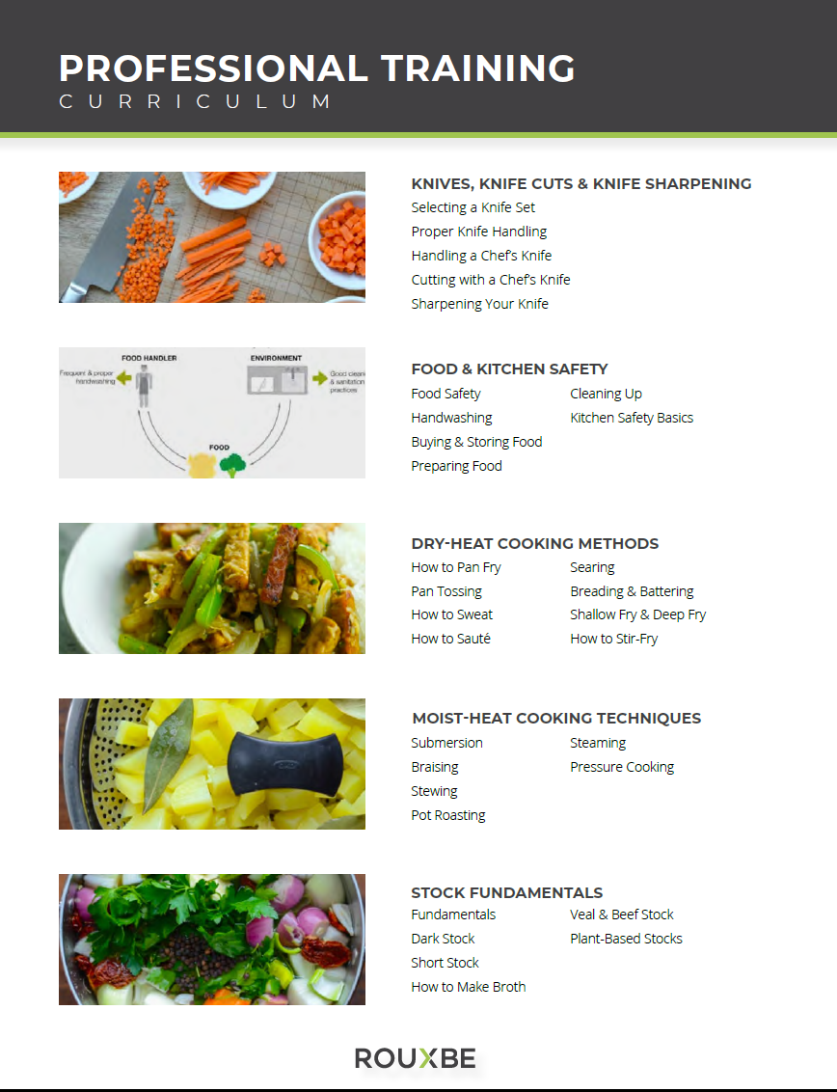
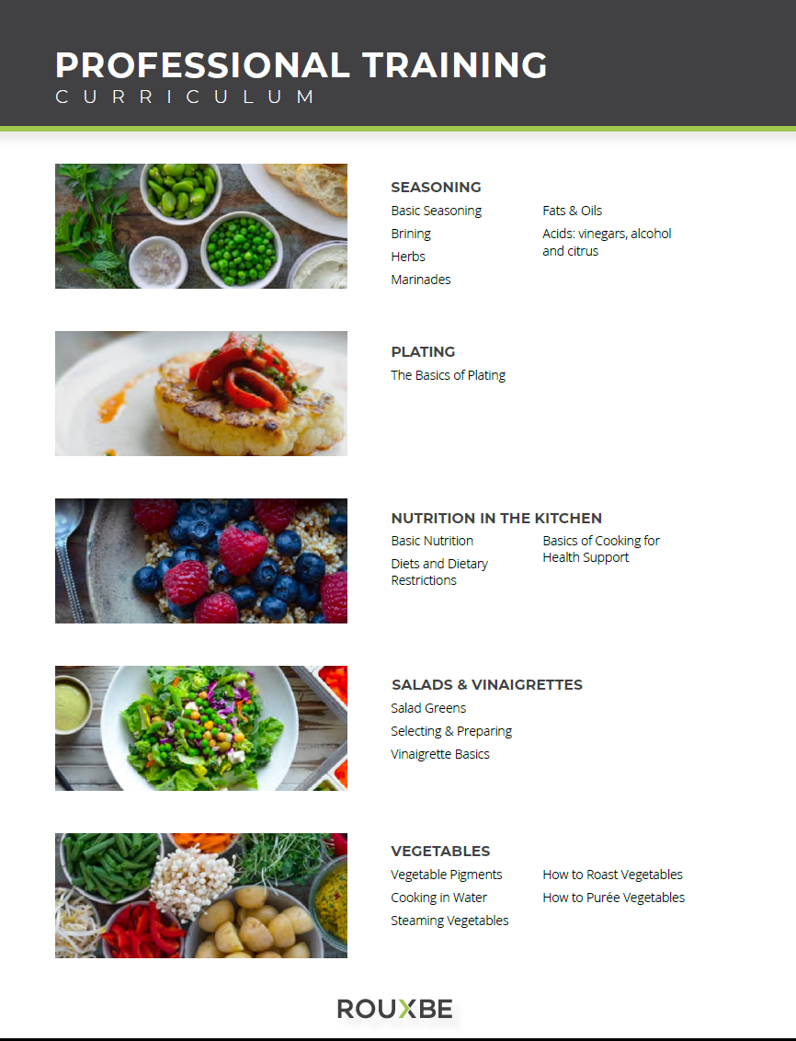

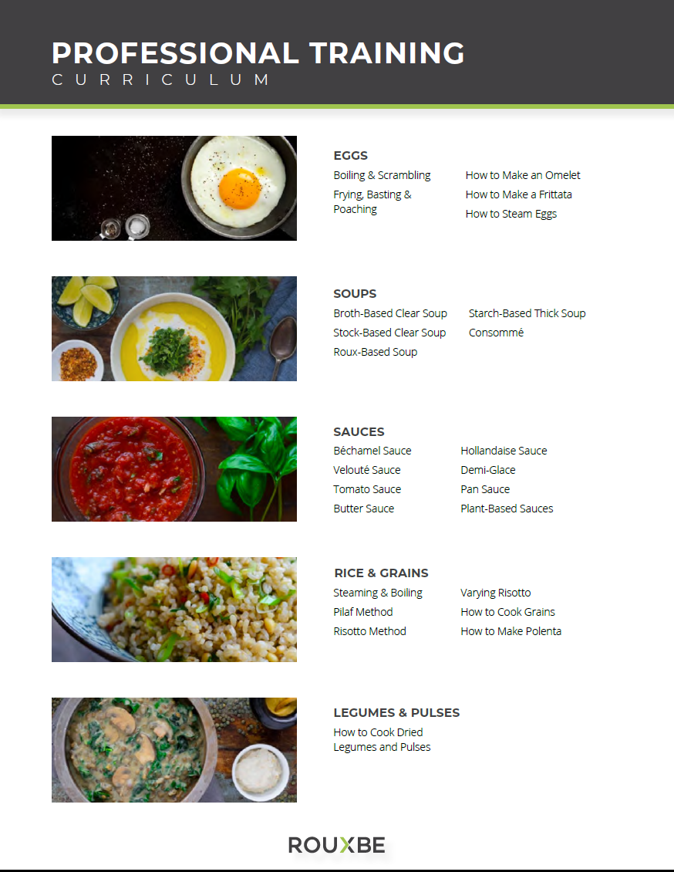

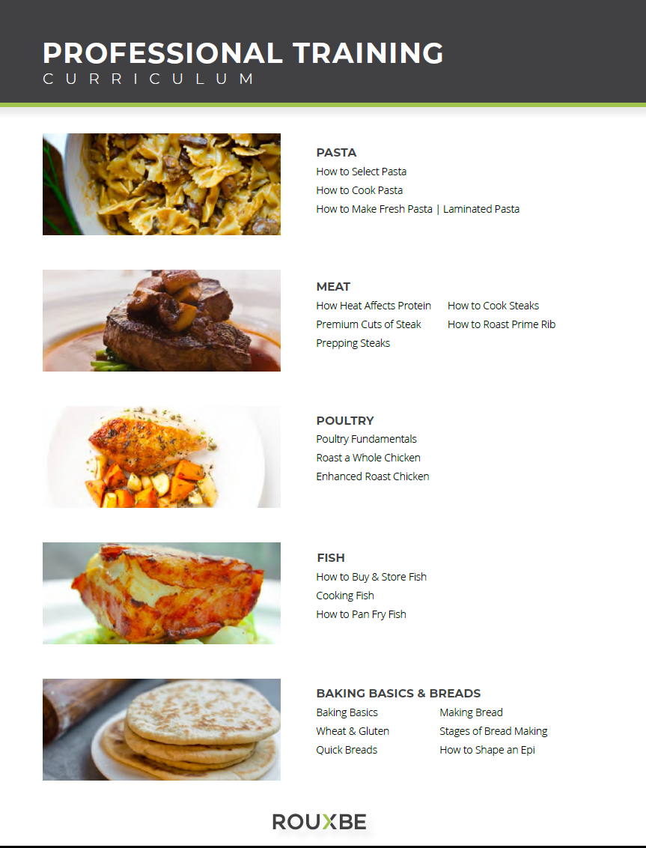



Appendix 4
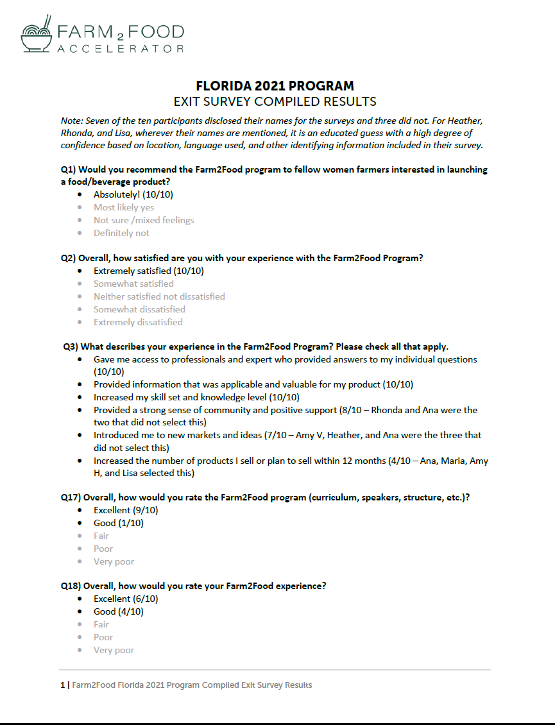
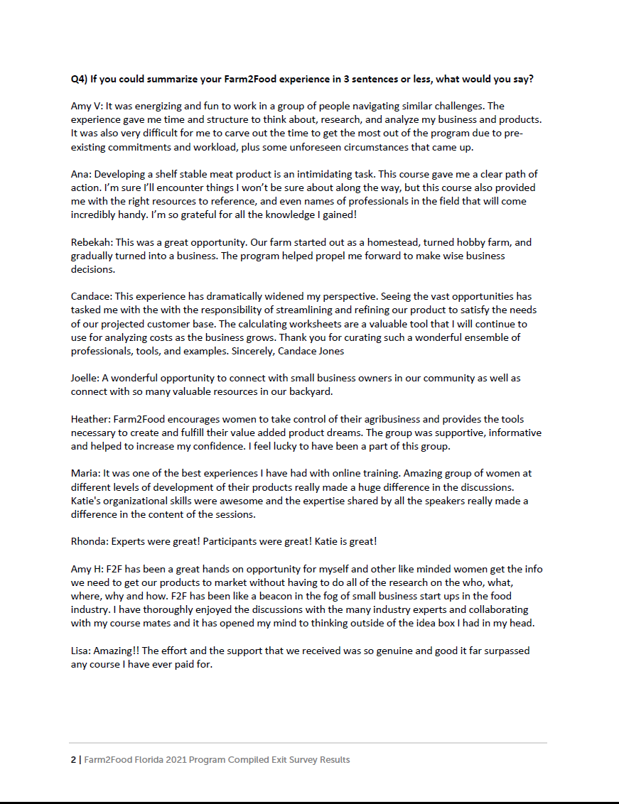

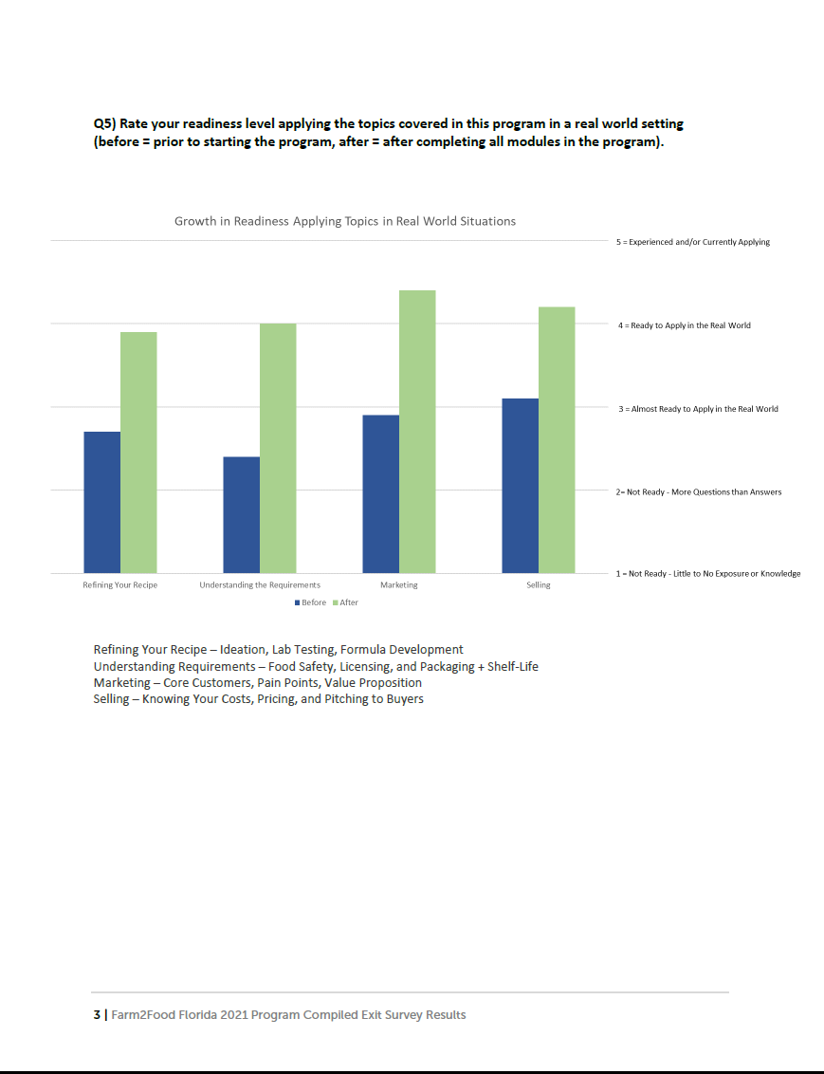

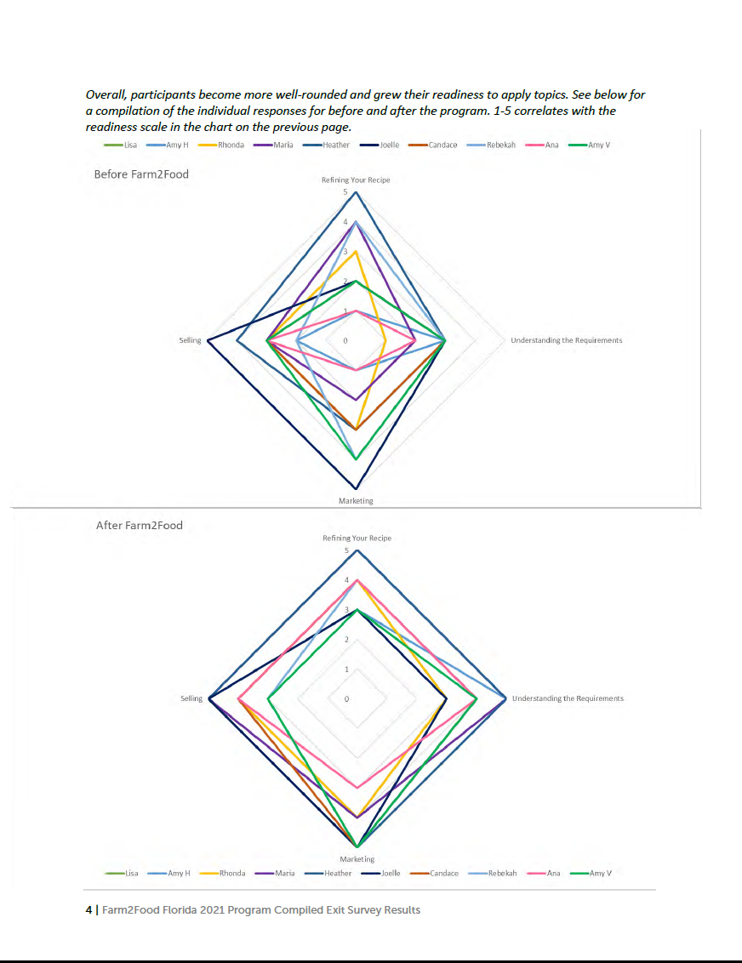

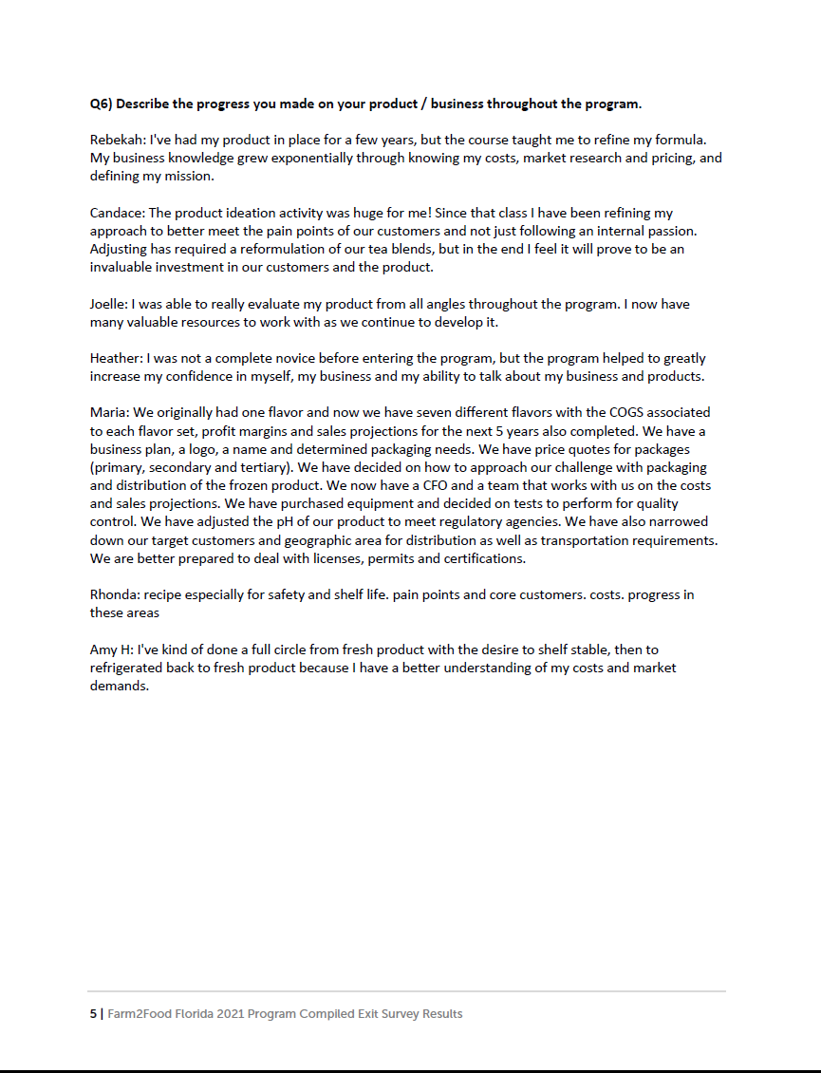

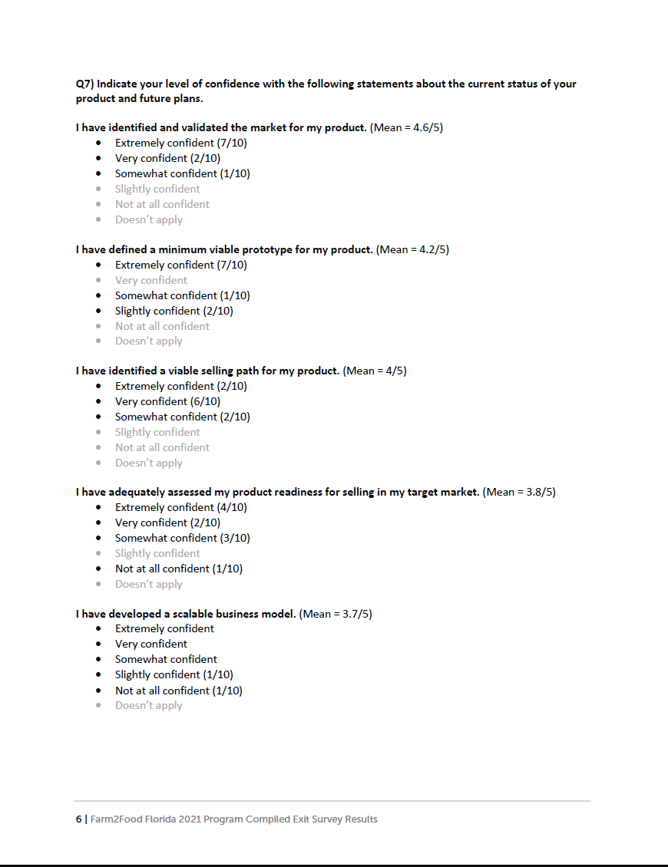

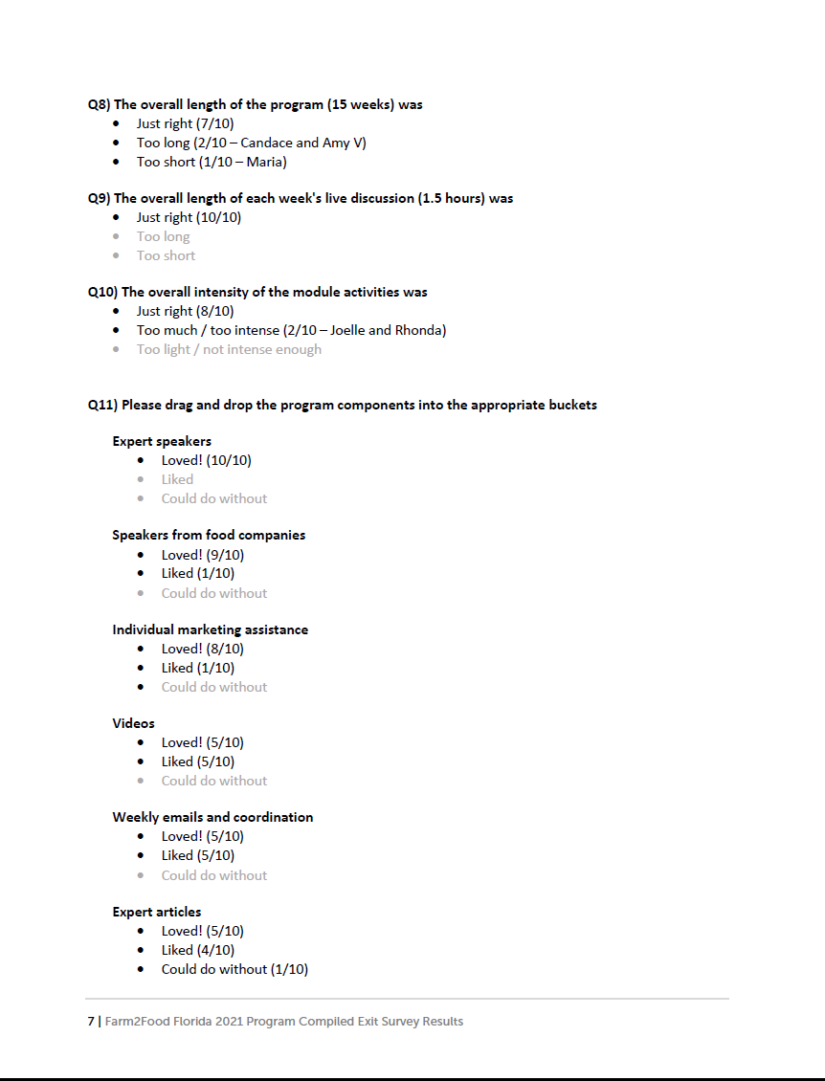

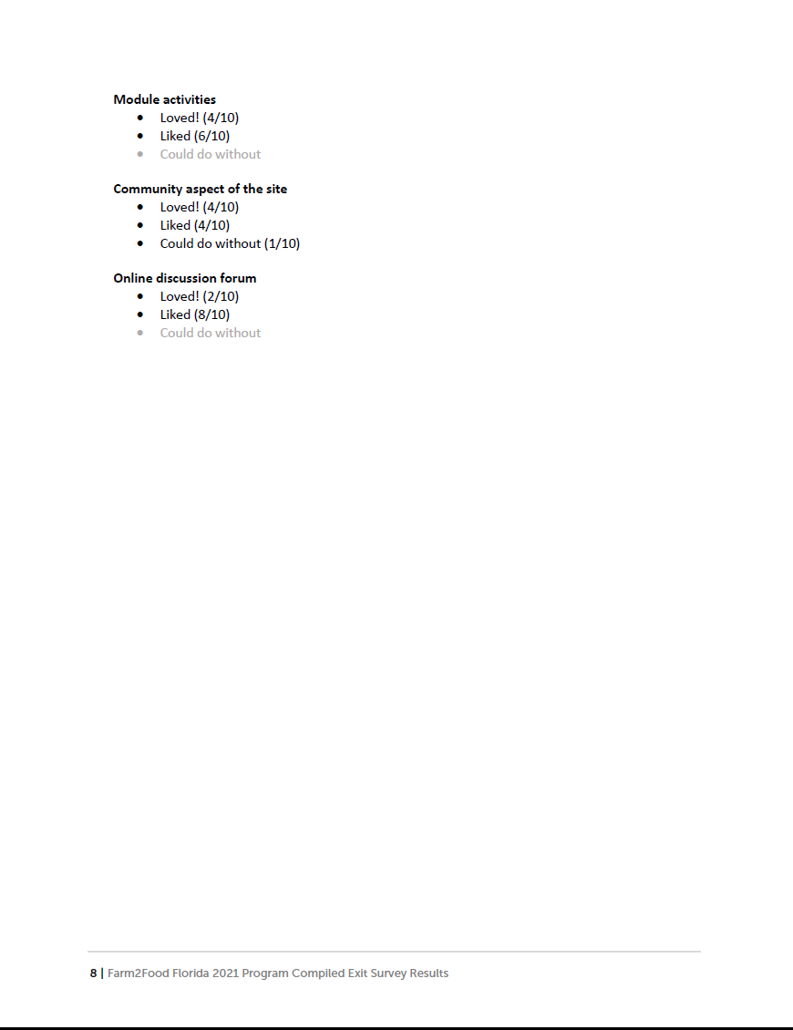

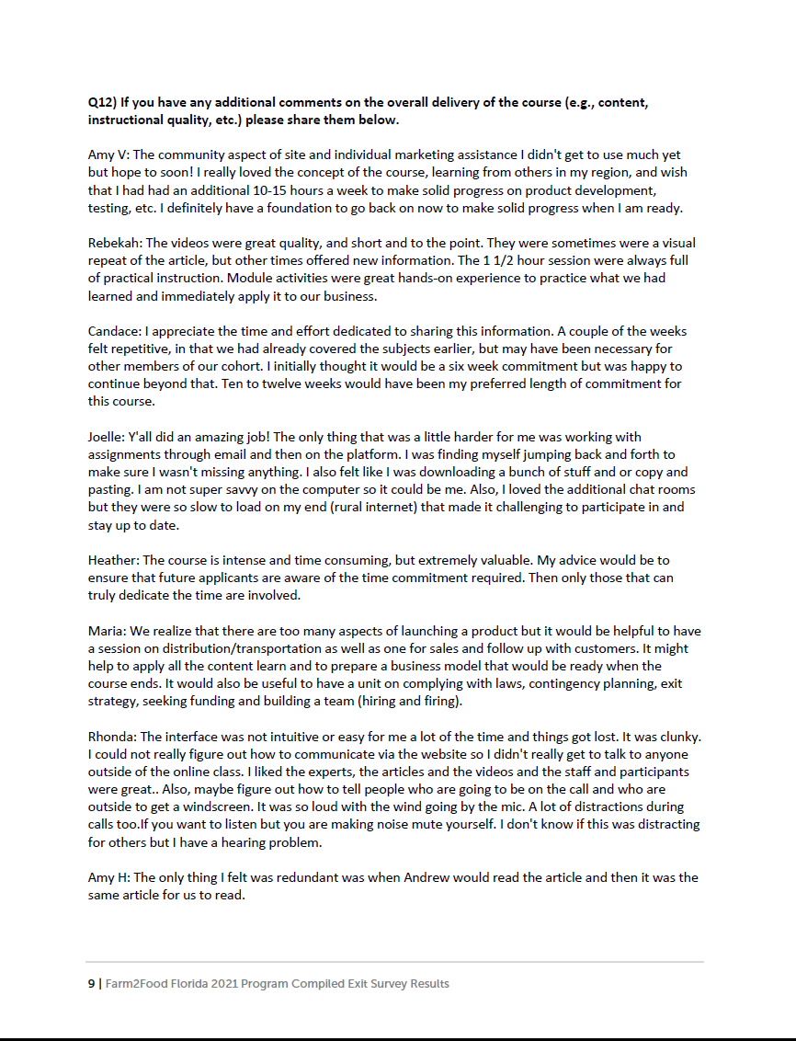

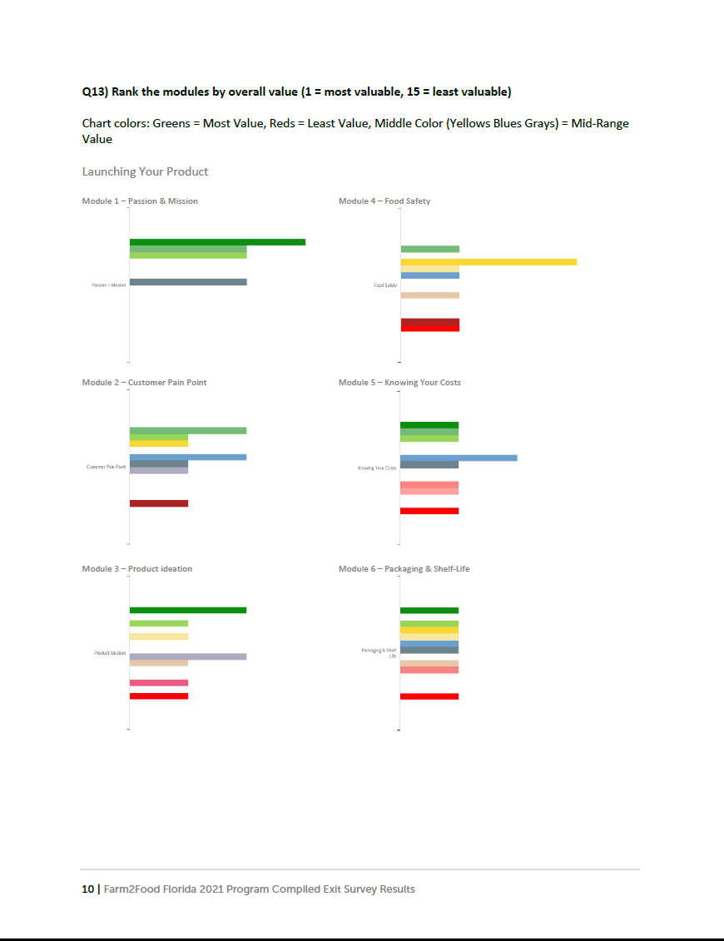

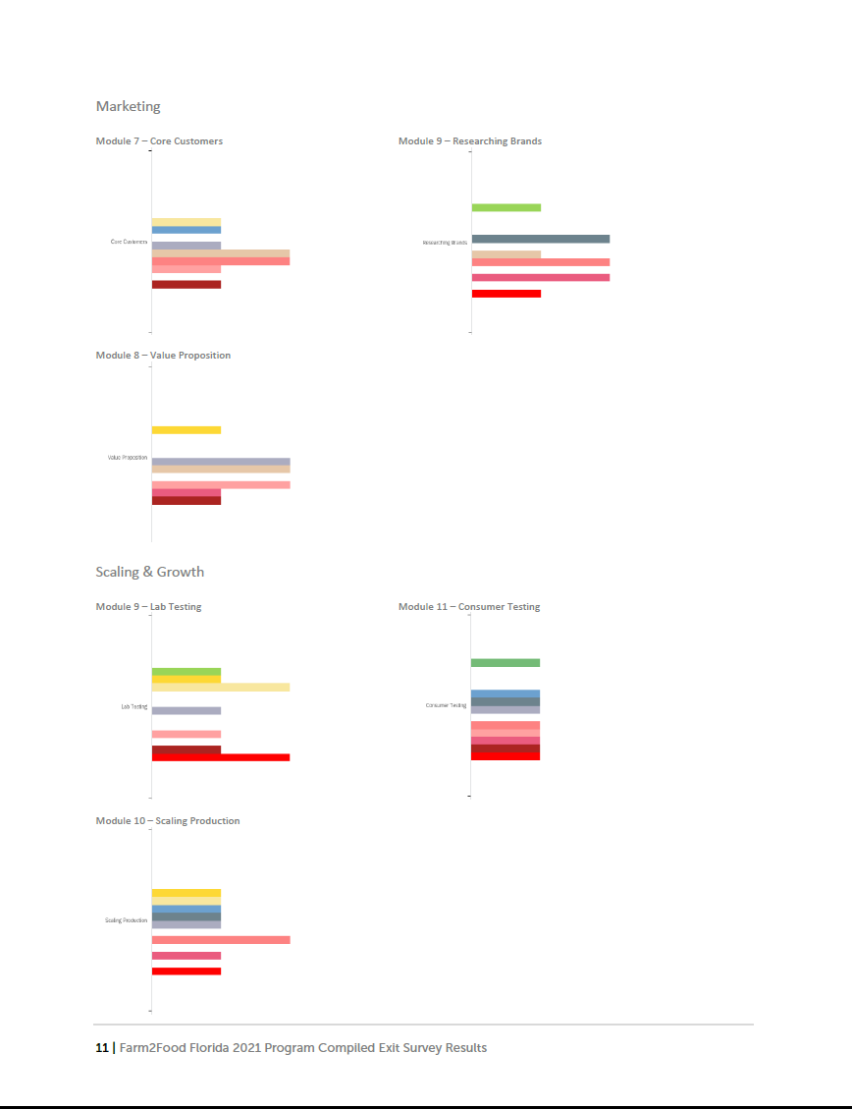

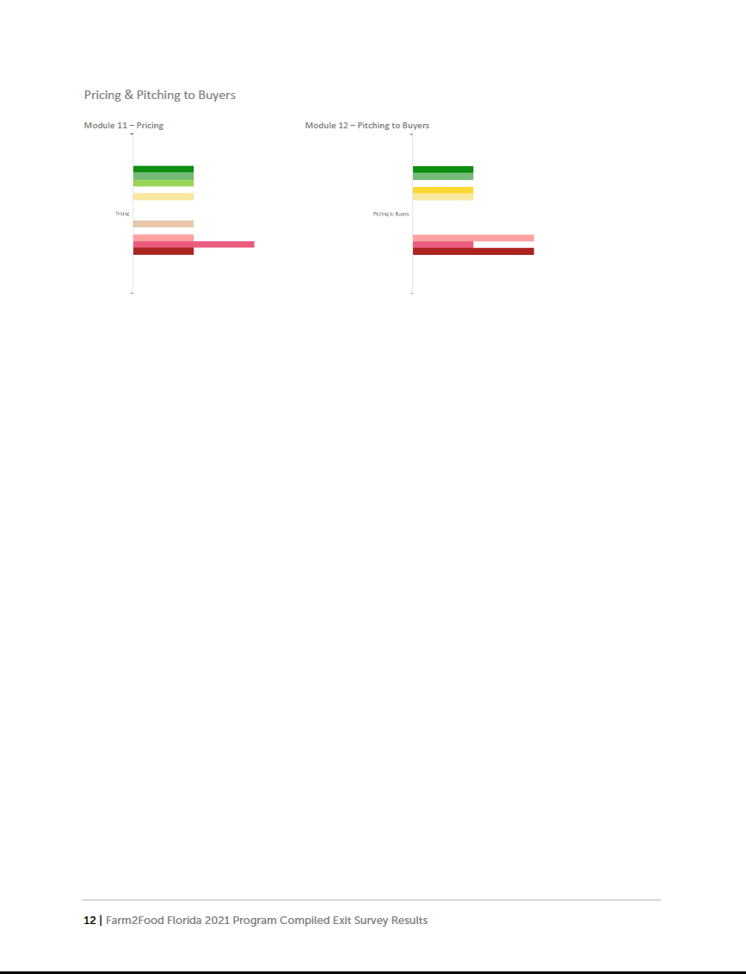

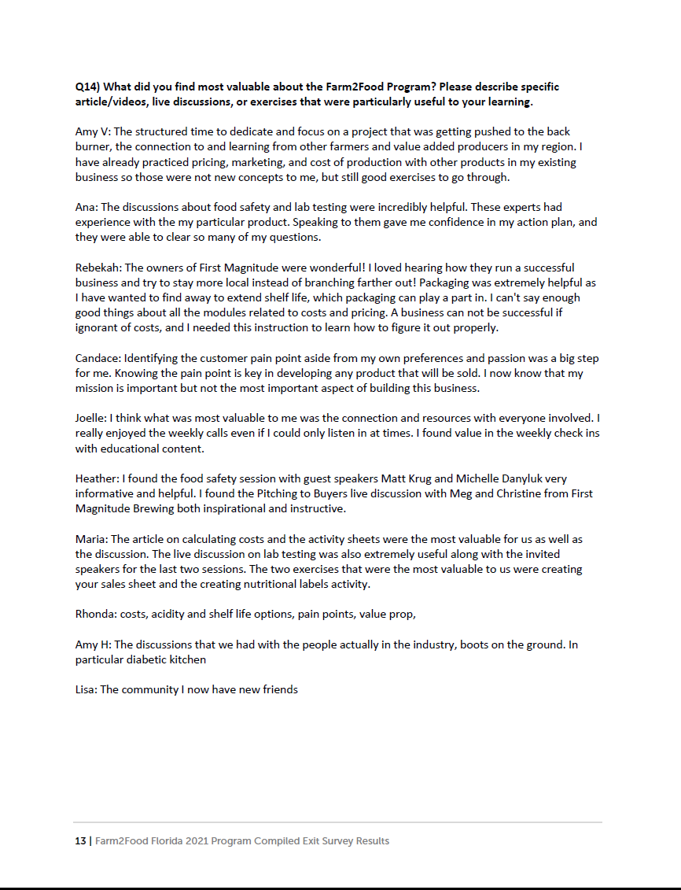

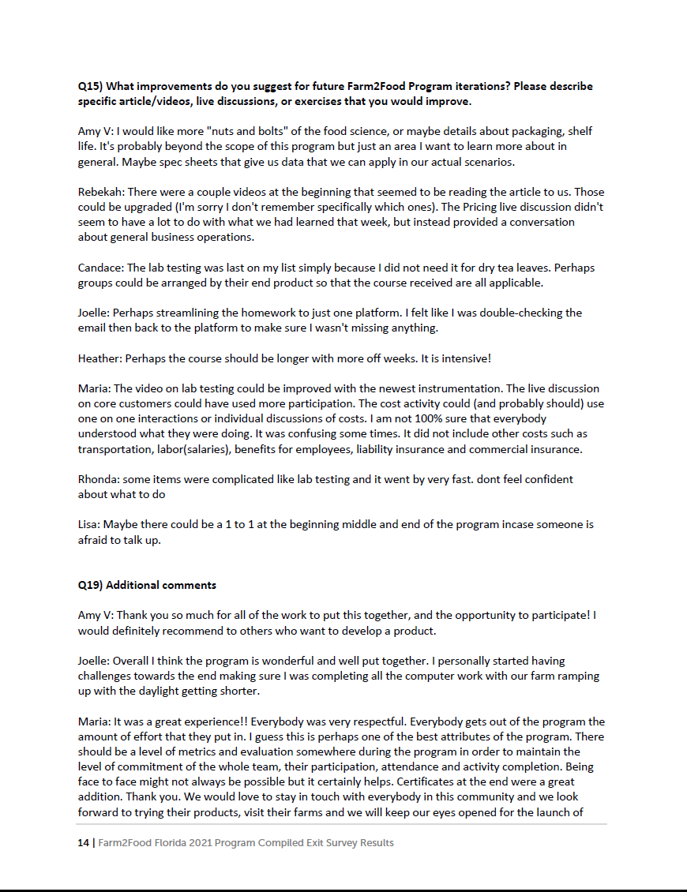

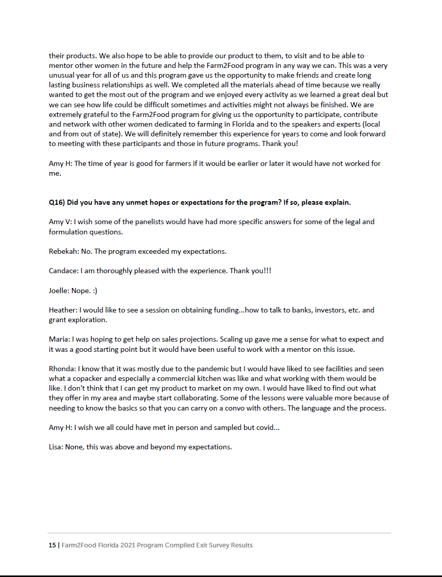

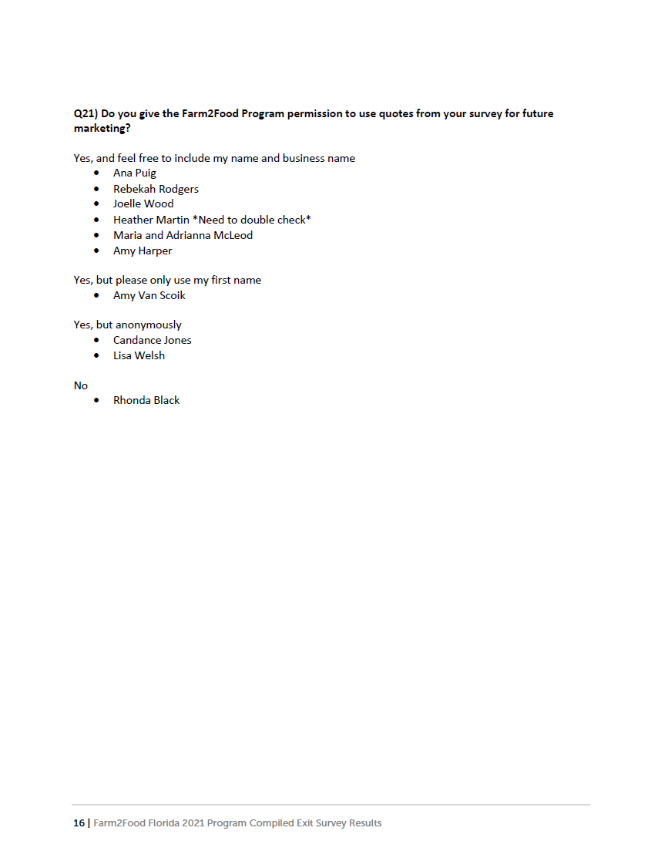

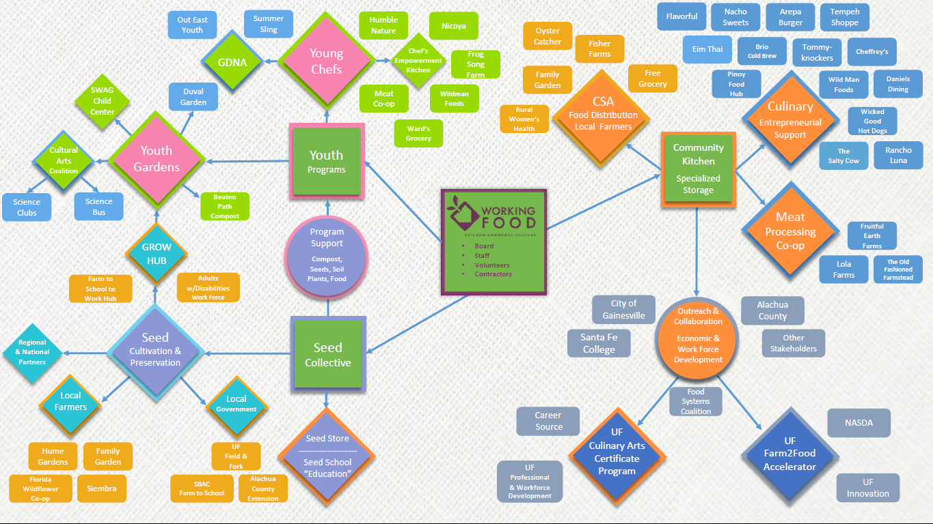

The Economic Policy Institute tracks Florida state unemployment rates, by race/ethnicity and overall, 2022Q1 listing black unemployment at 5.3% and white at 2.8% https://www.epi.org/indicators/state-unemployment-race-ethnicity/
https://map.feedingamerica.org/county/2018/overall/florida/county/alachua
https://alachuacounty.us/Depts/OMB/Stategic%20Alignment/Board%20Level%20Strategic%20Guide%20Overview.pdf
https://www.bebr.ufl.edu/sites/default/files/Research%20Reports/ri1_baseline_report.pdf
https://news.ufl.edu/2022/04/culinary-arts-program-/

