Community Food:
Fresh Food Pathways
State and Local Fiscal Recovery Funds
2022-2024 Work Plan Pilot Final 11/18/2022
Alachua County, Florida
2022-2023 Work Plan Pilot: Fresh Food Pathways

TABLE OF CONTENTS
TABLE OF CONTENTS 1
GENERAL OVERVIEW 2
Executive Summary 2
Supported Communities 2
Mobile Pop-Up Markets 2
Alachua County’s Strategic Aims 3
Uses of Funds 4
Promoting equitable outcomes 7
Communities (eaters) in Alachua County 8
Local Food and Farm Businesses and Entrepreneurs 14
Food Supply Chain Workers 19
Goals 20
Awareness 21
Access/Distribution 21
Outcomes 21
Community Engagement 22
Labor Practices 22
Use of Evidence 23
Performance Report 23
PROJECT INVENTORY 24
REFERENCES 31

GENERAL OVERVIEW

Executive Summary
In response to the COVID-19 Pandemic, the Federal government has provided Alachua County Board of County Commissioners (ACBoCC) funding through the American Rescue Plan – State and Local Fiscal Recovery Funds (SLFRF). Alachua County will use SLFRF funds to promote a strong and equitable recovery from the Covid-19 pandemic and economic downturn by piloting fresh and local retail food access strategies. These strategies seek to strengthen the local food system and improve control of and access to a diversity of fresh and nutrient-rich and locally-sourced foods in communities subjected to long-standing inequities exacerbated by Covid-based inequities, while recognizing and supporting existing resilient and creative food pathways already in these communities.

Supported Communities
The pilot strategies aim to support the connection between two types of communities/populations.
The first is rural and urban individuals and communities who have already developed creative, long-standing, and community-rooted solutions, based on rich social networks, in response to systemic and institutionally-imposed limited access to a diversity of fresh food choices. These households and communities have experienced Covid-19-related inequities as well as health and wellbeing inequalities both historically and currently. This population includes both eaters in Alachua County and eaters who work in the food supply chain that feeds our community, but who do not necessarily live in Alachua County. The negative health and wellness impacts are connected to historical health, political, and economic systemic issues and inequities, such as housing segregation, educational segregation, mortgage and housing redlining, low wage jobs, wage stagnation, lack of rights and protections, inequitable access to public resources and public political enfranchisement, in addition to more burdensome access to fresh, healthy, nutrient-rich, culturally appropriate foods in mainstream food retail. Ensuring access to convenient, affordable, and nutritious foods was reported as the 2nd highest contributing factor to a healthy community in a 2019 community health survey of Alachua County residents.
The second population is locally owned and managed, smaller-scale food and farm businesses and entrepreneurs that, despite facing food system-based challenges that threaten their livelihoods and compromise the resilience of our local food system, have continued to adapt and produce food for their community. They face challenges connected to inequitable market forces resulting from consolidation and industrialization of processing and distribution channels and inequitable and racially-based policies related to the distribution of resources and opportunities.

Mobile Pop-Up Markets
ACBoCC aims to support these two populations in their efforts to connect with each other through community-implemented pop-up mobile produce markets (MPMs). Mobile produce markets are “small fruit and vegetable markets that have the ability to travel and are not necessarily operated by the farmers/producers selling their own agricultural products.” These markets are flexible and typically travel to multiple neighborhoods on a set, advertised schedule, selling an assortment of goods in a farmer’s market style setup by individual item to allow for shopper choice. They also often offer pre-bagged selections of produce. MPMs are a low-barrier and low-cost strategy for increasing access in the short term to an array of fresh food choices for households and neighborhoods with disproportionately more difficult access to high quality fresh food choices, and they can be more responsive to shifting needs and changes in the neighborhood food environment. On average, they offer between 22-25 diverse fruits, vegetables, herbs, and healthful foodstuffs. Mobile produce markets have been found to support the health of individuals and families by facilitating access to healthy foods and increasing consumption of fruits and vegetables by up to one additional serving a day.,,,,
Mobile produce markets have also been initiated in some communities for increasing connection and demand for local agricultural products and addressing broader food justice issues. They often source “as locally as possible,” typically defined as within a 100-mile radius, therefore, decreasing the number of miles foods travel to consumers, and providing foods that are still rich with nutrients. For residents living in areas with limited access to fresh, local, nutrient-rich foods, MPMs are reported to be a viable supplement to personal health and well-being, with the aim of contributing to community economic sustainability, health, and resilience.

Alachua County’s Strategic Aims
This SLFRF-funded Fresh Food Pathways Pilot project is based on the Alachua County Commission’s Strategic Guide FY 2022. This pilot aims to meet the County’s strategic aim to address the root cause of issues and inequities by bolstering the local food system in such a way as to increase community engagement, control, and health. The pilot aims to support a foundation of our local economy and food system--small farmers & food entrepreneurs --to support direct relationships with consumers and improve their access to local community and neighborhood markets, as well as their control over food choices easily available to them in a way that recognizes their own food pathways and agency. Prioritizing these local, smaller-scale, food producers and entrepreneurs, who often develop creative solutions to systemically imposed challenges to producing and selling food, supports the County’s aim to focus economic development efforts on local businesses and removing barriers to economic opportunity, as well as its commitment to work with private and public partnerships. This pilot also intends to address root causes of inequities faced by those who work in the food chain supplying food to our communities, specifically low and sub-living wages for food chain workers, hazardous working conditions, and lack of power to improve their conditions as a result of being hidden and disconnected from those who eat the food they tend, harvest, and process.

Uses of Funds
The Alachua County Board of County Commissioners (ACBoCC) will allocate $750,000 of SLFRF funds from the end of 2022 through September 2024 to pilot pop up mobile produce markets in two (2) to four (4) COVID-impacted communities with the aim of increasing access to fresh, nutrient-rich and locally sourced foods that support residents’ health and well-being and existing food pathways and networks of resilience and agency in these communities, while strengthening the local food economy and community control of food system resources. Food pathways are defined as “the cultural and social practices that affect food consumption, including how and what communities eat, where and how they shop and what motivates their food preferences.” The framework of food pathways recognizes that the food consumption is political and dynamic rather than static. Local food economies will be strengthened through the following sourcing priorities:
- Smaller-scale local farms and food entrepreneurs, who face inequitable access to markets and resources;
- Farm and food businesses that meet the Valued Workforce criteria of the Good Food Purchasing Program, which was recently adopted by the ACBoCC; and
- Farm operations with labor that demonstrate health and safety protocols for farmworker protection from heat stress and other hazards, as well as living wages, and right to organize for farmworkers.
Local communities will further be supported via capacity building investments for community rooted organizations, including partnering with local financial and administration experts to provide incubation opportunities and resources addressing fiscal management and administration, tracking, and reporting systems required to access capital and funding pathways that facilitate communities meeting their own needs and priorities related to food access.
Supporting the work of small community rooted organizations and community groups, who are doing the work of addressing food inequities in their communities and neighborhoods in Alachua County, is critical to the equity aims of the county and real change for residents facing inequities. The County structures, processes, procedures, and requirements are often prohibitive to supporting and working with these groups. Part of the work that will be done during this pilot is identifying the obstacles these groups and communities face when trying to access County and other large institutional support and working with county staff to develop strategies and solutions to eliminating these obstacles.
The majority of the work will be done under Expenditure Category 2.0: Negative Economic Impacts in Sub-category EC 2.1: Household Assistance: Food Program. Pilot funds may be allocated toward the following, either as direct county expenses or through a sub-contract:
- Community investigation and knowledge building: Consistent community engagement prior to mobile markets operation is critical to the success of the project. These activities can include one-on-one conversations, attendance at community events, neighborhood meetings, speaking engagements, relationship building activities (i.e., skillshare events and social events), as well as pilot planning with community partners. Successful mobile produce markets select and implement market sites through partnerships with community organizations and groups already serving the community. Many studies recommend identifying communities of high need (i.e., communities with a high density of lower-income and/or SNAPeligible households) and high interest for such markets (established through community conversations). However, it is essential to shift this deficit framing to one that recognizes the strengths these communities have that characterize food pathways and resilience, despite systemic and imposed institutional inequities. This pilot intends to support these existing strengths and reduce the externally imposed obstacles to families and communities feeding themselves. For example, by hiring market staff at living wages from within the communities where the markets will operate and formally consulting with community members.
- Vehicle Costs: The Veggie Van Training Center recommends low cost, existing vehicle options initially so that when the MPM program does buy a market vehicle purchase it is better informed about the needs on the ground. Vehicle procurement priorities include energy efficiency. Retrofit costs ensure the vehicle is able to safely carry fresh produce and other food items, including shelving, refrigeration, power source, air conditioning, hand washing station, and insulation. Retail display set ups, including baskets, paint/signage, announcement system, tables, scale, etc.
- Procurement: Many mobile produce markets incorporate local farm sourcing as a priority, recognizing the importance of supporting local farmers and the local economy. However, a study of one mobile market model in Kentucky found that the relationship was not as financially sound for local farms supplying the market as intended, indicating a need for intentional and informed focus on this aspect in implementation of this type of model. The same study found that, if successful, an MPM model that specifically targets low income communities with transportation barriers can provide an entirely new market outlet for local farms. MPMs commonly adopt a strategy of “as local as possible,” recognizing that seasonality, cultural food preferences, prices, and local farms’ capacity and relationships will all influence availability. Experience from implementation of MPMs in other regions has demonstrated the importance of diversity of produce and foodstuff offered, including offering some staples (an aspect of availability in food access) in addition to considering other dimensions of access, such as price (affordability) and quality (acceptability) and meeting the needs of the shoppers (accommodation)., The Veggie Van Training Center recommends consistent year round weekly schedules. Therefore, sourcing from outside the local food system may be necessary to be able to offer more diversity and prioritize foodstuffs desired by the community on a consistent, year-round basis. The Good Food Purchasing Program (GFPP) is a tool for executing values-based procurement in more distant and invisible supply chains. It includes criteria for sourcing from suppliers that meet verifiable standards for improving food system labor conditions by providing better protections and power for workers to improve their working conditions- including increasing pay. The MPM pilot procurement activities may include community-farmer gatherings, community-farm liaison work, farm ordering software, supplier tracking database and data collection and analysis, coordinating with other institutions regarding GFPP qualifying suppliers, calculating costs of production capacity building, identifying and addressing obstacles for farmers to supply to markets, transport and tracking of foodstuffs, and inventory monitoring and assessment.
- Marketing and outreach: The MPM pilot may sub-contract with a marketing company to develop a marketing plan and materials and/or support community capacity building in this area. Persistent marketing strategies most commonly used by MPMs include canvassing, flyers, banners, loudspeakers, jingles, signage, broadcast (e.g., TV, radio), print and social media, digital outreach (e.g., text messages, emailed newsletters), ad campaigns, direct mail, and the visual appeal of the market, word-of-mouth, attending community events, and networking to community members. Especially important to surveyed shoppers of MPMs is transparency about pricing. Advertising locations, times, products and prices in advance is important,as well as creating a welcoming environment. Many MPM operations have found that paid community liaisons and staffing the mobile markets with community members are critical in market success; therefore marketing and outreach training and capacity building development may be included in the pilot activities.
- Pop-up market physical infrastructure: Market infrastructure includes displays, refrigeration/coolers (stand alone), tables, tents, signage, cooking demonstration and tasting equipment and set up, chef services, packaging, point of sale systems (see detail below), credit card processing and merchant service fees, laptop, mobile internet, location use fee/rent, etc..
- Disposables and Supplies: Cleaning supplies, paper supplies, ice, fuel, etc.
- Point of sale system: The hardware (can include bar-code scanner, card reader, register, internet connected device, cash drawer, receipt printer, receipt book, ledger) and software (can include mobile sales app, Square) at the place of a retail purchase (calculates cost, accepts payments and tracks sales, implements discounts and loyalty programs, and manages customer relationships and inventory) (Wikipedia: Point of Sale). Success of mobile produce markets is dependent on being able to utilize and accept multiple forms of payment, including food assistance program benefits (i.e., Farmers Market Special Supplemental Nutrition Program for Women, Infants, and Children [WIC] dollars, senior vouchers, and EBT/Supplemental Nutrition Assistance Program [SNAP]. Many programs also implement additional localized incentive strategies, such as coupons, vouchers, and reward cards.
- Operations hub infrastructure: Dry and cold storage facilities, re-packing space, equipment and supplies, rent/lease, and utilities.
- Training, capacity building, and awareness raising: Nutrition education events and materials, commonly including cooking demonstrations and tastings, distribution of materials recipes and informational handouts, and one-on-one exchange about produce handling and preparation. This pilot intends to recognize the existing and rich knowledge and skill community members already possess related to fresh food storage, processing, and preparation by partnering with these community members for cooking demonstration, tastings, and shopper education events. Capacity building for local community-rooted groups partnering on the project such as SNAP provider training (which can be provided by Marketlink). Community liaisons and staff training and resources, including talking points, tools for gathering feedback from community member shoppers about preferences and needs, marketing tactics, etc. As well as capacity building on any community identified areas of need related to fiscal and administrative management.
- Incentives and subsidized food cost planning: Affordability is demonstrated to be an important dimension to address for MPMs in Covid-impacted communities.,, MPMs across the country are typically subsidized by funds other than sales price. Fresh food costs can be subsidized by agencies or grants, which require staff and administrative overhead costs and reporting. Subsidies may be distributed as heart health / heart smart bucks, coupons, discounts, frequent shopper incentives, and sliding fee scale shares. Financial sustainability planning for the program is critical for MPM programs seeking to strengthen local food economies and continue to build community participation. Some MPMs struggle with finances and close before they have become embedded in community life. Year 1 will include substantial subsidies to make fresh produce affordable to targeted communities while applications for SNAP and FAB are submitted. The pilot activities will include financial sustainability planning with communities.
- Administrative activities: Program planning consultation, management and oversight, subcontracting, tracking, budgeting and bookkeeping, permitting, licensing, insurance, and reporting, including capacity building for community groups to conduct these activities, as well as internal evaluation of institution policies, procedures, and requirements to identify obstacles for partnering with small scale community groups and strategizing alternative policies, procedures, and requirements to eliminate those obstacles.
- Evaluation tools development: Community consultants will work with the county to set priorities in food access options, logistics, and capacity building; develop evaluation tools beyond those required by the Treasury; assess outputs and outcomes and make recommendations for revising the pilot model and sustained program.
- Translation and interpretation services: Simultaneous interpretation services and equipment for events, dual language staffing of mobile market, translation of written materials and information and all necessary correspondence, as needed for limited English proficiency community members targeted for mobile produce market service.

Promoting equitable outcomes
Equity was placed at the forefront of Alachua County through a November 2020 voter-approved charter amendment that directed “(an) examination of policies for all County operations for elements of racial, economic, and gender bias in the design and delivery of County programs and services. The County will identify and act to mitigate and improve upon the effects, patterns, and disparities imposed by said biases.” Alachua County’s commitment to promote equity across the County is illustrated in the County’s Strategic Plan, formally adopted by the Board of County Commissioners in early 2021, which notes that the County seeks the goal of being an “Equitable and Resilient Community.” Equitable is defined as “striving to treat everyone justly according to their circumstances, providing opportunity and access for everyone, while focusing on closing existing equity and access gaps.” Further, a fundamental component of the Plan’s second major goal “Achieve Social and Economic Opportunity for All” is the initiative to build equitable access to health (physical and behavioral), safety, and opportunity, especially for those who haven’t traditionally had access to those systems.
The equity goals of the Fresh Food Pilot Program are to support three population groups that face inequities:

- Communities (eaters) in Alachua County who, in the face of systemic and institutionally imposed limited access to a diversity of fresh food choices, have developed community-rooted solutions, based on rich social networks, to support their own well-being and who have experienced both Covid-19 related inequities as well as historical and current health and wellbeing inequalities. Including the hyper-local community and neighborhood groups that work to address inequities in their own communities. Part of this work includes identifying and addressing obstacles to these types of groups being able to partner with large institutions and access funding and resource pathways to do their work.
- Smaller-scale, local food and farm businesses and entrepreneurs who developed creative ways to feed their communities, despite facing inequitable access to resources and opportunities.
- Food system employees who work in the food procurement chain supplying food to Alachua county, who also have developed community-rooted strategies for self-reliance in the face of hostile, systemically-imposed inequities and who also experience long-standing and Covid-19 related health and wellbeing inequities.

Communities (eaters) in Alachua County
Alachua county’s food insecurity rate was consistently reported as higher than the state of Florida between 2014 and 2019. In Alachua County, 12.4% of the population in Alachua County was food insecure in 2020. The same data show higher food insecurity rates in Alachua County for Black community members (25%) and Latino community members (16%).
Even before the Covid-19 pandemic, there has been substantial focus on/discussion of food access and health and well being inequities in Alachua County. In 2015 the Economic Research Service (ERS) estimated that 37,664 individuals in Alachua County had low access to a food store (living more than 1 mile or 10 miles from a food store in urban and rural areas, respectively). The percentage of the population of the county living within ½ a mile from a healthy food store decreased from 2016 (23.5%) to 2019 (22.2%), making accessing a variety of fresh and nutrient rich foods more difficult for more residents.

The most recent community health assessment for Alachua County confirms the negative impact of long-standing systemic inequitable access to opportunity and resources for county residents identified as Black and Hispanic/Latinx. For example, Black residents have the highest infant mortality rate, the lowest life expectancy and household incomes, and the highest mortality rate in Alachua County and both demographic groups have lower household incomes than white residents.

All the areas considered to have low food access (Figure 1) are also considered to be low income in Alachua County (Figure 2). These areas also have a high correlation with areas of Alachua County that have a higher proportion of Black residents (Figure 3).

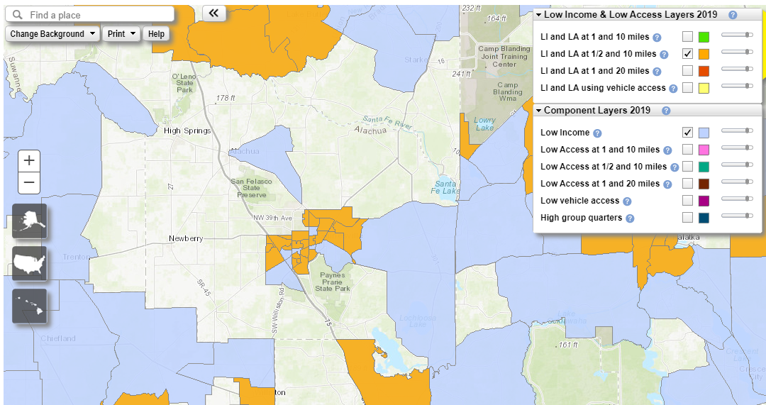
Figure 1. Low Food Access Areas in Alachua County (areas without a grocery store within ½ miles for urban locations and 10 miles for rural locations). Source: USDA ERS Food Access Atlas, 2021.

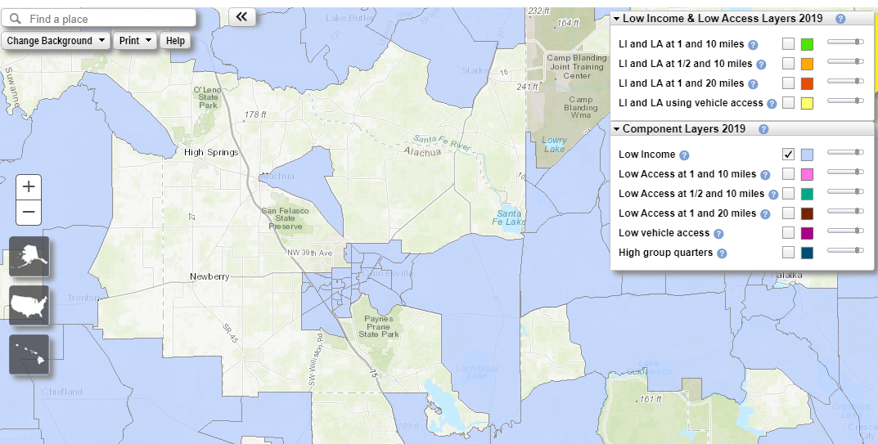
Figure 2. Low Income Areas in Alachua County. Source: USDA ERS Food Access Atlas, 2021.

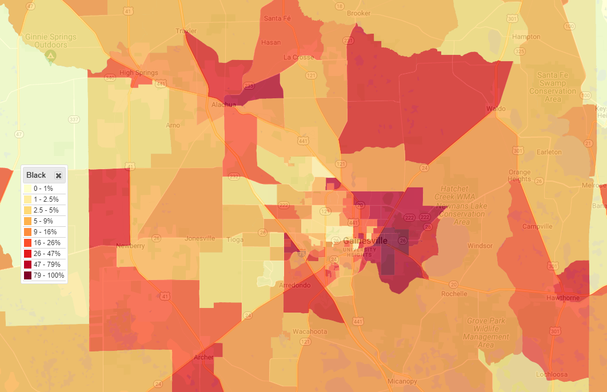
Figure 3: Percentage of Black residents in Alachua County. Source: Justice Map

These outcomes are connected to historical health, political, and economic systemic issues and inequities, such as profiteering from killing native residents of the land in Alachua county as well as buying and selling of enslaved skilled African scientists, craftsperson,and agriculturalists, racially-based housing segregation, educational segregation, mortgage and housing redlining,discriminatory tax benefit codes, employment restrictions, low wage jobs, wage stagnation for lower compensation employment, lack of rights and protections, inequitable access to public resources and public political enfranchisement,,

The Covid-19 pandemic hit households who were already experiencing a multitude of economic, social and political inequities, with more severe physical, financial and emotional impacts due to Covid-19, including increased food insecurity. The Treasury addresses this in their ARPA guidance:
“The final rule recognizes that the pandemic caused broad-based impacts that affected many communities, households, and small businesses across the country; for example, many workers faced unemployment and many small businesses saw declines in revenue. The final rule describes these as “impacted" households, communities, small businesses, and nonprofits.
At the same time, the pandemic caused disproportionate impacts, or more severe impacts, in certain communities. For example, low-income and underserved communities have faced more severe health and economic outcomes like higher rates of COVID-19 mortality and unemployment, often because pre-existing disparities exacerbated the impact of the pandemic. The final rule describes these as “disproportionately impacted” households, communities, small businesses, and nonprofits.”

Both urban and rural households of all races and genders who were already impacted by low income and lack of access to key health and wellness conditions faced additional difficulty due to the pandemic, but Black and Hispanic households in particular faced a disproportionate burden. The ALICE National Covid Survey Report, which assessed the impact of Covid on financial, mental, and physical health of households found that “ the pandemic is exacerbating racial inequities across all facets of life.”

Per Treasury guidance, the pilot program funds are targeted to communities in zip codes that have experienced COVID-based inequities, are generally low-income communities, and can be further defined as part of HUD’s Qualified Census Tract (QCT). For this pilot program, these residents and communities will be identified by meeting one or more of the following Treasury guidance points:
A program or service is provided at a physical location in a Qualified Census Tract [QCT] (for multi-site projects, if a majority of sites are within Qualified Census Tracts) and A program or service where the primary intended beneficiaries live within a Qualified Census Tract;
- The following are QCTs in Alachua County in 2022 (Figure 4): 2.00 (i.e. 2.01 & 2.02), 6.00, 8.06, 9.01, 15.14, 15.15, 15.16, 15.17, 15.19, 15.21 (i.e. part of 15.22), 16.05 (i.e. 16.03 & 16.04), 18.02, 19.02, 22.18.

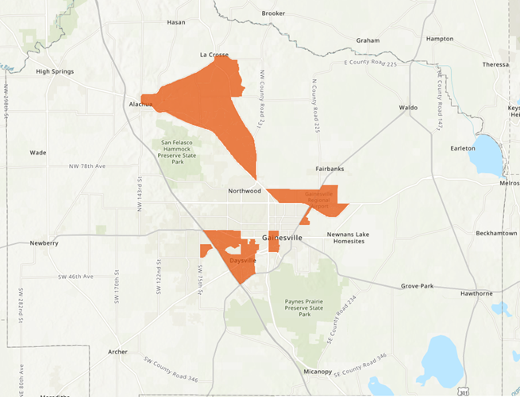
Figure 4: Map of 2022 Qualified Census Tracts
Low-income households and communities are those with (i) income at or below 185 percent of the Federal Poverty Guidelines [FPG] for the size of its household based on the most recently published poverty guidelines…based on the most recently published data.
- Per Treasury guidance, “communities” as referenced above can be determined as a qualified community if the community as a whole has a median income below 185 percent of FPG.
- These guidelines allow Alachua County to expand the number of qualifying Census tracts to also include tracts (Figure 5): 3.01, 3.02, 4.00, 7.00, 8.08, 8.09, 10.00, 15.20 (i.e. part of 15.22), 19.08, 20.00 (i.e. 20.01 & 20.02), 21.02, 22.17.
- Mobile Produce Market stops located within these Census tracts are eligible for program participation.

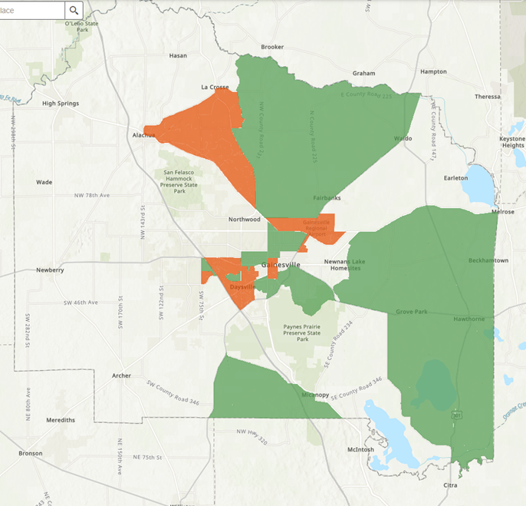
Figure 5: Map of Otherwise Qualified Census Tracts (green), based in 185% FPG. QCTs are shaded orange.
Low-income households and communities are those with…(ii) income at or below 40 percent of area median income [AMI] for its county and size of household based on the most recently published data.
The Treasury’s final rule allows both low-income (40% AMI) and moderate-income (65% AMI) to qualify for assistance.
- Residents in communities which do not qualify under the above requirements can still be eligible to participate in the program if their income is 50% AMI or less.
Finally, households can qualify for participation if they qualify for other federal benefits. These include:
- Temporary Assistance for Needy Families (TANF),
- Supplemental Nutrition Assistance Program (SNAP),
- Free- and Reduced-Price Lunch (NSLP) and/or School Breakfast (SBP) programs,
- Medicare Part D Low-Income Subsidies,
- Supplemental Security Income (SSI),
- Head Start and/or Early Head Start,
- Special Supplemental Nutrition Program for Women,
- Infants, and Children (WIC),
- Section 8 Vouchers,
- Low-Income Home Energy Assistance Program (LIHEAP), and
- Pell Grants

Mobile Produce Markets have become an increasingly utilized and effective model for addressing increasing food insecurity during the Covid-19 pandemic, particularly for communities more negatively impacted by both the pandemic and historical inequities, such as Black, Indigenous, and People of Color (BIPOC) families and households and single-headed households.
Repeated community engagement efforts in Alachua County have revealed that negatively impacted communities want co insistent, more convenient food access to be an investment priority of local government and community organizations. Residents have reported that more burdensome transportation, price, and longer distances to full option food stores are all obstacles to accessing food and food shopping sites that contribute to health and wellbeing. Many in these communities have also expressed that when these investments are made, that they want to be included in the planning and have decision-making power with regards to the investments. This is supported by the Prevention Institutes’ assessment of social determinants of health, which includes structural drivers, such as distribution of wealth and power: “At a fundamental level, inequity in health outcomes can be understood as a disparity in power. Groups with less power tend to suffer worse health outcomes.”
This is related to the fact that much of the data which describe lack of food access or health and wellbeing draw from data tools and frameworks that highlight the community characteristics focused only on deficiencies related to these issues, (all of which offer confirmation that a change is needed regarding the way public resources have been allocated.) What is often left out of this disparity-based assessment are the creative community-rooted social networks( and assets) that these communities have developed in the context of being excluded for broader social and governmental resources and opportunities. These communities often set up alternative networks for accessing food that rely on community connections and relationships in the face of government and market infrastructure support that failed them.

Local Food and Farm Businesses and Entrepreneurs

Since 1930’s, due to get-big-or-get-out federal farm policies, the US has lost 70% of family scale farms (Figures 6 and 7). The resulting divestment in local food economic infrastructure has diminished local community-centered control and wellbeing. These condition facilitated corporate consolidation of power and market share in the food and agricultural system from farm to retail, which has left smaller scale farms, food entrepreneurs and grocers, and local community members disconnected from each other and historical food pathways that priorities community health and wellbeing, as big farm products were increasingly shuttled to large-scale food distribution hubs to supply to large scale procurement channels across the nation and internationally.

“Economically speaking, studies over the past 50 years demonstrate that the encroachment of industrialized agriculture operations upon rural communities results in lower relative incomes for certain segments of the community and greater income inequality and poverty, a less active “Main Street,” decreased retail trade, and fewer stores in the community…. As animal production operations become larger and more technologically dependent, as market power and control shifts to meat processors and market access and choices decline, as production shifts from independent farmers to vertically integrated or coordinated operations, and as economic linkages that once bound farm with community dissolve, the social fabric of communities unravels. This manifests itself within communities by a deterioration of trust, neighborliness, community cohesion, networks of acquaintanceship, democratic values, and community involvement, as well as increased crime rates, civil suits, and stress.”

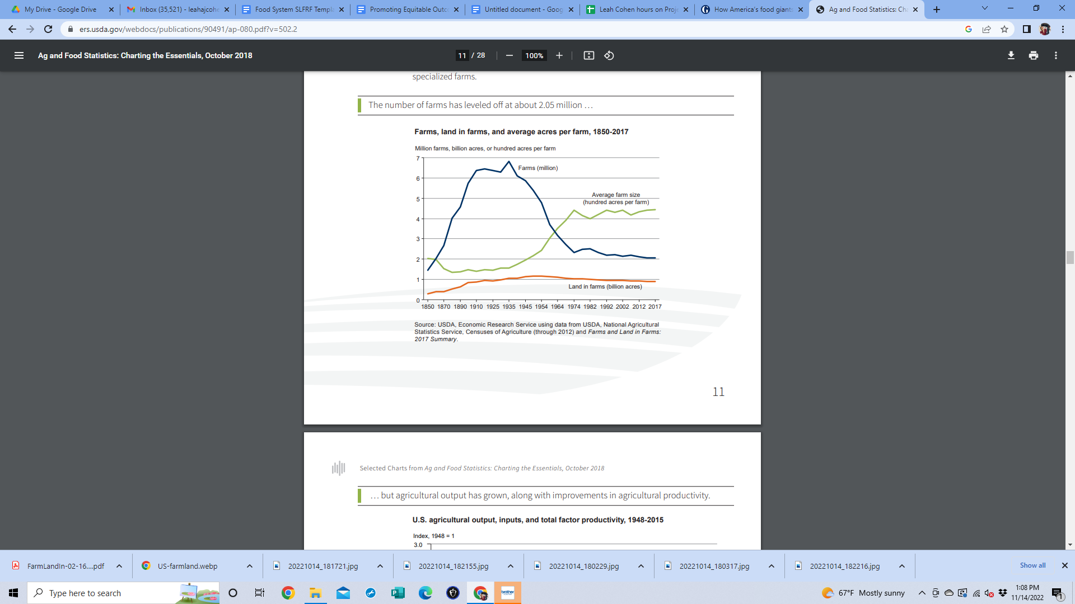
Figure 6: Farms, land in farms, and average acres per farm, 1850-2017
Source: USDA Economic Research Service
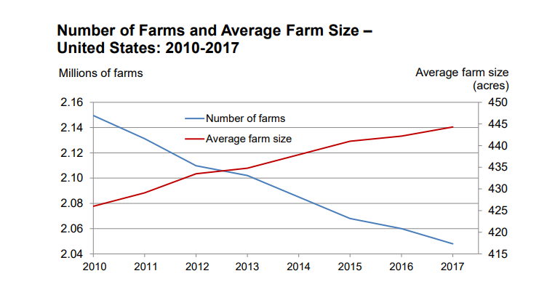
Figure 7: Farms and Land in Farms 2017 Summary (February 2018)
Source: USDA National Agricultural Statistics Service

In general farms rely on off-farm income. For small farms (with less than $350,00 in gross sales) they rely on off-farm income for almost all their household expenses and often do not even break even in farming, which threatens the sustainability of community-oriented farms (Figures 8 and 9).

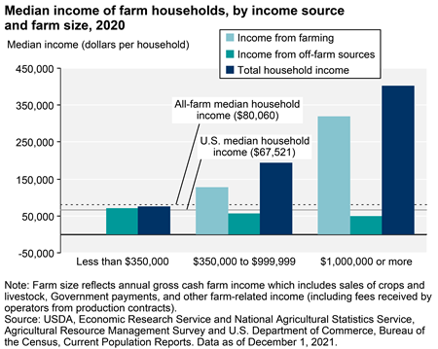
Figure 8: Median Income of Farm Households by Income Source and Farm Size
Source: USDA Economic Research Service
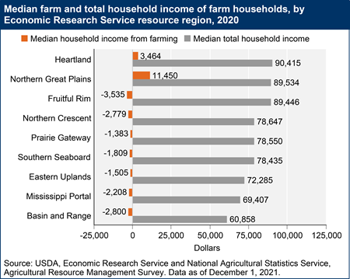
Figure 9: Median Farm and Total Household Income of Farm Households
Source: USDA Economic Research Service

The 2017 Agricultural Census found 1,611 farms in Alachua County, occupying a total of 178,182 acres of land, which includes food and non-food products. Market value of all the farm products sold in Alachua County during this year was an average of $62,019 per farm, which provided an average net income of $11,361 per farm. Approximately 73% of all the farms in the county have sales valuing less than $10,000 annually and 72% of farms occupy less than 50 acres.

In 2012 the percentage of farms in the county selling direct to consumers represented 9.15% of all farms in Alachua County and the value of direct farm sales per capita went down between 2007 and 2012 by 2.29%. The 2017 agricultural survey reports only 7% of farms selling direct to consumers.
Alachua County mirrors many areas across the country where small mom and pop groceries who often purchased local farm fresh products to sell to the surrounding community have been boarded up in favor of distantly owned big food corporations that prioritize profit, which results in sudden closures of retail outlets. Table 1 shows a decline in the number of food stores per capita in Alachua County in recent years.

Table 1: Change in Number of food stores per capita in Alachua County from 2011 and 2016
Type of Retail Food Store | Change in 3 of stores per capita (2011 to 2016)
Grocery Stores (non- supercenters and non-convenience stores percent change | -9.69%
Supercenters | -5.49%
Convenience Stores | -7.76%
Specialized Food Stores | -5.45%
SNAP authorized stores | -6.61%  (2012 to 2017)
WIC authorized stores | 1.79%
Source: ERS, USDA , Food Environment Atlas, accessed 10.10.2022

In general, nationally the number of small businesses open during the pandemic from Jan through August 2020 decreased by 19.1%. In addition to long-standing structural, economic and political challenges that local mid-size and smaller farms have faced, the Covid-19 pandemic introduced additional challenges, including severe labor shortages, dramatically increased costs of inputs for farms, and the sudden and complete end to many of the local market distribution channels farms relied upon (such as local wholesale restaurant markets).

As many restaurants and other retail food outlets closed or experienced supply disruptions and shoppers turned to safer shopping options, many farms lost their wholesale markets, while also suffering severe labor losses due to illness, often resulting from industry standard unsafe and overcrowded farm labor housing and transportation conditions. With the loss of markets and the demand for fresh air shopping venues, many farms scrambled to pivot their economic model, struggling with excessively long hours to feed their local communities. All within a context of dramatically increased costs of farm inputs while many shoppers on average faced loss of expendable income and an inability to pay higher food costs. Still, hyper local farms and community groups often attempted to fill in the gaps in food supply chain disruption and public safety needs by switching to direct market selling to their communities. In Alachua County, two new free grocery networks developed during the Covid-19 pandemic and several local groups sought free food from local farmers in order to meet the needs of those unable to buy the food they needed. Alachua County Health Department developed a food distribution network to get as much food as possible out to rural municipalities on a weekly basis. Working Food instituted a drive by food purchase system where local residents could buy from local farms on a regular basis.

ARPA Guidance Final Rule recognizes the disproportionately negative impact the Covid-19 pandemic has had on small businesses by designating them as an assumed to be impacted group.

That said, inequities in agriculture are not limited to economics and scale and size. In the period after the Civil War, Black communities, including Black farmers began to build wealth and farming and food production systems that would allow them to thrive and feed themselves. Black farmers’ landholdings increased to 925,000 acres by 1920, representing 14% of farms in the US. Due to rampant USDA based racial discrimination and systematic dismantling of Black community wealth and power, Black farmers lost their land during this time at 5 times the rate of white farmers and by 1975 they only operated 45,000 of the farms in the US, representing 2.5% of farms.

“The effects of these decades of discrimination are stark and well-documented. Persistent and ubiquitous racial discrimination has plagued the administration of USDA programs that are crucial to protecting and supporting farmers, and has profoundly impacted rural communities of color. Importantly, disproportionately low access to programs and assistance crucial to many agricultural producers has persisted beyond historical discrimination and well into modern times. For example, farmers of color received just 0.1% of the 2020 COVID-19 relief for farmers. Blackoperated farms today are, on average, much smaller and generate a fraction of the income of their white-operated counterparts. Farmland consolidation, dispossession of Native nations’ land, perpetual discrimination against farmers of color, and significant barriers faced by beginning farmers have resulted in inequities in land ownership. These inequities threaten the vitality of rural economies, the health of our environment, and the security of our food system.”

Despite a number of government programs designed to support farms during Covid, smaller scale BIPOC or Women led farms fared worse during the pandemic due to long-standing structural barriers to accessing pandemic-related farm assistance programs. In Alachua County 91% of producers were White and 5.8% were Black, in 2017. The National Equity Atlas recommends programs that set aside a specified number of contracts with public institutions for businesses owned by people of color as a strategy for addressing economic inequalities based on race. Hence, this pilot will prioritize partnering, sub-contracting, and sourcing food from entities owned and directed by people of color as well as those that are considered small businesses per ARPA guidance.

Food Supply Chain Workers

Farmworkers in the US, who are predominately, people of color and those who have immigrated from other countries of origin, are 20 times more likely to die of heat related conditions than the US civilian workers overall and more likely to be food insecure (studies report food insecurity rates between 50 and 82% for farmworkers). For example, continued exemption of agricultural work from Fair Labor Standards Act protections, such as right to organization and right ot overtime pay, contribute to agricultural workers being one of the lowest paid professions in the US In Florida, small farms that meet a low number of workforce criteria are not obligated to pay any minimum wage to their workers.

Many farmworker groups have organized across the county to improve their own working conditions and to provide safe community space for growing safe and clean food for themselves and their families, often working these garden plots after long hours without overtime pay in the agricultural industry.

Recommended strategies include local targeted hiring policies and reducing barriers to employment as well as raising wages to living wages, requiring paid sick days, ensuring workers’ rights to organize (for which agricultural workers are exempt in Florida) and implementing fair scheduling. Many of these criteria are required, verified, and tracked in the Valued Workforce standards of the Good Food Purchasing Program. Prioritizing food sourcing from food companies that meet these standards is one goal of this pilot, particularly when food cannot be sourced for targeted suppliers locally. In addition, farmworker organizations across the county are advocating for additional heat protection rights for farmworkers. Given the prevalence of illness and death due to heat stress for these workers, especially in Florida, this project will also prioritize sourcing from farms that have demonstrated additional voluntary heat stress protection policies and practices.

Goals
- Support two (2) to four (4) communities with intersections of Covid-19 impacts and:
  - Interested in having a mobile produce market in their community,
  - Low and moderate median household income (per Treasury criteria),
  - High proportion of BIPOC residents,
  - High proportion of limited English proficient speakers (LEP),
  - Disproportionately less access to fresh foods (per USDA criteria for low access), and
  - Existing community-based networks for supporting residents
by
  - Facilitating access to a more diverse array of high quality fresh and local food,
  - Contracting/hiring residents from within participating communities to do project work,
  - Increasing community control by consulting with key community members to shape project priorities and evaluate outcomes, and
  - Strengthening community capacity to fund and administer their own solutions to inequities, including creation of a fund that is more supportive and less restrictive, that facilitates community groups conducting the work of this pilot.
  - Identifying County policies, procedures, and requirements that create obstacles to supporting and working with community level organizations.
- Support at least two (2) local smaller-scale produce farms and food businesses who have experienced Covid-based inequities and:
  - Are local and independently owned and operated;
  - Meet the Treasury criteria for small impacted businesses;
  - Have faced historical and current social, economic, and political inequities as farm and food businesses; and
  - Are able and interested in selling into participating communities
by
  - souring from them for the mobile produce market,
  - facilitating connections and relationship building between these suppliers and communities,
  - reducing barriers to prevent these suppliers from accessing markets,
  - investing in capacity building and infrastructure needs (not already being addressed by other ARPA-funded food system projects, identified by these suppliers.
- Support farmworkers in the supply chains providing fresh produce to local communities targeted by this pilot by prioritizing sourcing from farm and food suppliers that commit to and demonstrate:
  - Paying living wages,
  - Providing paid sick leave and/or verified health and safety protections, including related to heat stress to their employees, and
  - Ensuring farmworkers’ right to organize.

Awareness
- Engagement with community-rooted groups and individuals in targeted communities, including compensation for their time and expertise.
- Employing individuals from participating communities that are the focus of pilot to be community liaisons and assist in implementation of pilot/project.

Access/Distribution
- Coordination with immigrant liaison for outreach to LEP speakers and communities.
- Creation of a fund to ensure small community-based groups asked to do implementation work do not have to front the funds for project work.
- County staff taking on administrative burdens that are burdensome for small community based groups partnering in the work.
- Hire community liaisons to do outreach in their own participating communities at wages and terms that are supportive to improving their livelihoods.
- Include in the project plan, investments in small community-based groups to build capacity associated with their role in the project that will serve them long-term.

Outcomes
- Increased sense of control over food choices available to them by local residents participating in the project.
- Increased fresh and local produce and foodstuffs easily available and affordable in targeted communities.
- Increased connections between local small farm and residents participating in the project
- Increased beneficial markets for impacted local small farm and food businesses.
- Improve the pricing farms get for their products so that they adequately cover their costs of production.
- Lessons learned and recommendations for revising, tracking, and scaling up and expansion of fresh and local retail food access for marginalized communities model for Alachua County with the aim of strengthening our local food economy and addressing food inequities among residents.
- List of strategies the County could implement to reduce obstacles to working with community groups.

Community Engagement
This pilot is an opportunity to work closely with residents in interested and targeted communities on setting the priorities, evaluating the outcomes of the pilot, and making recommendations for sustained programming. Community engagement will be done in the follow ways:
- Community conversations during initial pilot consideration: one-on-one conversations with key individuals who have food access or community organizing experience in targeted communities or who have lived experience accessing food in targeted communities. Aim is to determine level of interest and or potential in community for a mobile produce market, existing fresh and local food choices available and distribution pathways, key individuals the project should consult with/hire initially and throughout pilot, and potential sites in the community for mobile market stops.
- Consulting with community experts: Individuals with lived experience navigating inequities in availability of a variety of high quality fresh produce in their community will be formally consulted to provide feedback and set priorities regarding mobile market food items to be sold, market locations, incentives for purchasing, outreach planning, outcomes desired and assessment of progress towards those outcomes, as well as recommendations for sustained programming of a mobile market after the pilot.
- Staffing the pilot with community liaisons who can do outreach activities on a regular basis within their communities to promote the existence of MPM and encourage shopping at it.
- Partnering with community-rooted organizations embedded within the targeted communities (when interested and available) to conduct specific activities related to the pilot project plan based on their expertise. Provide these groups with the administrative support and technical assistance they may want to facilitate their involvement (i.e., reduce barriers to participation).

Labor Practices
Project Community Consultants:
ACBoCC supports quality workforce practices. In 2016, ACBoCC Established by Ordinance #16-15 of the County’s Purchasing Code the Alachua County Government Minimum Wage (GMW) requirement for certain contractors and subcontractors providing selected services to Alachua County Government. A contractor or subcontractor providing a covered service to the County shall pay to all of its covered employees the established GMW. For fiscal year 2022, the GMW is $16 per hour with qualifying health benefits amounting to at least $2 per hour. For contractors not offering health benefits, the GMW is $18 per hour. The intent of this project is to demonstrate the value of expertise and lived experience of residents in communities negatively impacted by Covid-19 and additional inequities by providing fair compensation for their participation in shaping and evaluating the pilot.
Food Procurement:
Procurement of food will prioritize sourcing from local, smaller scale farms and food businesses that face inequities and those that meet the standards for valued workforce under the Good Food Purchasing Program and/or voluntary health and safety practices, including those related to heat stress protection for farmworkers, and living wages for farm and food chain workers. Procurement practices and prices will be based on realistic costs of production, including these terms and including living wage compensation equivalent for producers.

Use of Evidence
Meta-analysis has found convincing evidence of a positive correlation between increased fruit and vegetable consumption and reduced risk of chronic diseases such as hypertension, coronary heart disease and stroke. The mobile produce market model, which is the main model employed in this pilot, is considered an evidence-based strategy to increase fruit & vegetable consumption and increase healthy foods in food deserts. In addition, MPM’s are reported to result in two additional potential outcomes: increased food security and reduced emissions (although not rated for these outcomes). It is noted that this model is best used for short term aims of improving access to fruits and vegetables while structural issues are worked on.

An additional evidence-based model this pilot intends to employ is competitive pricing for healthy foods, which has been determined to have strong evidence for increasing purchases of healthy foods and may also increase healthy food consumption and reduced energy use. “Competitive pricing assigns higher costs to non-nutritious foods than nutritious foods. Competitive pricing can include incentives, subsidies, or price discounts for healthy foods and beverages as well as disincentives or price increases for unhealthy foods and beverages.”
Finally, point of purchase prompts for healthy food is an evidence-based model that is compatible with mobile produce markets. The rated outcomes include increased fruit and vegetable consumption and improve dietary choice, although it is reported as not likely to reduce disparities alone.

Performance Report
The county will collect the following data and additional measures of impact desired by the community partners:
Performance indicators output measures
- Number of communities facing inequities served by MPM.
- Number of fresh food varieties sold via MPM.
- Dollar amount value of fresh produce sold.
- Dollar amount value of produce sold from small scale, local, farm and food businesses facing inequities.
- Number of local farms and food entrepreneurs sourced from.
- Number of transactions at MPM.
- Percentage of transactions using nutrition/food price incentives.
- Number of stops and/or number of hours MPM spends in targeted communities.

Performance indicators outcome measures
- Number of customers reporting easier access (reduced burden) to buying fresh produce.
- Number of customers reporting better access to a wider variety of quality fresh produce.
- Number of customers that report buying more/eating more fresh produce since shopping at the MPM.
- Number of customers that feel they have more control over their food choices.
- Dollar amount of increased sales for smaller scale, local food and farm businesses facing inequities.
- Number of small scale, local food and farm businesses facing inequities that report MPM as an improved market for their business.
For Treasury Required Programmatic Data, this additional information will be provided with every report.
- Number of households served by MPM.
- Dollar amount of funds used to support disproportionately impacted households.
- Dollar amount used on evidence-based interventions.

PROJECT INVENTORY

Project: Community Food: Fresh Food Pathways Pilot
Identification Number: TBD (created by the recipient and used thereafter in the quarterly
Program and Expenditure Report)
Funding amount: $750,000 to be allocated prior to Sept 30, 2024
Project Expenditure Category: EC 2: Negative Economic Impacts: Household Assistance: Food Program
Project Overview:
Pilot mobile produce markets in two (2) to four (4) COVID-impacted communities with the aim of increasing access to fresh, nutrient-rich and locally sourced foods that support residents’ health and well-being and existing food pathways and networks of resilience and agency in these communities, while strengthening the local food economy by sourcing from smaller-scale, local farm and food businesses that face inequities, and when necessary, prioritizing sourcing from non-local supply chains that meet worker standards that address known inequities they face.
Use of Evidence:
This pilot project uses three evidence-based strategies for increasing access to fresh produce for Covid-impacted communities:
- Mobile produce markets,
- Competitive pricing for healthy foods, and
- Point of purchase prompts for healthy food.

Project Performance Report:

Performance indicators output measures
- Number of communities facing inequities served by MPM.
- Number of fresh food varieties sold via MPM.
- Dollar amount value of fresh produce sold.
- Dollar amount value of produce sold from small scale, local, farm and food businesses facing inequities.
- Number of local farms and food entrepreneurs sourced from.
- Number of transactions at MPM.
- Percentage of transactions using nutrition/food price incentives.
- Number of stops and/or number of hours MPM spends in targeted communities.
Performance indicators outcome measures
- Percentage of customers reporting easier access (reduced burden) to buying fresh produce.
- Percentage of customers reporting better access to a wider variety of quality fresh produce.
- Number of customers that report buying more/eating more fresh produce since shopping at the MPM.
- Dollar amount of increased sales for small scale, local food and farm businesses facing inequities.
- Number of small scale, local food and farm businesses facing inequities that report MPM as an improved market for their business.
For Treasury Required Programmatic Data, this additional information will be provided with every report.
- Number of households served by MPM.
- Dollar amount of funds used to support disproportionately impacted households.
- Dollar amount used on evidence-based interventions.

Program Evaluation:

Pilot program will be evaluated by the project team, community consultants, supplier partners, and survey of shoppers and local suppliers at planning and evaluation meetings summer of 2024.

Project intends to primarily support disproportionately impacted households and small businesses.

Project Timeline - DRAFT - to be finalized with each community
Activity | Start | End |  | Notes
Project Start | 12/7/2022
Legal and logistical feasibility planning, including determining data needs | 12/7/2022 | 1/27/2023 |  | Based on community and local farmer supplier input
Site 1: Determine location for the mobile market route launch | 12/12/2022 | 1/27/2023 |  | County team continues community conversations (with residents, farmers, other suppliers, and community orgs).
Site 1: Determine capacity building needs | 12/12/2022 | 1/27/2023 |  | Consultation with key community members and organizations
Site 1: Onboarding | 1/2/2023 | 2/24/2023 |  | Community organizations and consultants
Development of marketing materials | 1/2/2023 | 2/24/2023 |  | Including translations as needed
Site 1: Community Outreach | 1/2/2023 | Ongoing |  | Identifying qualifying community members and getting them signed up
Procurement Logistics | 1/2/2023 | Ongoing |  | Purchase supplies and equipment, coordinate movement of these goods
Data collection and tracking methods planning | 1/2/2023 | Ongoing |  | To evaluate success metrics
Consult with community experts | 2/15/2023 | Ongoing |  | Ensuring that program is meeting community needs, continue program improvement
Site 1: Route Launch (soft launch) | 3/13/2023 | 3/31/2023
Site 1: Hard launch planning | 3/13/2023 | 4/24/2023 |  | Based on feedback and lessons learned in soft launch. April/May planned for hard launch
Site 1: Capacity Building | 3/15/2023 | Ongoing |  | Iterative consultation with key community members and organizations
Site 2: Determine location for the mobile market route launch | 4/3/2023 | 4/28/2023 |  | Iterative conversations with key community members and organizations
Site 1: Weekly route finalized | 4/28/2023
Site 1: Launch Event | May 2023, exact date TBD |  |  | Allowing date flexibility to account for event logistic
Apply for SNAP | 5/15/2023 | 5/19/2023
Site 2: Onboarding | 6/5/2023 | 6/30/2023 |  | Community organizations and consultants
Farmer/community planning preparation (for August) | 6/5/2023 | 7/28/2023
Outreach Event | June 2023, exact date TBD |  |  | Allowing date flexibility to account for event logistic
Site 2: Community Outreach | 7/3/2023 | Ongoing |  | Identifying qualifying community members and getting them signed up
Annual farmer/community planning | August 2023, exact date  TBD |  |  | Allowing date flexibility to account for event logistic
Apply for FAB | 8/21/2023
Site 2: Route Launch Event | October 2023, exact date TBD |  |  | Allowing date flexibility to account for event logistic
Outreach Event | October 2023, exact date TBD |  |  | Allowing date flexibility to account for event logistic
Site 3: Determine location for the mobile market route launch | 10/2/2023 | 12/29/2023 |  | Iterative conversations with key community members and organizations
Outreach Event | January 2024, exact date  TBD |  |  | Allowing date flexibility to account for event logistic
Site 3: Onboarding | 1/2/2024 | 1/26/2024 |  | Identifying qualifying community members and getting them signed up
Procurement of MPM vehicle | January-March 2024
Vehicle retrofit | March-April 2024
Begin sustainable funding conversations | February 2024 |  |  | Discussions with community partners regarding sustained funding mechanisms
Site 3: Weekly route finalized | 3/13/2024
Site 3: Route launch | 3/29/2024
Site 3: Route Launch Event | April 2024, exact date TBD |  |  | Allowing date flexibility to account for event logistic
Finalize sustained funding plan | June 2024
Outreach event | June 2024, exact date TBD |  |  | Allowing date flexibility to account for event logistic
Farmer/community planning preparation (for August) | 6/3/2024 | 7/26/2024
Evaluation and planning for sustained MPM program | 6/15/2024 | 09/1/2024
Impact data analysis and final report writing | 08/15/2024 | 09/15/2024

Project Budget December 2022- September 2024

Total Estimated Project Cost | $750,000
Line Item | Amount
Local Market Support and Development  - Food purchases  - Basic supplies, such as cleaning supplies and container materials  - Outreach and marketing, including app for advertising and management and linguistic translation services  - Location distribution set up, including tents, ice, etc. as needed  - Business administration expenses including:  - Certified kitchen space  - Permitting fees  - FAB and SNAP associated expenses  - Bookkeeping | $107,000
Transportation and Delivery Support  - Lease of existing vehicle in Year 1 during pilot phase  - Purchase of vehicle for full program based on pilot feedback, which includes:  - Sufficient cargo space  - Sufficient towing capacity  - Any necessary retrofits for program operations  - Paint/wrap which identifies the vehicle as a County vehicle associated with the SEEDS office  - Meets County sustainability objectives  - Insurance and licensing | $183,000
Grant Staffing Coordination & Program Delivery  Positions anticipated to be contractors and/or sub-contractors.  - Food Systems Consultant, FT  - Program Coordinator, FT  - Procurement Coordinator, PT  - Community Consultants (6),* PT, to serve as local experts on routes, food preferences, etc.  - Community Liaisons (1/community),* PT, advertising and outreach  - Community Education Consultants (3),* PT, to teach participants how to prepare vegetables, and conduct story-telling of local food culture  *Because these are part time needs, it may be the same or different individual | $380,000
Capacity Building & Technical Assistance  - Fiscal, HR, administration, IT, and other training for multiple small-scale non-profits | $80,000
TOTAL | $750,000

REFERENCES
AbuSabha, Rayane, Dipti Namjoshi, and Amy Klein. 2011. “Increasing Access and Affordability of Produce Improves Perceived Consumption of Vegetables in Low-Income Seniors.” Journal of the American Dietetic Association 111, no. 10 (October): 1549-1555. 10.1016/j.jada.2011.07.003.
Alachua County. 2021. “Alachua County Strategic Guide - FY 2022.” Alachua County. https://alachuacounty.us/Depts/OMB/Stategic%20Alignment/Board%20Level%20Strategic%20Guide%20Overview.pdf.
Alkon, Alison H., Daniel Block, Kelly Moore, Catherine Gillis, Nicole DiNuccio, and Noel Chavez. 2013. “Foodways of the Urban Poor.” Geoforum 48, no. August (May): 126-135. https://doi.org/10.1016/j.geoforum.2013.04.021.
Andrews, Brother David, and Timothy J. Kautza. no date. “Impact of Industrial Farm Animal Production on Rural Communities.” https://www.pcifapia.org/_images/212-8_PCIFAP_RuralCom_Finaltc.pdf.
Boeing, Heiner, Angela Bechthold, Achim Bub, Sabibe Ellinger, Dirk Haller, Anja Kroke, Eva Leschik-Bonnet, et al. 2012. “Critical review: vegetables and fruit in the prevention of chronic diseases.” European Journal of Nutrition 51 (June): 637-633. 10.1007/s00394-012-0380-y.
Browning, Elizabeth, and Keiki Tanaka. 2021. “A Farmers' Guide to Fresh Stop Market,” Project #LS18-300. SARE Grant Management System. https://projects.sare.org/wp-content/uploads/farmersguide_old111221.pdf.
Bureau of Community Health Assessment. 2019 data. “FLHealthCharts.gov.” Population Living Within ½ Mile of a Healthy Food Source. https://www.flhealthcharts.gov/ChartsDashboards/rdPage.aspx?rdReport=NonVitalIndRateOnly.TenYrsRpt&cid=9779.
Center for Good Food Purchasing. 2021. “Center for Good Food Purchasing.” The Program. https://goodfoodpurchasing.org/program-overview/#_standards.
Community Health Intervention Lab. 2021. “​Veggie Van Training Center.” Bringing a Mobile Farmers' Market to Your Community [Video]. https://www.myveggievan.org/.
Energy Justice Network and Sunlight Foundation. 2021. “Justice Map.” Justice Map. http://www.justicemap.org/.
Feeding America. 2022. “Map the Meal Gap.” Overall (all ages) Hunger & Poverty in Alachua County, Florida. https://map.feedingamerica.org/.
Florida Department of Health, Division of Public Health Statistics and Performance Management. 2019 data. “Food Insecurity Rate.” FLHealthCHARTS.gov. https://www.flhealthcharts.gov/ChartsReports/rdPage.aspx?rdReport=NonVitalIndRateOnly.DataViewer&cid=9910.
Gans, Kim M., Patricia Markham Risica, Akilah Dulin Keita, Laura Dionne, Jennifer Mello, Kristen Cooksey Stowers, George Papandonatos, Shannon Whittaker, and Gemma Gorham. 2018. “Multilevel approaches to increase fruit and vegetable intake in low-income housing communities: final results of the ‘Live Well, Viva Bien’ cluster-randomized trial.” International Journal of Behavioral Nutrition and Physical Activity 15 (80): 1-18. 10.1186/s12966-018-0704-2.
Hanks, Angela, Danyelle Solomon, and Christian E. Weller. 2018. “American Progress.org.” Systematic Inequality: How America's Structural Racism Helped Create the Black-White Wealth Gap. https://www.americanprogress.org/article/systematic-inequality/.
Hill, Brittany G., Ashley G. Melony, Terry Mize, Tom Himelick, and Jodie L. Guest. May. “Prevalence and Predictors of Food Insecurity in Migrant Farmworkers in Georgia.” American Journal of Public Health 101, no. 5 (2011): 831-833. 10.2105/AJPH.2010.199703.
Hsiao, Bi-sek, Lindiwe Sibeko, and Lisa M. Troy. 2019. “A Systematic Review of Mobile Produce Markets: Facilitators and Barriers to Use, and Associations with Reported Fruit and Vegetable Intake.” Journal of the Academy of Nutrition and Dietetics 119, no. 1 (January): 76-97. 10.1016/j.jand.2018.02.022.
Hsiao, Bi-sek, Lindiwe Sibeko, Kathy Wicks, and Lisa M. Troy. 2018. “Mobile produce market influences access to fruits and vegetables in an urban environment.” Public Health Nutrition 21, no. 7 (January): 1332–1344. 10.1017/S1368980017003755.
Kasprzak, Christina M., Julia J. Schoonover, Deanna Gallicchio, Lindsey Haynes-Maslow, Leah N. Vermont, Alice Ammerman, Samina Raja, Laurene Tumiel-Berhalter, and Lucia A. Leone. 2021. “Using common practices to establish a framework for mobile produce markets in the United States.” Journal of Agriculture, Food Systems, and Community Development 10, no. 4 (September): 73-84. 10.5304/jafscd.2021.104.029.
Lally, Anne E., Alban Morina, Leah N. Vermont, Jill N. Tirabassi, and Luccia A. Leone. 2022. “Impacts of the COVID-19 Pandemic on Mobile Produce Market Operations: Adaptations, Barriers, and Future Directions for Increasing Food Access.” International Journal of Environmental Research and Health 19, no. 18 (September): 1-16. https://doi.org/10.3390/ijerph191811390.
Leone, Lucia A., Gina L. Tripicchio, Lindsey Haynes-Maslow, Jared McGuirt, Jacqueline S. Grady Smith, Janelle Armstrong-Brown, Ziya Gizlice, and Alice Ammerman. 2018. “Cluster randomized controlled trial of a mobile market intervention to increase fruit and vegetable intake among adults in lower-income communities in North Carolina.” International Journal of Behavioral Nutrition and Physical Activity 15 (2): 1-11. 10.1186/s12966-017-0637-1.
Lucan, Sean C. 2019. “Local Food Sources to Promote Community Nutrition and Health: Storefront Businesses, Farmers’ Markets, and a Case for Mobile Food Vending.” Journal of the Academy of Nutrition and Dietetics 119, no. 1 (January): 39-44. 10.1016/j.jand.2018.09.008.
MarketLink. n.d. Home - Marketlink. Accessed November 15, 2022. https://marketlink.org/.
Miewald, Christiana, and Eugene McCann. 2014. “Foodscapes and the Geographies of Poverty: Sustenance, Strategy, and Politics in an Urban Neighborhood.” Antipode 46, no. 2 (March): 537-566. https://doi.org/10.1111/anti.12057.
“National Equity Atlas.” n.d. https://nationalequityatlas.org/indicators/poverty#/?geo=01000000000000000.
PennState Social Science Research Institute. 2020. “Point-of-purchase prompts for healthy foods.” County Health Rankings. https://www.countyhealthrankings.org/take-action-to-improve-health/what-works-for-health/strategies/point-of-purchase-prompts-for-healthy-foods.
PennState Social Science Research Institute. 2020. “Mobile produce markets.” County Health Rankings. https://www.countyhealthrankings.org/take-action-to-improve-health/what-works-for-health/strategies/mobile-produce-markets.
PennState Social Science Research Institute. 2021. “Competitive pricing for healthy foods.” County Health Rankings. https://www.countyhealthrankings.org/take-action-to-improve-health/what-works-for-health/strategies/competitive-pricing-for-healthy-foods.
Poudel, Padam Bahadur, Mukti R. Poudel, Aasish Goutam, Samiksha Phuyal, Chiran K. Tiwari, Nisha Bashya, and Shila Bashyal. 2020. “COVID-19 and its Global Impact on Food and Agriculture.” Journal of Biology and Today's World 9, no. 5 (May): 221. https://www.iomcworld.org/articles/covid19-and-its-global-impact-on-food-and-agriculture.pdf.
Prevention Institute. 2015. “Measuring What Works to Achieve Health Equity: Metrics for the Determinants of Healt.” https://www.preventioninstitute.org/sites/default/files/publications/Measuring%20What%20Works%20to%20Achieve%20Health%20Equity%20_Full_Report.pdf.
Reese, Ashanté M. 2018. “We will not perish; we're going to keep flourishing’: Race, Food Access, and Geographies of Self- Reliance.” Antipode 50, no. 2 (February): 407-424. 10.1111/anti.12359.
Sibeko, Lindiwe, Bi-sek Hsiao, and Lisa M. Troy. 2019. “A Systematic Review of Mobile Produce Markets: Facilitators and Barriers to Use, and Associations with Reported Fruit and Vegetable Intake.” Journal of the Academy of Nutrition and Dietetics 119, no. 1 (January): 76-97. 10.1016/j.jand.2018.02.022.
Steinman, Jon. 2019. Grocery Story: The Promise of Food Co-ops in the Age of Grocery Giants. Canada: New Society Publishers.
Tanaka, Keiko, Bree Pearsall, Barbra Justice, Whitney Sewell, Charlotte Tolley, Jenny Williams, Lisa Munniksma, et al. 2021. “Final report for LS18-300 - SARE Grant Management System.” SARE Grant Management System. https://projects.sare.org/project-reports/ls18-300/.
United for ALICE. 2021. “The Pandemic Divide: An ALICE Analysis of National COVID Surveys.” file:///C:/Users/briley/Downloads/21ALICENationalCOVIDReport.pdf.
USDA. 2020. “Go to the Atlas.” USDA ERS. https://www.ers.usda.gov/data-products/food-environment-atlas/go-to-the-atlas/.
USDA. 2021. “America’s Farmers: Resilient Throughout the COVID Pandemic.” https://www.usda.gov/media/blog/2020/09/24/americas-farmers-resilient-throughout-covid-pandemic.
US Department of Agriculture. 2021. “Food Research Access Atlas.” https://www.ers.usda.gov/data-products/food-access-research-atlas/go-to-the-atlas/.
U.S. Department of Health and Human Services. 2022. “Poverty Guidelines for 2022.” https://aspe.hhs.gov/topics/poverty-economic-mobility/poverty-guidelines.
U.S. Department of the Treasury. 2022. “Coronavirus State & Local Fiscal Recovery Funds: Overview of the Final Rule.” Treasury.gov. https://home.treasury.gov/system/files/136/SLFRF-Final-Rule-Overview.pdf.
U.S. Supreme Court. 1832. The United States, Appellants v. Don Fernando de la Maza Arredondo and Others, Appellees. https://www.law.cornell.edu/supremecourt/text/31/691.
“Veggie Van Toolkit.” n.d. Veggie Van Training Center. Accessed November 15, 2022. https://www.myveggievan.org/toolkit.html.
WellFlorida Council. 2020. “Alachua County: Community Health Needs Assessment,” Report. FloridaHealth.gov. https://alachua.floridahealth.gov/programs-and-services/community-health-planning-and-statistics/data-and-reporting/_documents/cha-2020.pdf.
Wender, Melanie J. 2011. “Goodbye Family Farms and Hello Agribusiness: The Story of How Agricultural Policy is Destroying the Family Farm and the Environment.” Villanova Law Environmental Law Journal 22 (1). https://digitalcommons.law.villanova.edu/cgi/viewcontent.cgi?article=1016&context=elj.
Yeatter, Alan, dir. 2008. In the Shadow of Plantations. The Alachua County Manager's Communications Office, 2014. https://www.youtube.com/watch?v=AMjWEjQy7yI.
Zepeda, Lydia, Anna Reznickova, and Luanne Lohr. 2014. “Overcoming challenges to effectiveness of mobile markets in US food deserts.” Appetite 79 (April): 58-67. 10.1016/j.appet.2014.03.026.

(WellFlorida Council 2020)
(Sibeko, Hsiao, and Troy 2019, 76-97)
(Lucan 2019, 40)
(AbuSabha, Namjoshi, and Klein 2011, 1549-1555)
(Leone et al. 2018, 1-11)
(Gans et al. 2018, 1-18)
(Hsiao et al. 2018, 1341)
(Zepeda, Reznickova, and Lohr 2014, 58-67)
(Zepeda, Reznickova, and Lohr 2014, 58-67)
(Reese 2018)
(Alkon et al. 2013, 127)
(Miewald and McCann 2014, 539)
Other large public institutions recognize this challenge and are attempting to put in place alternative processes to address it. https://sbsd.admin.ufl.edu/initiatives/mentor-protege-program/
(Kasprzak et al. 2021, 74)
(Kasprzak et al. 2021)
(Reese 2018, 408)
(Hsiao, Sibeko, and Troy 2019, 93)
(“Veggie Van Toolkit”, n.d.)
(Tanaka et al. 2021)
(Browning and Tanaka 2021)
(Kasprzak et al. 2021, 73-84)
(Zepeda, Reznickova, and Lohr 2014, 58-67)
(Lucan 2019, 39-44)
(Center for Good Food Purchasing 2021)
(Zepeda, Reznickova, and Lohr 2014, 58-67)
(Hsiao, Sibeko, and Troy 2019, 76-97)
(Kasprzak et al. 2021, 73-84)
(MarketLink, n.d.)
(Zepeda, Reznickova, and Lohr 2014, 58-67)
(Hsiao, Sibeko, and Troy 2019, 76-97)
(Kasprzak et al. 2021, 73-84)
(Community Health Intervention Lab 2021)
(Tanaka et al. 2021)
(Zepeda, Reznickova, and Lohr 2014, 58-67)
(Alachua County, Strategic Guide - FY 2022)
(Florida Department of Health, Division of Public Health Statistics and Performance Management 2019 data)
(Feeding America 2022)
(Food Research Access Atlas 2021)
(Bureau of Community Health Assessment 2019 data)
(Well Florida Council 2020)
(U.S. Supreme Court 1832)
(Yeatter 2008)
(Hanks, Solomon, and Weller 2018)
(United for ALICE 2021, 2-3)
(U.S. Department of the Treasury 2022)
(United for ALICE 2021, 3)
(United for ALICE 2021, 3)
(U.S. Department of the Treasury 2022)
(U.S. Department of Health and Human Services 2022)
(U.S. Department of the Treasury 2022, 385-386)
(U.S. Department of the Treasury 2022, 19-20)
(Lally et al 2022)
(Well Florida Council 2020)
(Prevention Institute 2015)
(Reese 2017)
(Wender 2011)
(Andrews and Kautza no date)
(USDA ERS Food Environment Atlas).
(Steinman 2019)
(United for ALICE 2021)
(Johansson 2021)
(Poudel et al 2020)
(Equity in Agriculture, Production and Governance 2022, 2)
(National Equity Atlas)
(Hill et al, 2011)
(National Equity Atlas)
(Alachua County 2022)
(Boeing et al 2012)
(PennState Social Science Research Institute 2020)
(PennState Social Science Research Institute 2021)
(PennState Social Science Research Institute 2020)

